

July 28, 2022

Ivanhoe Electric updates activities at its flagship Santa Cruz Project in Arizona

Santa Cruz is the second-largest undeveloped copper deposit in the Lower 48 States, the largest leachable deposit and the largest on private land

85,000-meter program of resource in-fill, geotechnical, hydrological and metallurgical drilling well underway on the Santa Cruz deposit

Seven drill rigs now active

Proprietary Typhoon™ geophysical survey completed to identify deposit extensions and new zones of mineralization

Ivanhoe Electric’s vision is for a green, low-impact, solar powered underground mine

NEW YORK, New York – Ivanhoe Electric (NYSE American: IE; TSX: IE) Chairman and Chief Executive Officer Robert Friedland and President Eric Finlayson are pleased to provide an update on its flagship Santa Cruz Copper Project in Arizona.

Ivanhoe Electric acquired the Santa Cruz Project in mid-2021 after several years of negotiation. Copper mineralization on the property was originally discovered over 50 years ago, with the Santa Cruz, Texaco and Park Salyer high-grade copper deposits identified beneath gravel cover.

A validation drill program completed in late 2021 on the Santa Cruz deposit allowed calculation and disclosure of a current mineral resource estimate in accordance with S-K 1300 and NI 43-101. With seven drill rigs currently active on the deposit, an 85,000-meter program of resource in-fill, geotechnical, hydrological and metallurgical drilling is now well underway to assess options for underground mine development. These deposits remain open for further expansion. A significant proportion of the copper occurs as readily leachable secondary copper minerals.

Mr. Friedland commented: “Ivanhoe Electric’s vision is for a green, low-impact, underground mine with minimal surface expression, powered by solar energy and with vanadium-redox battery storage provided by Ivanhoe Electric’s 90%-owned private subsidiary, VRB Energy. Apart from producing ultra-low emissions copper that will contribute to American supply chain independence, we also can see opportunities for a multi-use project hosting other commercial and industrial activity together with renewable power generation opportunities.

“While the Santa Cruz deposit is already the second-largest undeveloped copper deposit in the Lower 48, we believe that there is significant potential to expand the deposit, to add new resources at Texaco and Park Salyer, and to identify new zones of mineralization.

“Very recently, we completed a proprietary Typhoon™ deep-penetration induced polarization and resistivity survey over a 26.5 km² (6,500-acre) area to identify extensions to known deposits and new zones of mineralization. Data processing is underway by Ivanhoe Electric’s 94%-owned private subsidiary Computational Geosciences of Vancouver, Canada, and results will be announced when available. Extensive exploration drilling will test the anomalies identified by Typhoon™.

“Ivanhoe Electric has the opportunity to re-invent American mining with green, clean copper production from a world-scale deposit, located in the heart of Arizona, the Copper State.”

Located in the heart of the Copper State

The Santa Cruz Copper Project is in the prolific copper mining state of Arizona, approximately one-hour’s drive south of Phoenix, 11 km west of the city of Casa Grande, and in proximity to numerous major copper mines. Arizona has produced approximately 10% of all copper ever mined and is rated within the top-five best mining jurisdictions in the world according to the Fraser Institute. Since 1980, Arizona has produced more than 35 million tonnes of copper, which is approximately 65% of total United States copper production.

The Santa Cruz Project is located within a mineral deposit corridor running between the Ajo and Globe Miami copper mines. This is a fundamental geological feature, which is estimated to control approximately 35% of all known copper resources in Arizona.

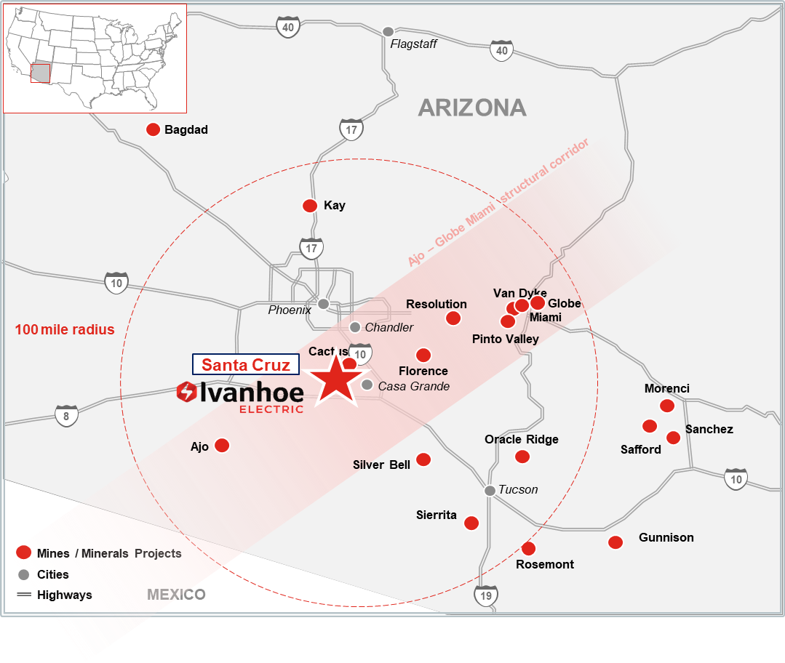

Well-established infrastructure and industry in proximity to the Santa Cruz Project.
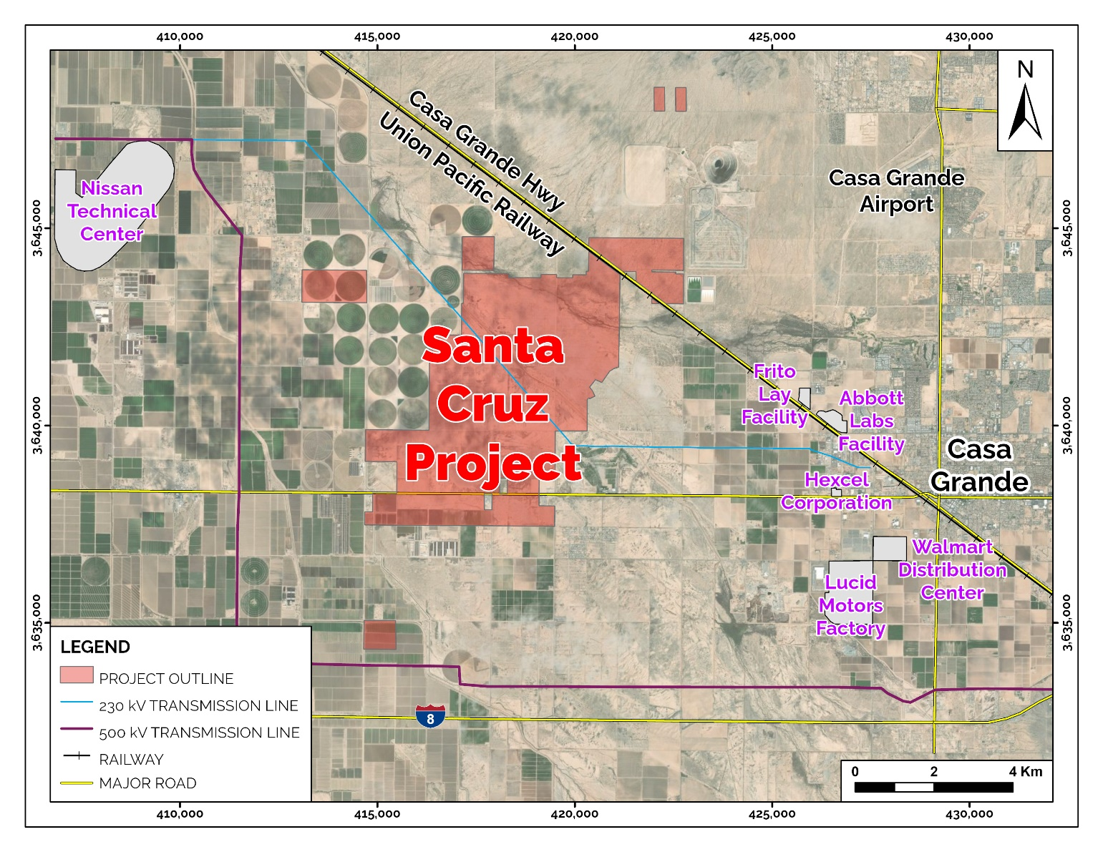

Project site is flat Sonoran Desert that has been previously impacted by agricultural and other land-use activities.

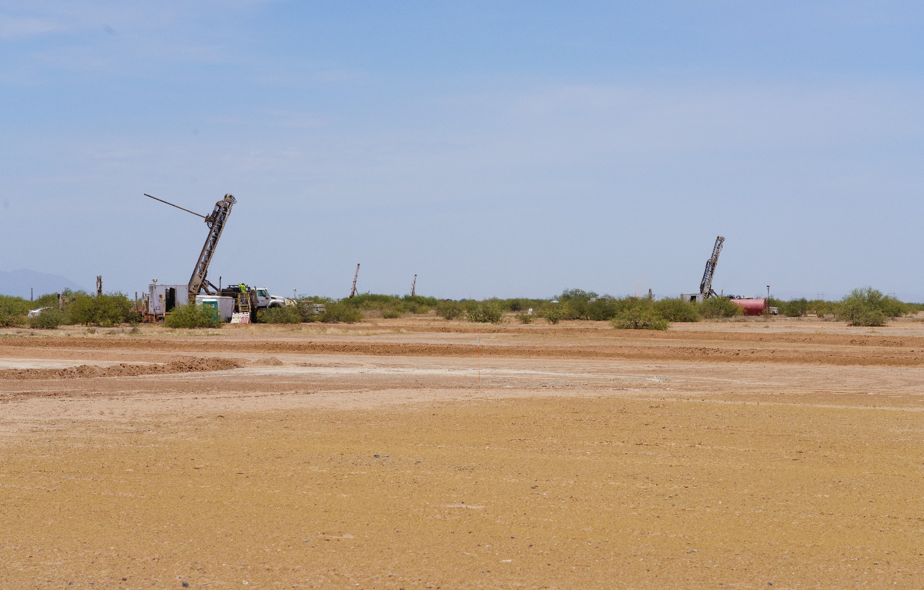

Three identified copper mineralized zones located on private land

Ivanhoe Electric’s Santa Cruz Project covers 78 km² (19,300 acres), including 28 km² (6,900 acres) of private land, 31 km² (7,700 acres) of Arizona State Mineral Exploration permits, and 238 unpatented claims over 19 km².

Copper mineralization at the Santa Cruz Project was originally identified more than 50 years ago after reports of copper minerals from agricultural water wells. Following a staking rush involving several different major mining companies, the Santa Cruz, Texaco and Park Salyer deposits were discovered concealed beneath gravel cover, but were not closed-off by drilling. All three deposits lie on private land.

While the largest of the three bodies of mineralization is the Santa Cruz deposit, the three deposits may originally have been part of one or more Laramide-age porphyry copper systems subsequently dismembered by Basin-and-Range extensional faulting.

Santa Cruz is the largest mineralized zone in the cluster.

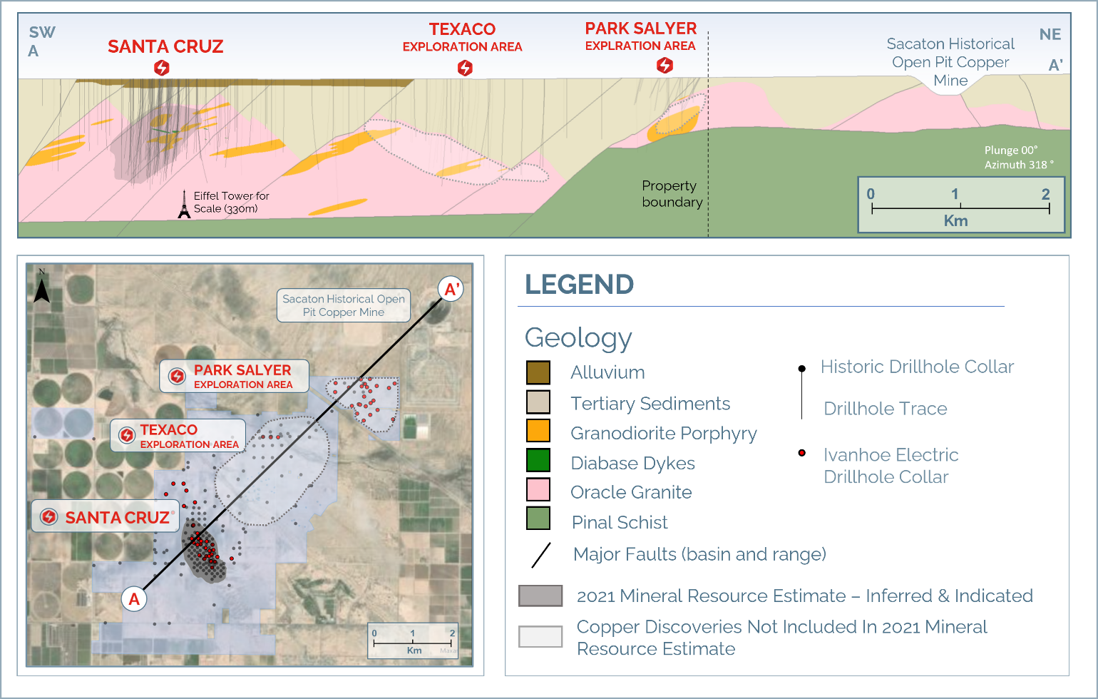

During this post-mineral faulting, the Santa Cruz deposit experienced significant supergene copper enrichment. This is a geological process in which copper in a deposit is moved by groundwater from its original site of formation and is then redeposited into much higher-grade accumulations. At Santa Cruz, these accumulations include the oxide minerals chrysocolla and atacamite, and the copper-rich sulfide mineral chalcocite. In other Arizona copper mines, these minerals are amenable to copper recovery using solution extraction and electro-winning methods (SX/EW) to produce copper cathode on site.

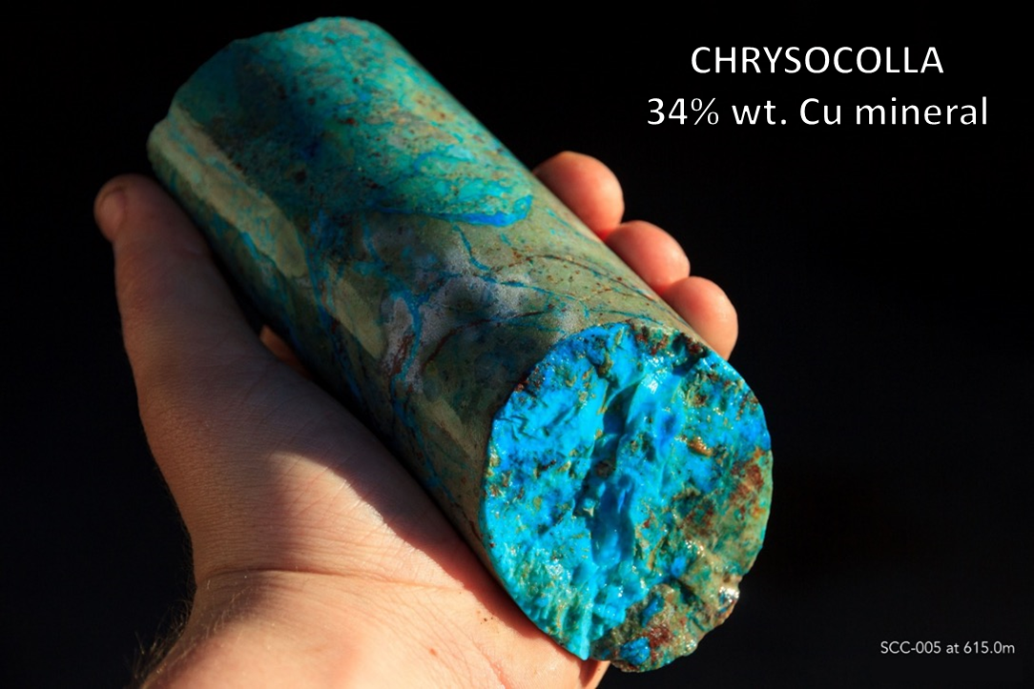

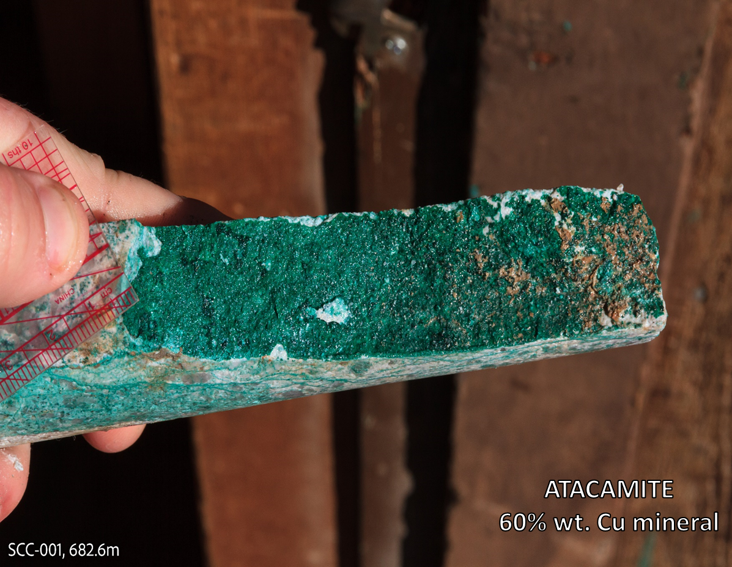

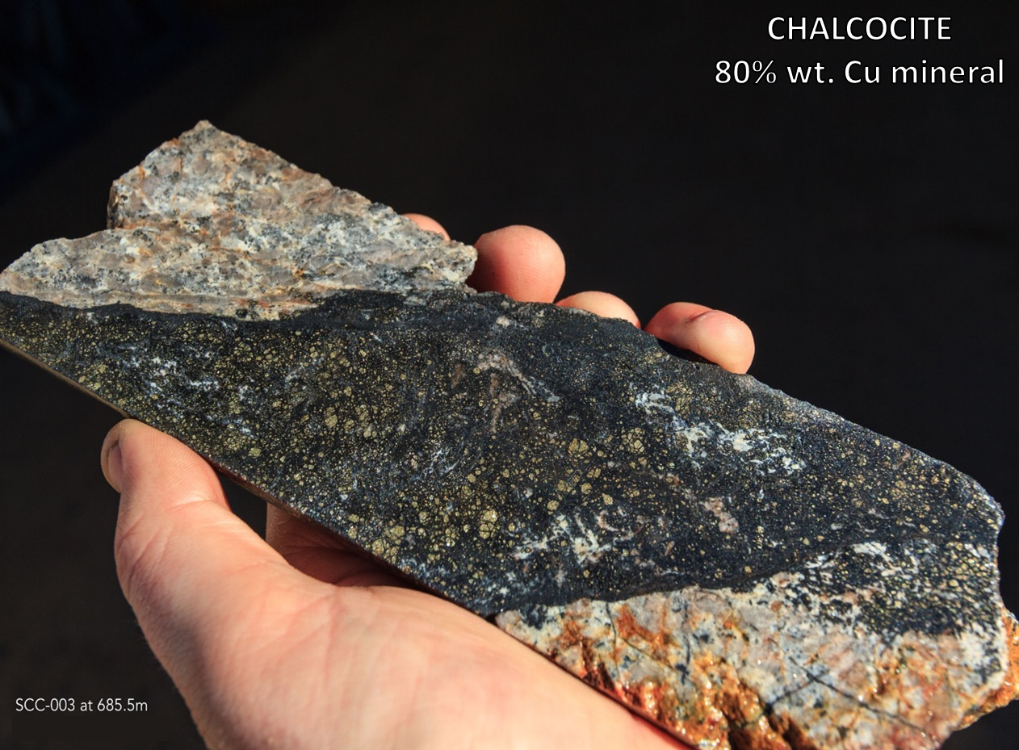

The Santa Cruz deposit is the second-largest undeveloped copper deposit in America’s Lower 48 States, and the largest on private land

After acquiring the Santa Cruz Project in mid-2021, Ivanhoe Electric completed a four-hole diamond drilling program totaling 3,601 meters on the Santa Cruz deposit to verify widths and grades of mineralization reported in the approximately 100,000 meters of historical drilling.

All verification samples from within the deposit were assayed using sequential copper analysis for total copper, acid soluble copper and cyanide soluble copper, and were also analyzed for molybdenum and other elements. Geology and alteration logs were also compared to the historical holes.

Based on the excellent correlation between the verification and historical holes, independent consulting engineers Nordmin Engineering completed a current Mineral Resource Estimate for the Santa Cruz deposit in accordance with the definitions for Mineral Resources in S-K 1300 and using the 2014 CIM Definition Standard for Mineral Resources and Mineral Reserves and 2019 CIM Best Practice Guidelines.
Table 1: Santa Cruz Deposit Mineral Resource Estimate shown with sensitivity to various cut-off grades.
Category | Copper  Cut-Off Grade  (%) | Tonnage  (millions of tonnes) | Total  Copper Grade  (%) | Acid  Soluble  Copper Grade  (%) | Total  Contained  Copper  (millions of tonnes) | Total  Contained  Acid Soluble  Copper  (millions of tonnes)
Indicated | 2.0 | 22.9 | 2.58 | 1.37 | 0.6 | 0.3
Indicated | 1.0 | 83.4 | 1.69 | 0.68 | 1.4 | 0.6
Indicated | 0.8 | 117.2 | 1.46 | 0.52 | 1.7 | 0.6
Indicated | 0.5 | 219.1 | 1.07 | 0.30 | 2.4 | 0.7
Indicated | 0.39 | 274.0 | 0.93 | 0.25 | 2.5 | 0.7
Inferred | 2.0 | 28.1 | 2.66 | 1.72 | 0.7 | 0.5
Inferred | 1.0 | 74.1 | 1.87 | 1.08 | 1.4 | 0.8
Inferred | 0.8 | 98.1 | 1.63 | 0.90 | 1.6 | 0.9
Inferred | 0.5 | 174.9 | 1.19 | 0.60 | 2.1 | 1.1
Inferred | 0.39 | 248.8 | 0.91 | 0.44 | 2.3 | 1.1
Notes on Mineral Resources:
- The Mineral Resources in this estimate were independently prepared by Nordmin Engineering Ltd and the Mineral Resources were prepared in accordance with the definitions for Mineral Resources in S-K 1300 and with NI 43-101 and with the CIM Definition Standards for Mineral Resources and Mineral Reserves (2014) and the CIM Estimation of Mineral Resources and Mineral Reserves Best Practice Guidelines (2019). Mineral Resources that are not Mineral Reserves do not have demonstrated economic viability. No environmental, permitting, legal, title, taxation, sociopolitical, marketing, or other relevant issues are known that may affect this estimate of Mineral Resources.
- Verification included multiple site visits to inspect drilling, logging, density measurement procedures and sampling procedures, and a review of the control sample results used to assess laboratory assay quality. In addition, a random selection of the drill hole database results was compared with original records.
- The Mineral Resources in this estimate for the Santa Cruz Deposit used Datamine Studio RMTM software to create the block models.
- The Mineral Resources have an effective date of December 8, 2021.
- Underground Mineral Resources are reported at a CoG of 0.39% Total Cu, which is based upon a Cu price of US$3.70/lb and a Cu recovery factor of 80%.
- Specific gravity was applied using weighted averages by lithology.
- All figures are rounded to reflect the relative accuracy of the estimates, and totals may not add correctly.
- Excludes unclassified mineralization located along edges of the Santa Cruz deposit where drill density is poor.
- Report from within a mineralization envelope accounting for mineral continuity.
- Acid soluble Cu and cyanide soluble Cu are not reported for the Primary Domain.
- Mineral Resources were classified into Indicated and Inferred categories based on geological and grade continuity, in conjunction with data quality, spatial continuity based on variography, estimation pass, data density, and block model representativeness, specifically assay spacing and abundance, kriging variance, and search volume block estimation assignment. The Mineral Resource Estimate has been defined based on an applied percentage (%) CuT CoG to reflect processing methodology and assumed revenue stream from Cu. The Mineral Resource Estimate is based on an underground bulk mining methodology and surface float and leach process to recover cathode Cu or a mixture of cathode Cu and Cu saleable concentrates.

An attractive feature of the Santa Cruz Mineral Resource Estimate is the amount of metal at higher cut-off grades. This higher-grade material tends to be in the acid- and cyanide-soluble categories, potentially allowing for lower cost, lower energy and lower water-consuming processing methods. At a 0.39% copper cut-off grade, the resource contains 2.5 million tonnes of copper in the Indicated category with an average grade of 0.9% copper, and 2.3 million tonnes of copper in the Inferred category with an average grade of 0.9% copper. However, when a 1% copper cut-off grade is applied, Santa Cruz maintains nearly 60% of its contained metal, with 1.4 million tonnes of copper in the Indicated category at an average grade of 1.7% copper and 1.4 million tonnes of copper in the Inferred category at an average grade of 1.9% copper.

The Santa Cruz Deposit compares favorably to other large-scale United States copper projects (contained copper in millions of tonnes).
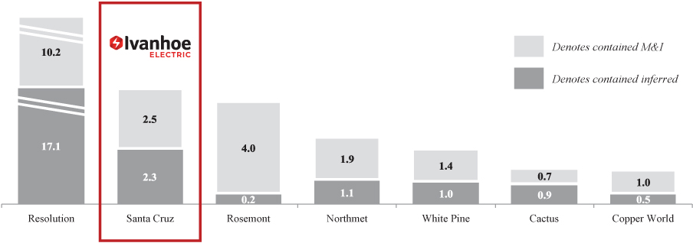
Mineralization at the Santa Cruz deposit can be divided into three main domains:

- Supergene oxide mineralization forms the uppermost zone of mineralization and is dominated by chrysocolla (a copper oxide that is 34% copper by weight) and atacamite (a copper chloride that is 60% copper by weight).
- Supergene sulfide mineralization underlies the supergene oxide zone and is comprised primarily of chalcocite (80% copper by weight), with accessory chalcopyrite and pyrite that was incompletely replaced by chalcocite.
- Hypogene sulfide mineralization underlies the supergene sulfide zone and consists of chalcopyrite (35% copper by weight), pyrite, molybdenite, and minor bornite and covellite, hosted within porphyry-style phyllic alteration. Intensity of mineralization is highest around Laramide-age dyke intrusions that cut the mineralized Proterozoic-age Oracle Granite country rock.

A fourth mineralization domain, exotic oxide mineralization, is of more limited known occurrence and forms very high-grade mineralization in paleo-valleys at the contact of the mineralized bedrock and the overlying gravel cover. This mineralization formed in basal gravels through precipitation of copper dissolved in migrating groundwater. These zones represent important areas for exploration as they can be spectacularly high grade, as demonstrated by Ivanhoe Electric drill hole SCC-005 which intersected 24 meters @ 7.0 % copper, as part of a larger intercept of 57 meters @ 3.5% copper. Full drill results can be found at the Ivanhoe Electric website at https://ivanhoeelectric.com/investors/technical-reports/.

Santa Cruz mineralized domains shown at 0.39% copper cut-off.

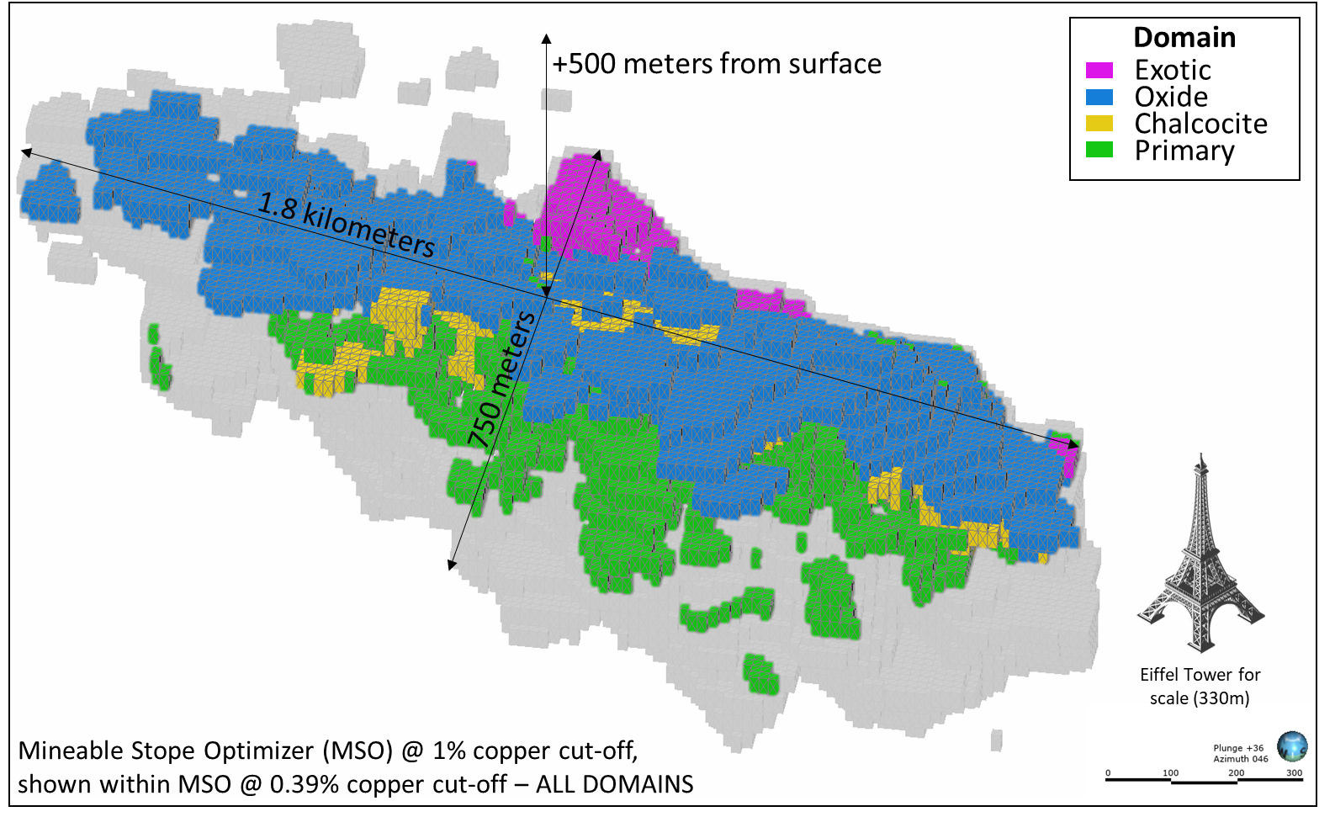

Santa Cruz resource at 1% copper cut-off.

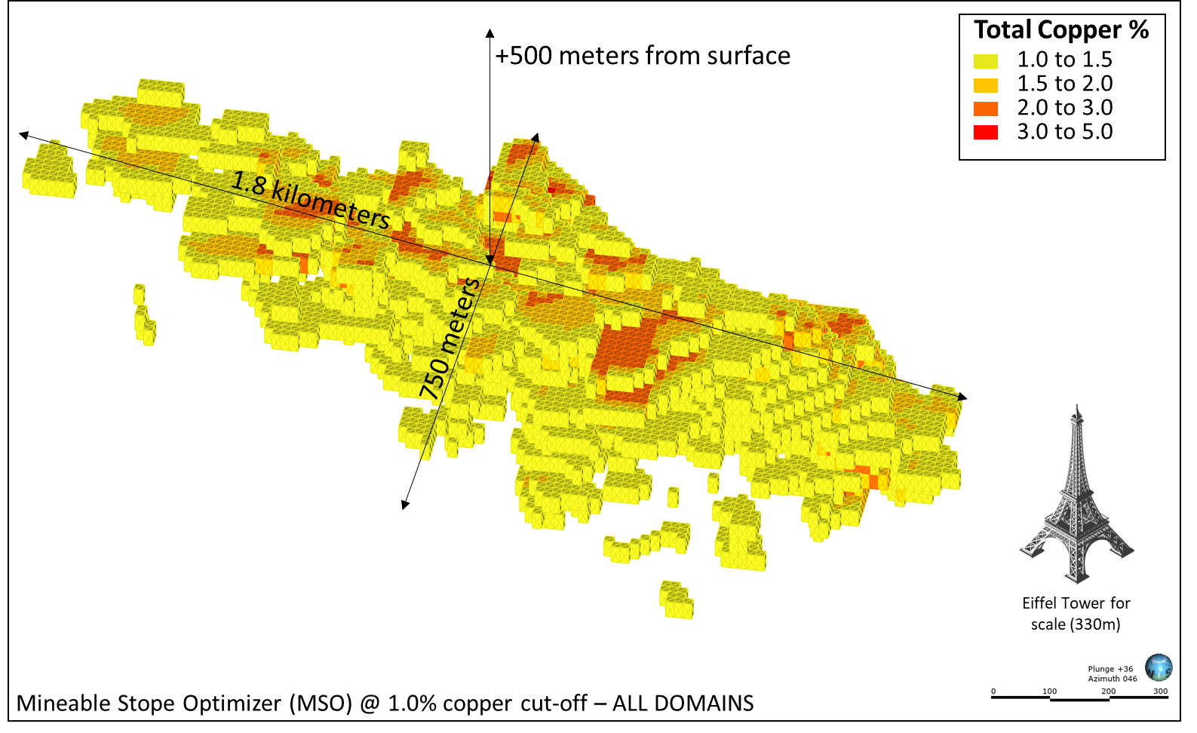

Table 2: Santa Cruz Deposit Mineral Resource Estimate at 0.39% total copper cut-off grade divided into the four distinct mineralization domains.
Domain | Resource  Category | Tonnage (millions of tonnes) | Total  Copper Grade  (%) | Total  Soluble  Copper Grade  (%) | Total  Contained Copper  (millions of tonnes) | Total  Soluble Contained Copper  (millions of tonnes)
Exotic  Oxide | Indicated | 7.0 | 1.05 | 0.80 | 0.07 | 0.06
Exotic  Oxide | Inferred | 11.7 | 1.28 | 1.00 | 0.15 | 0.12
Supergene  Oxide | Indicated | 53.0 | 1.34 | 1.27 | 0.71 | 0.67
Supergene  Oxide | Inferred | 126.1 | 1.06 | 1.00 | 1.34 | 1.25
Supergene  Sulfide | Indicated | 29.1 | 1.25 | 1.13 | 0.36 | 0.33
Supergene  Sulfide | Inferred | 14.8 | 1.36 | 1.28 | 0.20 | 0.19
Hypogene | Indicated | 184.9 | 0.75 | n/a | 1.39 | n/a
Hypogene | Inferred | 96.1 | 0.59 | n/a | 0.57 | n/a
TOTAL
 | Indicated | 274.0 | 0.93 | 0.38 | 2.54 | 1.05
 | Inferred | 248.8 | 0.91 | 0.63 | 2.26 | 1.56

Seven drills are currently operating to in-fill and expand the Santa Cruz deposit. The 75,000-meter in-fill drilling program is more than 50% complete, with 36,637 meters completed by the end of June 2022. Ivanhoe Electric will seek and provide updated independent mineral resource estimate calculations after the completion of the current drilling program.

Program emphasis is on the larger, higher-grade portions of the deposit, which appear to have sufficient dimensions to support various bulk underground mining methods. While many sample assays are still pending, mineralization encountered to date is consistent with Ivanhoe Electric’s expectations.

Additional program objectives include step-out out drilling outside of the current resource footprint to test areas where mineralization remains open; obtaining large-diameter drill core for geotechnical and metallurgical test work, including material for the ongoing environmental and hydrogeological work programs; and geotechnical drilling on potential ramp and shaft access locations.

The Texaco copper discovery is the second-largest body of mineralization known at the Santa Cruz Project

The Texaco copper discovery is located 3.5 km northeast of the Santa Cruz deposit. Historical and Ivanhoe Electric drilling have confirmed that the deposit remains open, that supergene copper mineralization is sulfide-dominated, and that there are indications of underlying high-grade hypogene mineralization.

High-grade Ivanhoe Electric drill intercepts include 73 meters @ 2.2% copper, within 100 meters @ 1.7% copper from drill hole SCC-019; and 43 meters @ 1.3% copper, within 318 meters @ 0.9% copper from drill hole SCC-017. Full drill results can be found at the Ivanhoe Electric website at https://ivanhoeelectric.com/investors/technical-reports/.

The Texaco zone is sparsely drilled relative to the Santa Cruz deposit. Significant additional drilling is required to better understand the potential of this large discovery area. A program of validation and expansion drilling to support an initial Mineral Resource Estimate for Texaco is planned for later this year.

Park Salyer discovery is 2.5 km southwest of the past-producing Sacaton copper mine

The Park Salyer copper discovery is located 2.5 km northeast of the Texaco copper discovery and 2.5 km southwest of the past-producing Sacaton copper mine. Ivanhoe Electric drilling conducted to date has confirmed the presence of mixed oxide and sulfide supergene mineralization at shallow depth and the presence of underlying pyrite-dominated breccia-hosted hypogene copper mineralization.

Opportunities for resource expansion

Ivanhoe Electric recently completed a 26.5-km² (6,500-acre), 3D induced polarization and resistivity geophysical survey using its proprietary high-power Typhoon™ transmitter system. While data is currently being processed by Ivanhoe Electric’s 94%-owned private subsidiary Computational Geosciences, results from orientation Typhoon™ surveys in early 2022 demonstrated that the Santa Cruz and Texaco deposits could be successfully imaged through the gravel cover, that new anomalies for exploration drilling were identified, and that water in the gravel cover could be mapped.

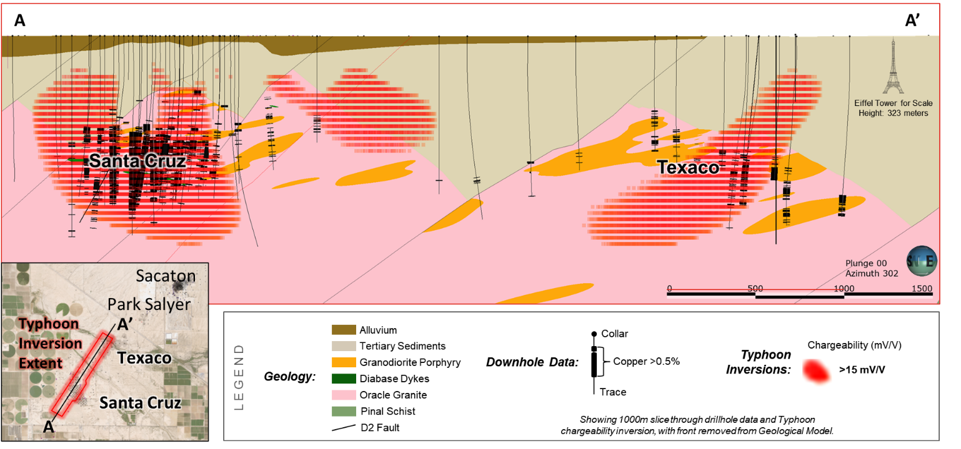
Results from the initial Typhoon™ orientation surveys. The red horizonal bars represent chargeability anomalies indicating the presence of sulfide mineralization. These areas have not been fully tested and are open for exploration.

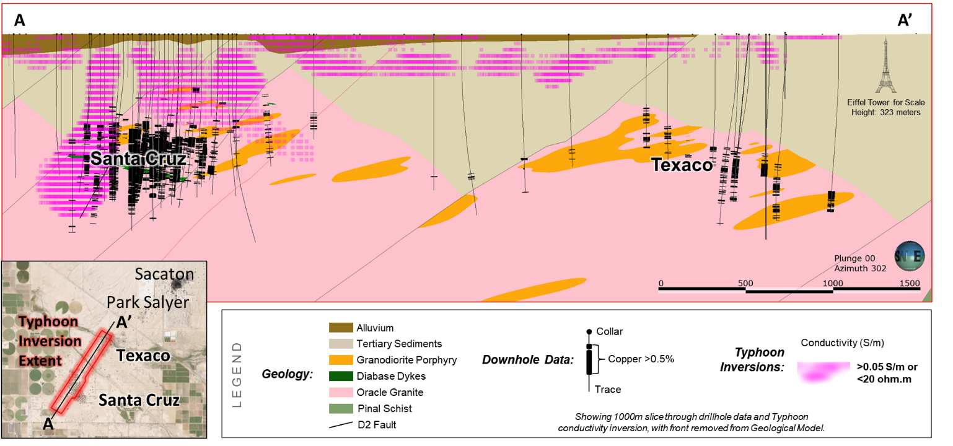
The purple horizonal bars show conductivity of the host rock and illustrate the shallow perched water.
Ivanhoe Electric expects that the newly completed 3D survey will identify several untested areas for exploration drilling. There are also profound regional implications for Ivanhoe Electric’s ability to discover porphyry copper deposits beneath similar basin-fill gravels in other parts of the Basin-and-Range province of the western United States when the company uses its proprietary Typhoon™ technology coupled with its Computational Geosciences geophysical data processing software.

Ivanhoe Electric’s proprietary, high-power Typhoon™ system at Santa Cruz.
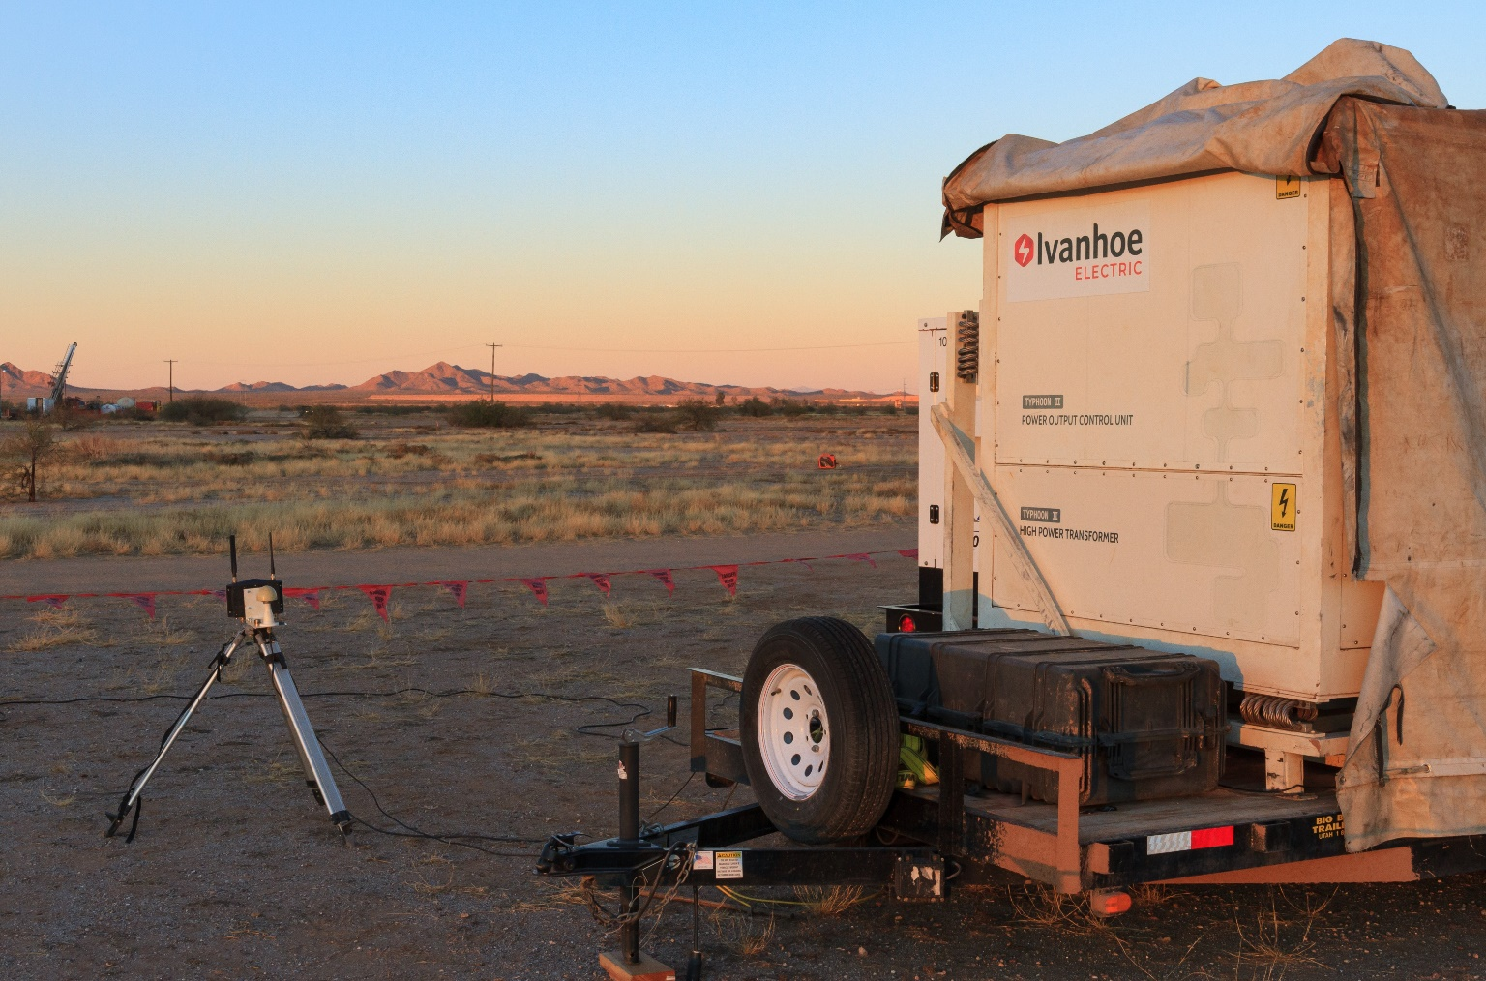

Re-inventing mining for the electrification of everything

Corporate social and environmental performance is about protecting the health and well-being of society and the environment on which we all depend. Ivanhoe Electric’s ambition is to “re-invent mining” to result in net-positive social and environmental impacts.

While the Santa Cruz Project is located on private, industrially zoned land outside of Casa Grande and approximately 6.5 km (4 miles) from the nearest Native American community, Ivanhoe Electric acknowledges and respects the ancestral use of the lands on which it operates and has established contact with the Native American Nations with the closest ancestral links to the project area. Ivanhoe Electric places a high value on establishing and maintaining positive relationships with all stakeholder groups and is actively working to develop a robust community engagement program and to provide sustainable, long-term benefits for the communities in which it operates.

Given the highly attractive metallurgical characteristics of the Santa Cruz deposit, Ivanhoe Electric believes that any mine development will have low water and energy requirements when compared to other major copper projects. However, Ivanhoe Electric is also aware that it operates in a region currently experiencing water shortages and is committed to developing a water resources strategy that will provide long-term benefits for the region. It is also committed to a solar energy strategy that seeks to lower carbon emissions per unit of copper produced to the greatest extent feasible.

Ivanhoe Electric geotechnicians Aaron Strange (top) and Adriana Ledesma (center), and geologist Emalyn Glastetter (bottom) at the Santa Cruz Project core facility.
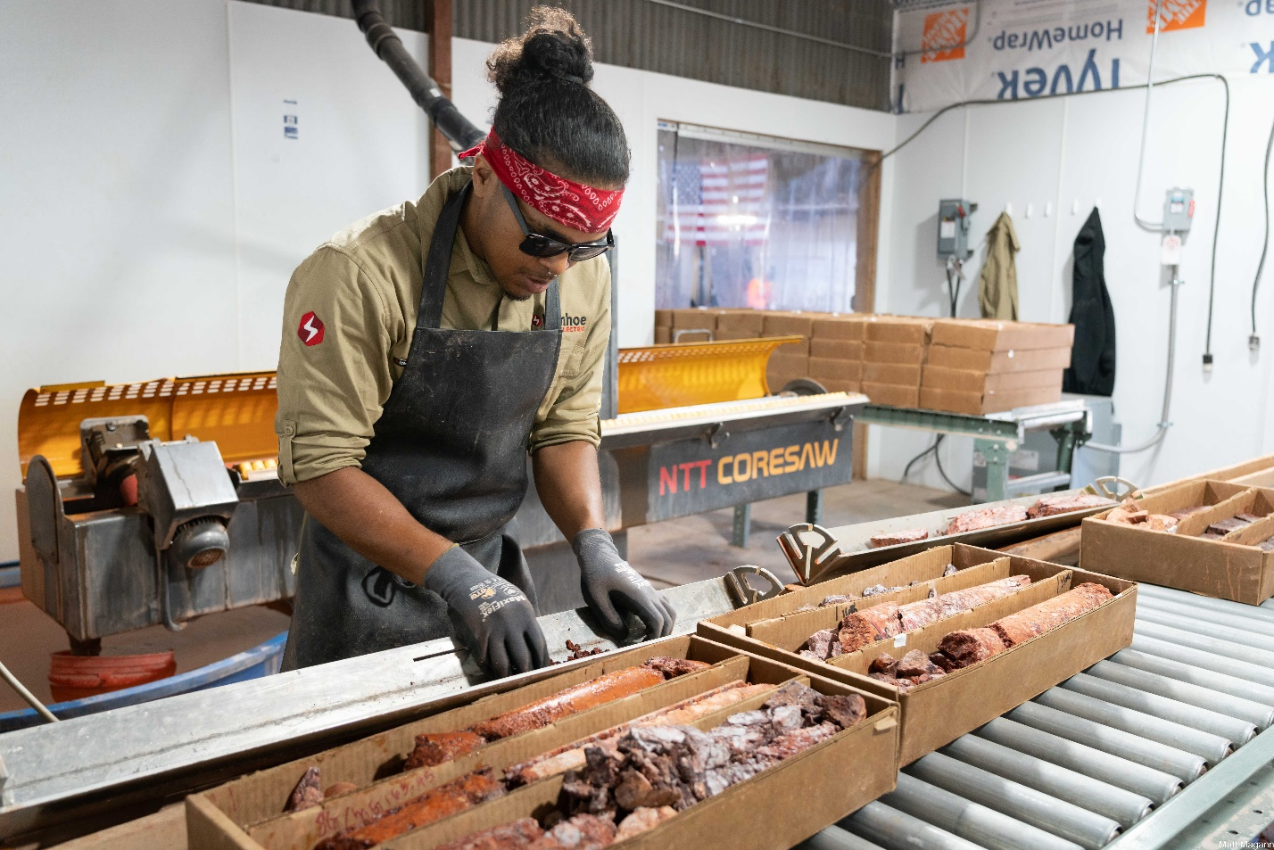
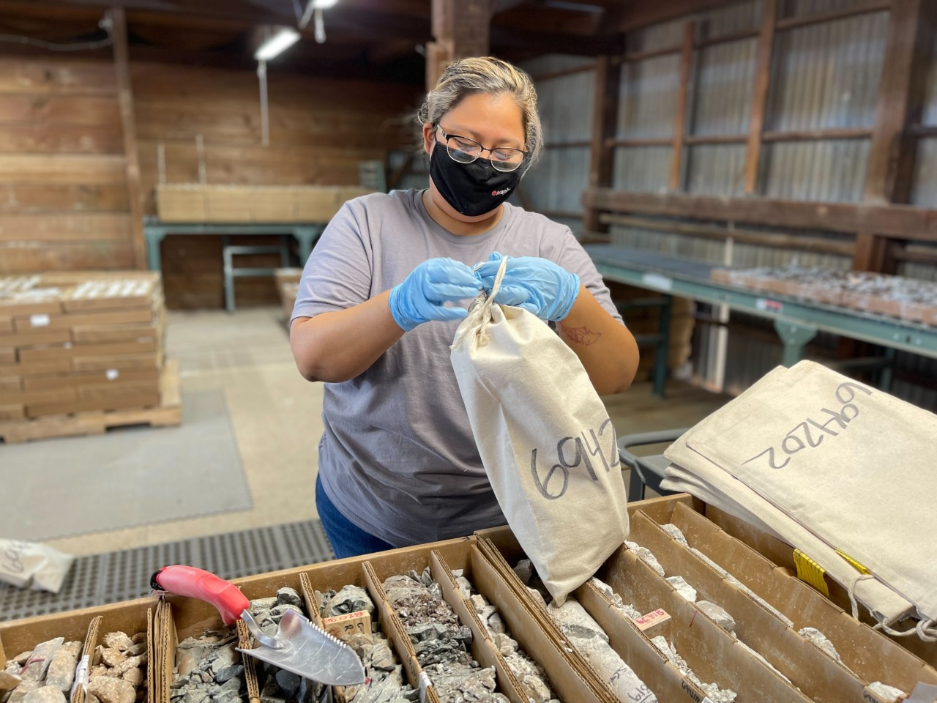

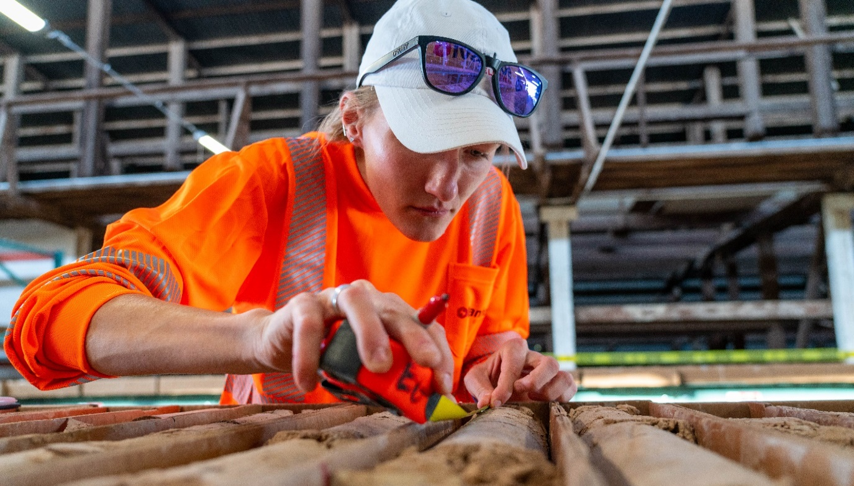
Qualified Persons

Disclosures of a scientific or technical nature included in this news release, including the sampling, analytical and technical data underlying the information, has been reviewed, verified, and approved by Glen Kuntz, P.Geo., and Christopher Seligman, MAusIMM CP (Geo), each of whom are Qualified Persons as defined by Regulation S-K, Subpart 1300 promulgated by the U.S. Securities and Exchange Commission and by Canadian National Instrument 43-101. Each of Mr. Kuntz and Mr. Seligman is an employee of Ivanhoe Electric.

Ivanhoe Electric had prepared an independent technical report summary for the Santa Cruz Project prepared under SEC Regulation S-K, Subpart 1300 and an independent technical report prepared under Canadian Instrument NI 43-101. Each is available on the company’s website and under the company’s EDGAR and SEDAR profiles:
- “Technical Report Summary on the Santa Cruz Project, Arizona, USA” prepared by Nordmin Engineering Ltd. (“Nordmin”) with an effective date of June 7, 2022 (S-K 1300 Report).
- “NI 43-101 Technical Report and Mineral Resource Estimate for the Santa Cruz Project, Arizona, USA” prepared by Nordmin with an effective date of June 7, 2022.

The technical report summary and technical report include relevant information regarding the assumptions, parameters and methods of the mineral resource estimates on the Santa Cruz Project cited in this news release, as well as information regarding data verification, exploration procedures and other matters relevant to the scientific and technical disclosure contained in this news release.

About Ivanhoe Electric

Ivanhoe Electric is an American technology and mineral exploration company that is re-inventing mining for the electrification of everything by combining advanced mineral exploration technologies, renewable energy storage solutions and electric metals projects predominantly located in the United States. Ivanhoe Electric uses its Typhoon™ transmitter, an accurate and powerful geophysical survey system, together with advanced data analytics provided by its subsidiary, Computational Geosciences, to accelerate and de-risk the mineral exploration process as well as to potentially discover deposits of critical metals that may otherwise be undetectable by traditional exploration technologies. Through its controlling interest in VRB Energy, Ivanhoe Electric also develops and manufactures advanced grid-scale vanadium redox battery storage systems. Finally, through advancing its portfolio of electric metals projects located primarily in the United States, headlined by the Santa Cruz Copper Project in Arizona and the Tintic Copper-Gold Project in Utah, as well as projects in Montana, Oregon and North Carolina, Ivanhoe Electric is also well positioned to support American supply chain independence by delivering the critical metals necessary for electrification of the economy.

Information contact

Investors

Evan Young +1-604-689-8765

Forward-looking statements

Certain statements in this release constitute “forward-looking statements” or “forward-looking information” within the meaning of applicable U.S. and Canadian securities laws. Such statements and information involve known and unknown risks, uncertainties and other factors that may cause the actual results, performance or achievements of the company, its projects, or industry results, to be materially different from any future results, performance or achievements expressed or implied by such forward-looking statements or information. Such statements can be identified by the use of words such as “may”, “would”, “could”, “will”, “intend”, “expect”, “believe”, “plan”, “anticipate”, “estimate”, “scheduled”, “forecast”, “predict” and other similar terminology, or state that certain actions, events or results “may”, “could”, “would”, “might” or “will” be taken, occur or be achieved. These statements reflect the company’s current expectations regarding future events, performance and results and speak only as of the date of this release.

Such statements include without limitation statements regarding: (i) Ivanhoe Electric’s vision is for a green, low-impact, underground mine that will produce ultra-low carbon emissions copper; (ii) any future mining operations will have a minimal surface footprint and be powered by solar energy, with potential for vanadium-redox battery storage provided by Ivanhoe Electric’s 90%-owned private subsidiary, VRB Energy; (iii) results and timing of data processing by Computational Geosciences; (iv) the provision of updated independent mineral resource estimate calculations after the completion of the current drilling program; (v) the newly completed 3D survey will identify several untested areas for exploration drilling; (vi) any mine development will have low water and energy requirements when compared to other major copper projects, and the outcome of the company’s water resources strategy that will provide long-term benefits for the region; and that (vii) the newly completed 3D Typhoon™ survey will identify several untested areas for exploration drilling.

This news release also contains references to estimates of mineral resources. The estimation of mineral resources is inherently uncertain and involves subjective judgments about many relevant factors. Mineral resources that are not mineral reserves do not have demonstrated economic viability. The accuracy of any such estimates is a function of the quantity and quality of available data, and of the assumptions made and judgments used in engineering and geological interpretation (including estimated future production from the company’s projects, the anticipated tonnages and grades that will be mined and the estimated level of recovery that will be realized), which may prove to be unreliable and depend, to a certain extent, upon the analysis of drilling results and statistical inferences that ultimately may prove to be inaccurate. Mineral resource estimates may have to be re-estimated based on: (i) fluctuations in the price of copper or other minerals; (ii) results of drilling; (iii) metallurgical testing and other studies; (iv) proposed mining operations, including dilution; (v) the evaluation of mine plans subsequent to the date of any estimates and/or changes in mine plans; (vi) the possible failure to receive required permits, approvals and licences; and (vii) changes in law or regulation.

Forward-looking statements are based on management’s beliefs and assumptions and on information currently available to management. Such statements are subject to significant risks and uncertainties, and actual results may differ materially from those expressed or implied in the forward-looking statements due to various factors, including changes in the prices of copper or other metals Ivanhoe Electric is exploring for; the results of exploration activities and/or the failure of exploration programs or studies to deliver anticipated results or results that would justify and support continued exploration, studies, development or operations; the significant risk and hazards associated with any future mining operations, extensive regulation by the U.S. government as well as local governments; changes in laws, rules or regulations, or their enforcement by applicable authorities; the failure of parties to contracts with the company to perform as agreed; and the impact of political, economic and other uncertainties associated with operating in foreign countries, and the impact of the COVID-19 pandemic and the global economy. These factors should not be construed as exhaustive and should be read in conjunction with the other cautionary statements described in Ivanhoe Electric’s registration statement on Form S-1, as amended, filed with the U.S. Securities and Exchange Commission and base PREP prospectus filed with Canadian securities commissions.

No assurance can be given that such future results will be achieved. Forward-looking statements speak only as of the date of this press release. Ivanhoe Electric cautions you not to place undue reliance on these forward-looking statements. Subject to applicable securities laws, the company does not assume any obligation to update or revise the forward-looking statements contained herein to reflect events or circumstances occurring after the date of this release, and Ivanhoe Electric expressly disclaims any requirement to do so.

