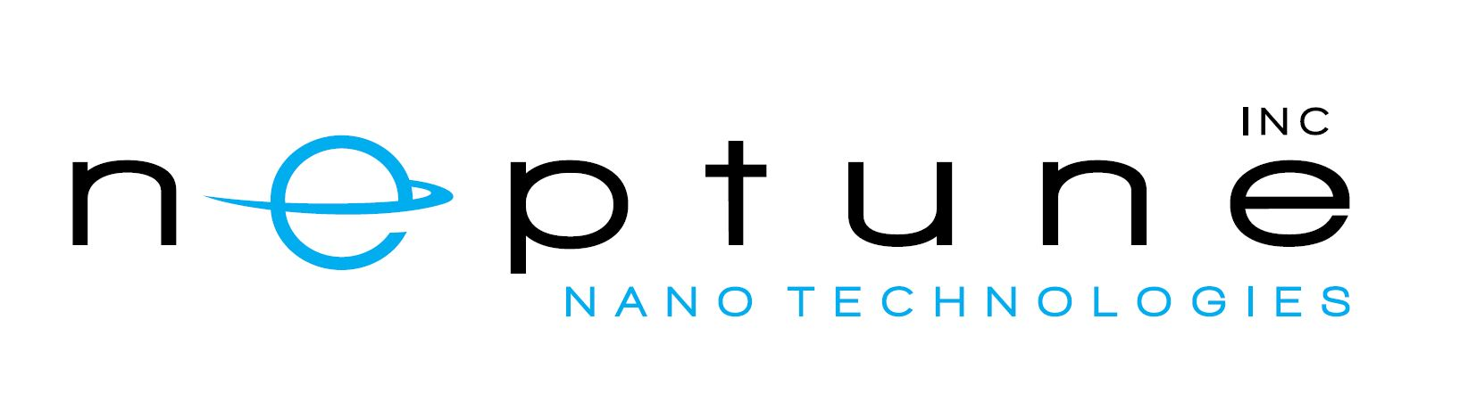

BIG GRANT FOR ONTARIO COMPANY USING SHELLFISH NANOCRYSTALS TO MAKE PLASTIC PACKAGING 100% RECYCLABLE
August 9, 2022, Markham, ON – Neptune Nanotechnologies is poised to tackle the world’s plastics problem thanks to nanotechnology derived from shellfish waste — and to Seed funding from Sustainable Development Technology Canada (SDTC).
The Markham, ON startup has developed a process to convert shellfish-processing waste into bio-based nanocrystals that are stronger than steel, lighter than plastic, non-toxic and biodegradable. Incorporating just a handful of these crystals into plastic packaging film can drastically increase its strength and block the penetration of moisture and oxygen. The resulting material preserves freshness, extends shelf life and prevents contamination — and at the end of its life, it can be tossed in the blue bin, not in the trash.
“We’re developing the world’s first 100% recyclable single-layer plastic with the barrier properties that food and pharmaceutical companies need,” says Neptune Nano founder and CEO Aaron Guan. “This will radically reduce the amount of plastic waste clogging up landfills and polluting our oceans.”
SDTC funding will help Neptune Nano equip a 2,000 sq.ft. pilot facility the company is currently building and begin producing nanocrystal at the kilogram scale to trial with U.S. partners.
“This material has the potential to transform the plastic packaging industry,” says Paul Albee, president of P3N Technology, a New Jersey company that specializes in developing ingredients for plastic manufacturing. “We’re excited to be a part of bringing it to market.”
“To seize the opportunities of the Net Zero economy in Canada, we need to be supporting all stages of innovation. Seed companies like Neptune Nanotechnologies represent the next generation of sustainable solutions paving the way to a greener future. SDTC is proud to support innovative young companies get their ideas off the ground.” – says Leah Lawrence, President, and CEO of SDTC, who announced the funding today.
About Neptune Nanotechnologies Inc.
Neptune Nanotechnologies Inc. is an innovative, venture-backed technology startup committed to delivering next-generation green nanotechnology. Led by an inventor, serial entrepreneur, and Forbes 30Under30 list maker, Neptune is commercializing a technology to convert organic fishing waste into ultra-high-value nanocrystals. These strong, lightweight, biodegradable crystals have a wide range of applications in aerospace/automotive composites, coatings, electronics, 3D printing and structural adhesives, offering all the benefits of nanotechnology with none of the environmental and safety drawbacks.
About Sustainable Development Technology Canada
At SDTC, we support companies attempting to do extraordinary things. From initial funding to educational support and peer learning to market integration, we are invested in helping our small and medium- sized businesses grow into successful companies that employ Canadians from coast to coast to coast. We are relentlessly focused on supporting our companies to grow and scale in an increasingly competitive marketplace.
The innovations we fund help solve some of the world’s most pressing environmental challenges: climate change, regeneration through the circular economy, and the well-being of humans in the communities they live in and the natural environment they interact with.
Contacts
Aaron Guan
Neptune Nanotechnologies Inc.
1-647-882-9890
aaron.guan@neptunenano.com
Follow Sustainable Development Technology Canada on Twitter: @SDTC_TDDC

