EYEFI GROUP TECHNOLOGIES INC.
NEWS RELEASE
EYEFI CLOUD CONNECT WELL RECEIVED AT THE PRE-LAUNCH EVENT
August 25, 2022 - Toronto, Canada - EYEfi Group Technologies Inc. (CSE: EGTI) (OTC: EGTTF) (“EYEfi”) is pleased to announce the successful pre-launch of its VSaaS (Video Software as a Service) product, EYEfi Cloud Connect at the ASIAL Security Exhibition and Conference (see our previous ASIAL press release)
EYEfi’s Cloud Connect product was featured by the major sponsor of the event, Axis Communications, generating a great deal of interest and demand with many sales opportunities emerging from prospective customers, distributors, systems integrators, and resellers.
EYEfi Cloud Connect provides the following key benefits:
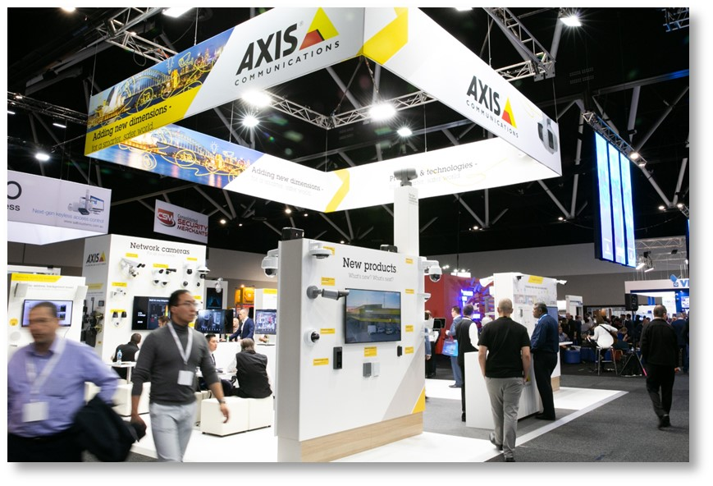
- easy for customers to connect their Axis cameras to the internet and monitor live video and events across multiple sites for improved security
- a simple and affordable subscription-based pricing model
- distributors, resellers, and systems integrators get the opportunity to share in revenue generated from the product
EYEfi collaborated with Axis Communications to build the VSaaS cloud platform, powered by EYEfi’s cloud technology. The strategic agreement with EYEfi enables Axis' customers to seamlessly activate, monitor, and control their cameras on the internet.
EYEfi's CEO, Simon Langdon said “The pre-launch of EYEfi Cloud Connect at ASIAL fully validated our strategy to collaborate on this product with market-leading camera hardware vendor, Axis Communications. We were delighted to see the positive reaction from everyone that attended, with many partners and customers registering interest in the product. We are looking forward to onboarding customers as part of the upcoming official launch”
EYEfi Cloud Connect will officially launch in the coming weeks (date to be announced shortly) and EYEfi is working with large distributors to introduce the product into other regions around the world following the launch here in Australia and New Zealand.
More information on EYEfi can be found here
More information about Axis Communications can be found here
---- end ---
About EYEfi in detail:
EYEfi is connecting the world's people and devices with the world around them, in real-time and in ways not previously possible.
EYEfi is a software and electronics engineering company that has developed, patented and commercialized an innovative spatial technology; spatial, predictive, approximation and radial convolution (SPARC) and an associated product suite, that turns sensors, cameras and smartphones (fixed, mobile, airborne, portable or handheld) into geo-target co-ordinate acquisition devices.
EYEfi has also developed IIoT sensor hardware and associated cloud software, as a second pillar within its product offering. EYEfi Cloud is a next generation cloud platform that provides a secure and centralized environment where customers can manage their EYEfi product deployments and applications.
On behalf of the board of directors of
EYEFI GROUP TECHNOLOGIES INC.
“Simon Langdon”
Simon Langdon, CEO
For more information contact:
Simon Langdon  Chief Executive Officer  EYEfi Group Technologies Inc.  Email: info@eyefi.com.au | Mark van der Horst  Investor Relations  EYEfi Group Technologies Inc.  Telephone: +1 (604) 760 7604  Email: mark@galecapital.com
THE CANADIAN SECURITIES EXCHANGE HAS NOT REVIEWED AND DOES NOT ACCEPT RESPONSIBILITY FOR THE ACCURACY OR ADEQUACY OF THIS RELEASE.

NO SECURITIES COMMISSION OR OTHER REGULATORY AUTHORITY HAS APPROVED OR DISAPPROVED THE INFORMATION CONTAINED HEREIN.
FORWARD LOOKING INFORMATION
This news release contains forward-looking statements and forward-looking information within the meaning of applicable securities laws. These statements relate to future events or future performance. All statements other than statements of historical fact may be forward-looking statements or information.
The forward-looking statements are based on the reasonable assumptions, estimates, opinions and analyses of management made in light of its experience and perception of historical trends in the delivery of services through its Cloud, current conditions, expected future developments and other factors management of EYEfi believes are appropriate, relevant and reasonable in the circumstances at the date that such statements are made. All of these assumptions, estimates and opinions will necessarily be subject to change due to future events and other circumstances outside the control of EYEfi, including the effect of the Covid 19 virus. EYEfi has based the forward looking information on various material assumptions, including: despite the threat of the Covid 19 virus, EYEfi will sustain or increase profitability although on a slower projection then previously planned, and will be able to fund its operations with existing capital and projected revenue from its current agreements with its Channel Partners; EYEfi will be able to attract and retain key personnel in future if required; the general business, economic, financial market, regulatory and political conditions in which EYEfi operates will remain positive as its services can be provided in EYEfi’s Cloud although deliver of its hardware may be affect by supply chain disruptions; that the general regulatory environment will not change in a manner adverse to the business of EYEfi; the tax treatment of EYEfi and its subsidiary will remain constant and EYEfi will not become subject to any material legal proceedings; the economy generally; competition, and anticipated and unanticipated costs.
Accordingly, readers should not place undue reliance on the forward-looking statements, timelines and information contained in this news release. Readers are cautioned that the foregoing list of factors, assumptions and exclusions is not exhaustive.
The forward-looking statements and information contained in this news release are made as of the date hereof and no undertaking is given to update publicly or revise any forward-looking statements or information, whether as a result of new information, future events or otherwise, unless so required by applicable securities laws or the Canadian Securities Exchange. The forward-looking statements or information contained in this news release are expressly qualified by this cautionary statement.

