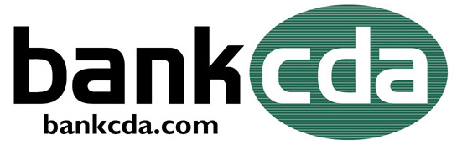

September 27, 2022


Jacklin appointed to Coeur d’Alene Bancorp and bankcda board of directors

Coeur d’Alene, Idaho – Coeur d’Alene Bancorp today announced Tag Jacklin has joined the Coeur d’Alene Bancorp and bankcda Board of Directors.

“I am honored and excited to join the bankcda board, community banking is integral to our local economy, and I look forward to working with the leadership team to expand the bank’s presence and service capabilities throughout our community.”
Tag is a Post Falls native; he earned his Bachelor of Science degree in Finance and Economics from Tulane University and his MBA from Washington State University. After leaving the area for several years he returned in 2016 to join the family business. Tag is a board member and President of Jacklin Land Company and Riverbend Commerce Park in Post Falls and a partner in Bighorn Ventures. He cumulatively manages approximately 600,000 square feet of leasable building space and 1,100 acres of land in varying stages of development across Kootenai County. Tag currently volunteers as a Board Director for the Post Falls Chamber of Commerce and as a Board Director and Treasurer for the Coeur d’Alene Area Economic Development Corporation (formerly Jobs Plus).

“We are pleased Tag has joined our board; he will be a great asset as we continue to grow our company and serve the people and business of Inland Northwest. His knowledge of the residential and commercial real estate market fits perfectly with our business model.” said Wes Veach, President, and CEO.

About bankcda
Headquartered in Coeur d’Alene, bankcda is a business focused community bank built on personal relationships offering small business banking, and a full line of consumer products. bankcda has total assets of approximately $270 million with four branches in Coeur d’Alene, Hayden, Post Falls and Kellogg Idaho.

For more information, visit www.bankcda.bank or contact Wes Veach at 208-415-5006.
# # #

