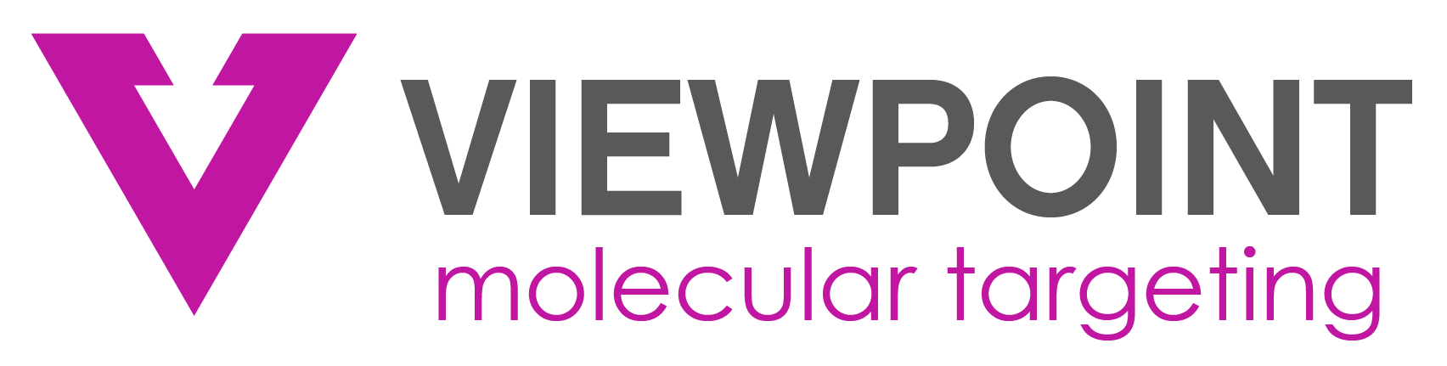

Viewpoint Molecular Targeting Announces Appointment of Markus Puhlmann, MD, MBA as Chief Medical Officer
Dr Puhlmann has over 20 years of oncology drug development experience and has spearheaded the global development and approval of multiple cancer drugs

CORALVILLE, IOWA – October 4, 2022 –Viewpoint Molecular Targeting, Inc. (“Viewpoint” or the “Company”), a radiopharmaceutical company developing precision lead-212-based α-particle oncology therapeutics and complementary diagnostic imaging agents, today announced the appointment of Markus Puhlmann, MD, MBA as Chief Medical Officer (CMO).

“Markus joins Viewpoint with an impressive track record of building and leading successful oncology programs,” said Thijs Spoor, CEO of Viewpoint Molecular Targeting. “His broad, global experience across many tumor types at all stages of clinical development make him the ideal candidate to join Viewpoint as CMO. I am thrilled to have Markus on our management team and look forward to working together.”

Dr Puhlmann has 20 years of experience in oncology drug development in solid and liquid tumor indications. Before joining Viewpoint, he was the CD30 Franchise Head of Global Clinical Development, Seagen. Prior to his time at Seagen, Dr. Puhlmann’s work as Section Head at Merck & Co led to many successful regulatory filings for pembrolizumab in various indications for urothelial carcinoma, RCC and cervical cancer. Earlier in his career, he held various positions with increasing responsibilities in clinical development and medical affairs at Schering Plough, Bayer and Amgen. Dr. Puhlmann began his career as an academic physician in Germany, the UK and in the US at the National Cancer Institute (NCI).

Dr. Puhlmann commented, “The opportunity to lead the development of Viewpoint’s pipeline programs is extremely exciting for me as a cancer drug developer. I think the application of targeted alpha-particle therapy will have a profound impact on the treatment of oncology patients.”

About Viewpoint Molecular Targeting
Viewpoint Molecular Targeting is a radiopharmaceutical company developing precision oncology therapeutics and complementary diagnostic imaging agents. The Company’s proprietary technology utilizes the isotope lead-212 to deliver powerful alpha radiation specifically to cancer cells via specialized targeting peptides. Viewpoint is also developing complementary imaging diagnostics that incorporate the same targeting peptides which provide the opportunity to personalize treatment and optimize patient outcomes. This “theranostic” approach enables the ability to see the specific tumor and then treat it to potentially improve efficacy and minimize toxicity associated with many other types of cancer treatments.
The Company’s melanoma (VMT01) and neuroendocrine tumor (VMT-𝛼-NET) programs are entering Phase 1/2a imaging and therapy trials for the treatment of metastatic melanoma and neuroendocrine tumors at several leading academic institutions. The Company has also developed a proprietary lead-212 generator to secure isotope supply for clinical trial and commercial operations. For more information, please visit the Company’s website www.viewpointmt.com.

Viewpoint previously announced on September 29, 2022 that it has entered into a definitive agreement to merge with Isoray, Inc. or Isoray (NYSE AMERICAN:ISR (“Isoray”)), a medical technology company and innovator in seed brachytherapy. Additional details regarding the contemplated merger along with the merger agreement can be found in Isoray’s current report on Form 8-K which was filed with the Securities and Exchange Commission on September 28, 2022. The consummation of the merger is subject to approval by the shareholders of both Isoray and Viewpoint along with other customary closing conditions.

Forward-Looking Statements

This press release contains information that includes or is based upon “forward-looking statements” within the meaning of the Securities Litigation Reform Act of 1995. Forward-looking statements provide the Company’s expectations or forecasts regarding future events. These statements can be identified by the fact they do not relate strictly to historical or current facts. They may use words such as “believe,” “potential,” “estimate,” “expect,” “will,” and other terms of similar meaning in connection with a discussion of future operating or financial performance. In particular, forward-looking statements include statements relating to intended future actions; the Company’s expectations about its addressable markets and market share; the consummation of the merger with Isoray and the realization of the anticipated benefits of the combination; the functionality and capabilities of the Company’s therapies; the potential size of the commercial market for the Company’s treatment programs; and the Company’s expectations beliefs, intentions or strategies regarding the future. Any or all of the Company’s forward-looking statements here and elsewhere may turn out to be wrong. They can be affected by inaccurate assumptions or by known or unknown risks and uncertainties that could cause actual results to differ materially from those expressed or implied in such statements and from expected or historical results. Many such factors will be important in determining the Company’s actual future results. Consequently, no forward-looking statement can be guaranteed. The Company undertakes no obligation to correct or update any forward-looking statements, whether as a result of new information, future developments, or otherwise, except to the extent required by applicable law. These forward-looking statements (except as may be otherwise noted) speak only as of the date of this press release. Factors or events that could cause the Company’s actual results to differ may emerge from time to time, and it is not possible for the Company to predict all of them.

Contacts
Investor / Media / Public Relations: Thijs Spoor (319) 665-2150

