BrightRock Gold Corp Announces Completed Official Staking of its 1400 acre expansion at the Midnight Owl Lithium Project.

GURNEE, IL / ACCESSWIRE / October 31, 2022 / BrightRock Gold Corp. (OTC PINK:BRGC) is pleased to announce the successfully completed staking of its 1400 acre expansion disclosed earlier this year (see 6/21/2022 Company News). The Company has staked 68 additional unpatented lode claims covering more than 2 square miles (nearly 6 square kilometers) in the northeastern part of the White Picacho District approximately 13 miles east of Wickenburg, Arizona . This extends the “Midnight Owl Lithium Project” over numerous pegmatite bodies, most of which have not seen much exploration or production aside from brief small scale output during the 1940’s. In the map attached below you will find the original 20.66 acre Midnight Owl Mine highlighted in purple. The adjoining white boxes are the 100% owned, confirmed valid, and completely staked 68 claim, 1400 acre expansion.

BRGC CEO Mac J. Shahsavar, P. Eng. commented “Staking is back breaking work, that difficulty is only amplified in a desert type environment. We are thank-ful and give tremendous credit to Steven Cyros and his team for accomplishing such a task with accuracy. Attention to detail like this is vitally important during these historic times in the lithium market when so many are looking for a piece of a pie.”

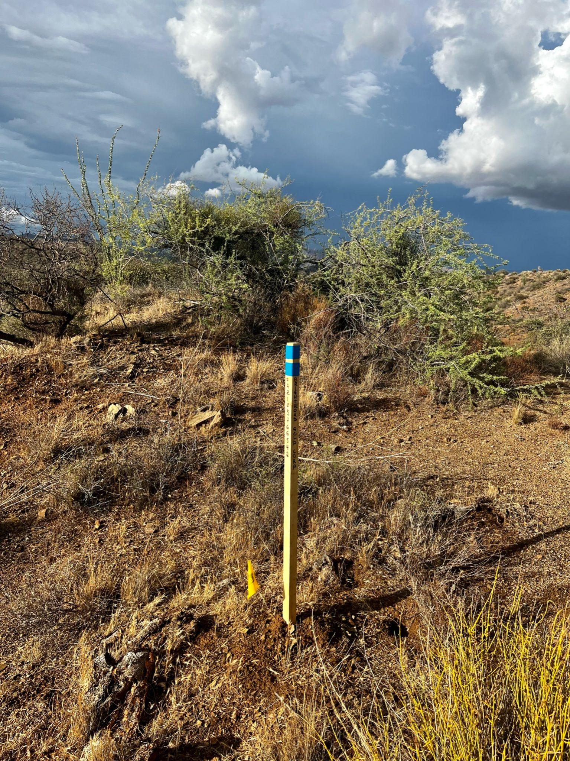
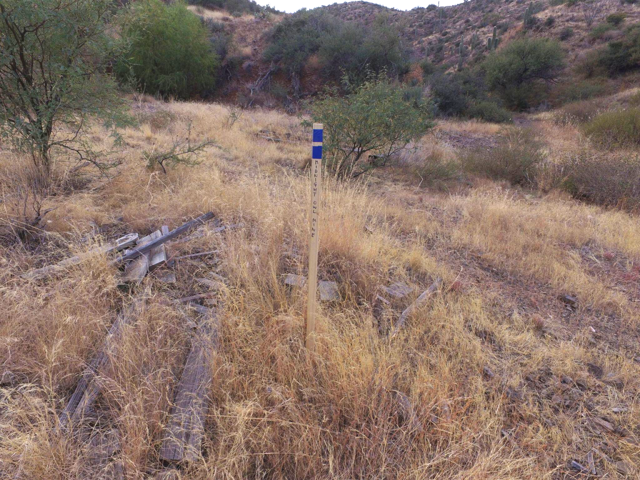
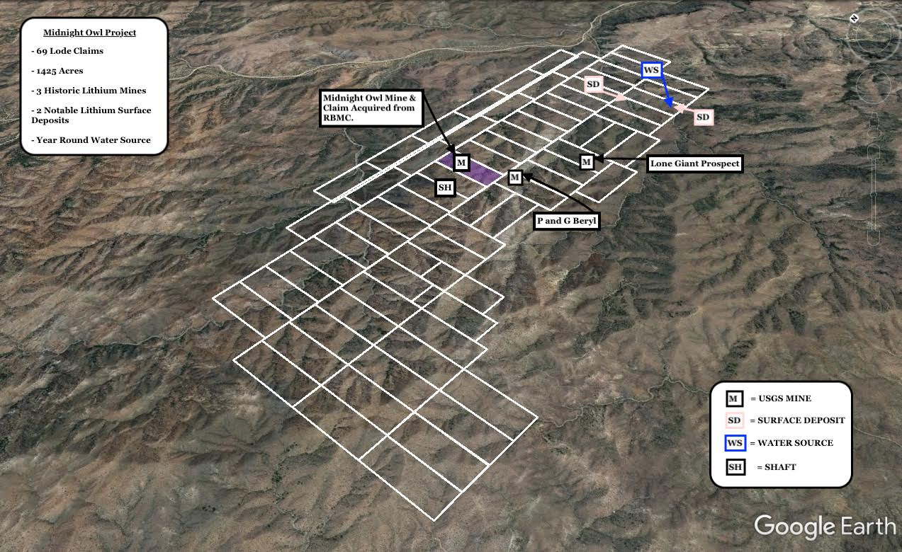
*aerial view of BrightRock's 1425 acre, 69 lode claim pegmatite lithium project
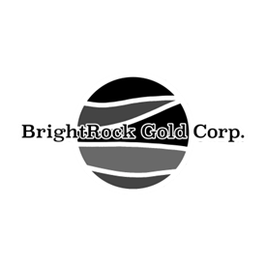
Contact & Learn More:

BrightRock Gold Corporation
Phone 866-600-5444
brightrockgold@gmail.com

Corporate Website: http://brightrockgold.com/ and/or northamericalithium.com
Corporate Linkedin: https://www.linkedin.com/company/brgc-corp
Corporate Twitter: https://twitter.com/brightrock_corp
Corporate Instagram: https://www.instagram.com/brightrock_gold_corp/

About BrightRock Gold Corp.
BrightRock Gold Corp. is a lithium exploration company focused on developing its flagship project "Revival of the Midnight Owl Mine". Previously known in historical records as the "Lithium King Mine" located approximately 13 miles east of Wickenburg, Arizona. BrightRock Gold Corp. holds a 100% ownership and interest in the "Midnight Owl Mine" along with an adjoining 1400 acres, 69 lode claims. A lithium pegmatite project strategically located within 70 miles of two under construction battery plants. The Company is seeking to develop this portfolio of lithium-rich assets to become a major supplier of lithium-based products.

FORWARD-LOOKING STATEMENTS:
This press release contains forward-looking statements as defined within Section 27A of the Securities Act of 1933, as amended, and Section 21E of the Securities Exchange Act of 1934, as amended. These statements relate to future events, including our ability to raise capital, or to our future financial performance, and involve known and unknown risks, uncertainties and other factors that may cause materially different from any future results, levels of activity, performance or achievements expressed or implied by these forward-looking statements. You should not place undue reliance on forward-looking statements since they involve known and unknown risks, uncertainties and other factors which are, in some cases, beyond our control and which could, and likely will, materially affect actual results, levels of activity, performance or achievements. Any forward-looking statement reflects our current views with respect to future events and is subject to these and other risks, uncertainties and assumptions relating to our operations, results of operations, growth strategy and liquidity. We assume no obligation to publicly update or revise these forward-looking statements for any reason, or to update the reasons actual results could differ materially from those anticipated in these forward-looking statements, even if new information becomes available in the future.
For a discussion of these risks and uncertainties, please see our filings with the OTC Markets Group Inc. Our public filings with the OTC Markets Group Inc are available from commercial document retrieval services and at the website maintained by the OTC Markets at https://www.otcmarkets.com/stock/BRGC/disclosure.

