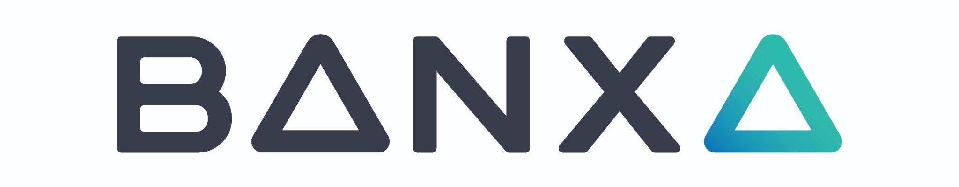
Trade Cessation Status and Business Update

TORONTO, November 23rd 2022 - BANXA Holdings Inc. (TSX-V: BNXA) (OTCQX: BNXAF) (FSE: AC00) ("Banxa" or "The Company"), the leading global web3 on/off ramp solution, provides a further update on the trade cessation status and general business matters.

The Company continues to make progress with its auditor, RSM Canada, on completing its audited financial statements for the fiscal year ended June 30, 2022, and will provide a further update to the market in the coming weeks. As a result of the FY22 audit delay, the September quarterly financial report (Q1-FY23) will also be delayed. The Company is unable to release the financial statements and MD&A until the FY22 audit is completed as there is a requirement to have confirmed opening balances.

Holger Arians, CEO of Banxa stated: “With volatility returning to the crypto markets in light of the recent FTX situation, Banxa has seen some of its largest trading days this calendar year in the month of November. Banxa has quickly identified increased adoption of non-custodial, decentralised exchanges and platforms and has successfully integrated with several notable partners including decentralised app ZenGo, and decentralised exchange dYdX, and is working on several more major decentralised finance (DeFi) partner integrations. Paid integrations and token listings continue to contribute positively to the gross profit margin, helping the business on its path to profitability later this financial year. “

The Company now has 11 Money Transmitter Licences (MTL) in the US market with the most recent MTL approved last week and further MTLs expected to be approved in the coming months.

The Company wishes also to announce that Konstantin Lichtenwald has stepped down from his role as public company CFO. The Company thanks Konstantin for his valued contribution and is pleased to report that he will remain engaged as an advisor to the Audit Committee and Finance department with the objective of completing the audit as soon as possible. The Company is continuing its search for a Group CFO and currently interviewing for this position.

CONTACTS

Investors:
MZ North America
Brian M. Prenoveau, CFA
BNXA@mzgroup.us
561-489-5315

Media:
Wachsman
Ethan Lyle
banxa@wachsman.com

ENDS
ON BEHALF OF THE BOARD OF DIRECTORS
Per: "DOMENIC CAROSA" https://twitter.com/dcarosa
Domenic Carosa = Chairman (1-888-218-6863)

Neither TSX Venture Exchange nor its Regulation Services Provider (as that term is defined in policies of the TSX Venture Exchange) accepts responsibility for the adequacy or accuracy of this release

Forward-looking Information and Statements

This news release includes certain statements and information that may constitute forward-looking information within the meaning of applicable Canadian securities laws. Forward-looking statements relate to future events or future performance and reflect the expectations or beliefs of management of the Company regarding future events. Generally, forward-looking statements and information can be identified by the use of forward-looking terminology such as “intends”, “expects” or “anticipates”, or variations of such words and phrases or statements that certain actions, events or results “may”, “could”, “should”, “would” or will “potentially” or “likely” occur. This information and these statements, referred to herein as "forward‐looking statements", are not historical facts, are made as of the date of this news release and include without limitation, statements regarding the completion of the Audit by RSM, and the filing of the Annual Filings by the Company.

These forward‐looking statements involve numerous risks and uncertainties and actual results might differ materially from results suggested in any forward-looking statements. These risks and uncertainties include, among other things, risks related to the completion of the Audit by RSM within the timeframe expected by management, and risks relating to the filing of the Annual Filings within the timeframe expected by management, and risks related to changes in general economic, business and political conditions, including changes in the financial markets, changes in applicable laws, and compliance with extensive government regulation, as well as those risk factors discussed or referred to in the Company’s disclosure documents filed with the securities regulatory authorities in certain provinces of Canada and available at www.sedar.com.

In making the forward-looking statements in this news release, the Company has applied several material assumptions, including without limitation, assumptions regarding the completion of the Audit by RSM in a timely manner and the filing of the Annual Filings by the Company in a timely manner.

Although management of the Company has attempted to identify important factors that could cause actual results to differ materially from those contained in forward-looking statements or forward-looking information, there may be other factors that cause results not to be as anticipated, estimated or intended. There can be no assurance that such statements will prove to be accurate, as actual results and future events could differ materially from those anticipated in such statements. Accordingly, readers should not place undue reliance on forward-looking statements and forward-looking information. Readers are cautioned that reliance on such information may not be appropriate for other purposes. The Company does not undertake to update any forward-looking statement, forward-looking information or financial out-look that are incorporated by reference herein, except in accordance with applicable securities laws. We seek safe harbor.

