Sterling Metals Expands Heimdall and Announces Discovery of New High Grade Zone 500m North
December 12, 2022 – Toronto, Ontario – Sterling Metals Corp. (TSXV: SAG) (“Sterling Metals” or the “Company”) is pleased to report results from its 2022 drilling on the Sail Pond Silver and Base Metal Project in the Great Northern Peninsula of Newfoundland. Drilling results are from the Heimdall Zone and new zone 500m north of Heimdall. The company will be hosting a zoom webinar at 2PM EST on Monday December 12, 2022, to discuss these findings in more detail. Registration for the event can be found at: https://us02web.zoom.us/webinar/register/WN_oWaOO7foTjKgQk5lnTFjvQ.
Significant drill results are listed below:
- 3,499.1 g/t Ag Eq over 0.35 m (1,564 g/t Ag, 8.33% Cu, 12.83% Pb, 2.74% Sb, & 3.93% Zn) within a broader interval of 294 g/t Ag Eq over 4.67m (129 g/t Ag, 0.66% Cu, 1.19% Pb, 0.22% Sb, & 0.45% Zn in hole SP-22-064 beginning at 179.23 m downhole; and
- 1,914 g/t Ag Eq over 0.28m (848 g/t Ag, 3.24% Cu, 4.27% Pb, 1.02% Sb, & 9.62% Zn) within a broader interval of 171.1 g/t Ag Eq over 6.74m (77.2 g/t Ag, 0.29% Cu, 0.69% Pb, 0.09% Sb, 0.61% Zn) in hole SP-22-053 beginning at 219.0 m downhole; and
- 1,485.3 g/t Ag Eq over 0.63m (520 g/t Ag, 1.81% Cu, 6.93% Pb, 0.57% Sb and 10.86% Zn) within a broader interval of 179.8 g/t Ag Eq over 5.58 m (63.3 g/t Ag, 0.22% Cu, 0.84% Pb, 0.07% Sb, & 1.29% Zn) in hole SP-22-047 beginning at 125.47 m downhole; and
- 530.8 g/t Ag Eq over 0.93m (162.6g/t Ag, 0.79% Cu, 1.46% Pb, 0.22% Sb, 4.71% Zn) within a broader interval of 115.4 g/t Ag Eq over 7.3m (35.9 g/t Ag, 0.17% Cu, 0.41% Pb, 0.05% Sb, & 0.95% Zn) in hole SP-22-050 beginning at 194.7 m downhole.
Mathew Wilson, CEO of Sterling Metals, commented: “It is a pleasure to finally share with the market the terrific work we have done in only our second drill campaign at Sail Pond. This drill campaign solidifies the Heimdall Zone footprint, a 400m x 200m x 150m zone of mineralization. Through boots on the ground prospecting and reinterpretation of old data, we were also able to discover a completely new zone, 500m to the north, where previous drilling had not been able to identify a mineralized structure. This resulted in one of the highest-grade intervals we have seen to date, and the highest-grade copper and antimony we have seen at the project. The company is in an enviable position with a rapidly advancing high grade polymetallic mineral system, $4m in cash and a very strong team fully focused on unlocking the potential of the Sail Pond Project.”
Sail Pond Drilling
Sterling’s 2022 drilling program successfully completed 34 new holes for over 7,500m of drilling at both new targets and the Heimdall Zone. Highlights of the program are the expanded mineralization at Heimdall and newly identified mineralized zone 500m to the north. The gap between Heimdall and the new zone to the north is virtually wide open and considered very prospective. Two holes drilled in this gap in the 2021 campaign drilled overtop of the mineralization. Targeting for the 2022 program incorporated a detailed structural interpretation by SRK and a comprehensive study by Goldspot which utilized soil sampling, trenching, prospecting, and geophysics along ~12 km of prospective strike length. Assays are pending on other target areas.
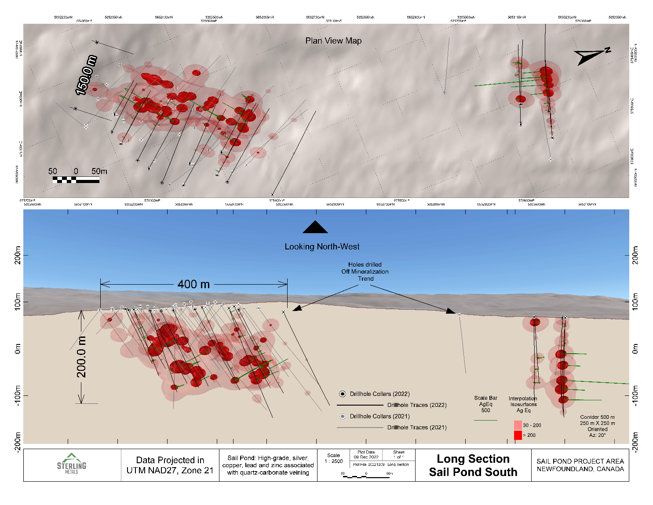
Figure 1: Longitudinal section looking west showing drilling with silver equivalent mineralization on drillholes
With the new discovery north of Heimdall, the footprint of precious and base metal mineralization now extends over 1 kilometre and is open to the north as seen in a longitudinal section looking at the Zone from underground (Figure 1, above). There are multiple high-grade mineralized veins within the mineral zones and these will be the focus of future drill programs. An example of such veins is shown with core photos in Figure 2 and Figure 3 (below). Figure 4 (below) shows a plan map of the drilling completed to date.
Jeremy Niemi, Director of Exploration commented: “Since joining this company, my understanding of Sail Pond and my excitement for this project has grown with each new drill hole. Each new data point is leading us to fine tuning our exploration strategy making us very well positioned for our 2023 work campaign.”
Today’s results come from drillholes targeting the Heimdall Zone, a significant zone of mineralization, and an adjacent target to the north. Both are within the South Zone of the Sail Pond project. The Heimdall Zone, which is hosted by dolostone, occurs in a favorable structural corridor and metal accumulates in close proximity to a high strain area. There are multiple styles of mineralization at Sail Pond; a broad zone of lower grade precious and base metals associated with breccia-style or veinlet-style sulfide mineralization and a tighter vein system of high grade precious and base metal mineralization.
The mineralization at Sail Pond, especially the high-grade veins, is structurally controlled and understanding the orientation of the structures is vital to expanding zones and identifying potential new zones along preferred structural trends. The Company has completed an extensive down hole optical televiewer study to measure the orientation of high-grade veins and other structural features in important drill holes across the property. Preliminary results from this study have been encouraging and have successfully mapped the orientation of high-grade veins at Heimdall. This data and the enhanced geological model, will play a significant role in the targeting for the next drill programs.
The primary host rock for mineralization identified to date is a thick sequence of highly altered and often brecciated dolostone of the Cambro-Ordovician Saint George Group. Mineralization encountered to date typically consists of tetrahedrite-tennantite, chalcocite, sphalerite, galena, pyrite, and potentially additional sulfosalt minerals. Quartz veining and associated mineralization are ubiquitous throughout the dolostone unit, but included metallic mineralization is best developed in areas of combined brecciation and veining. The structural evolution and metallogenic sequencing are very complex, and mineralization has been identified in association with a multitude of structural events.

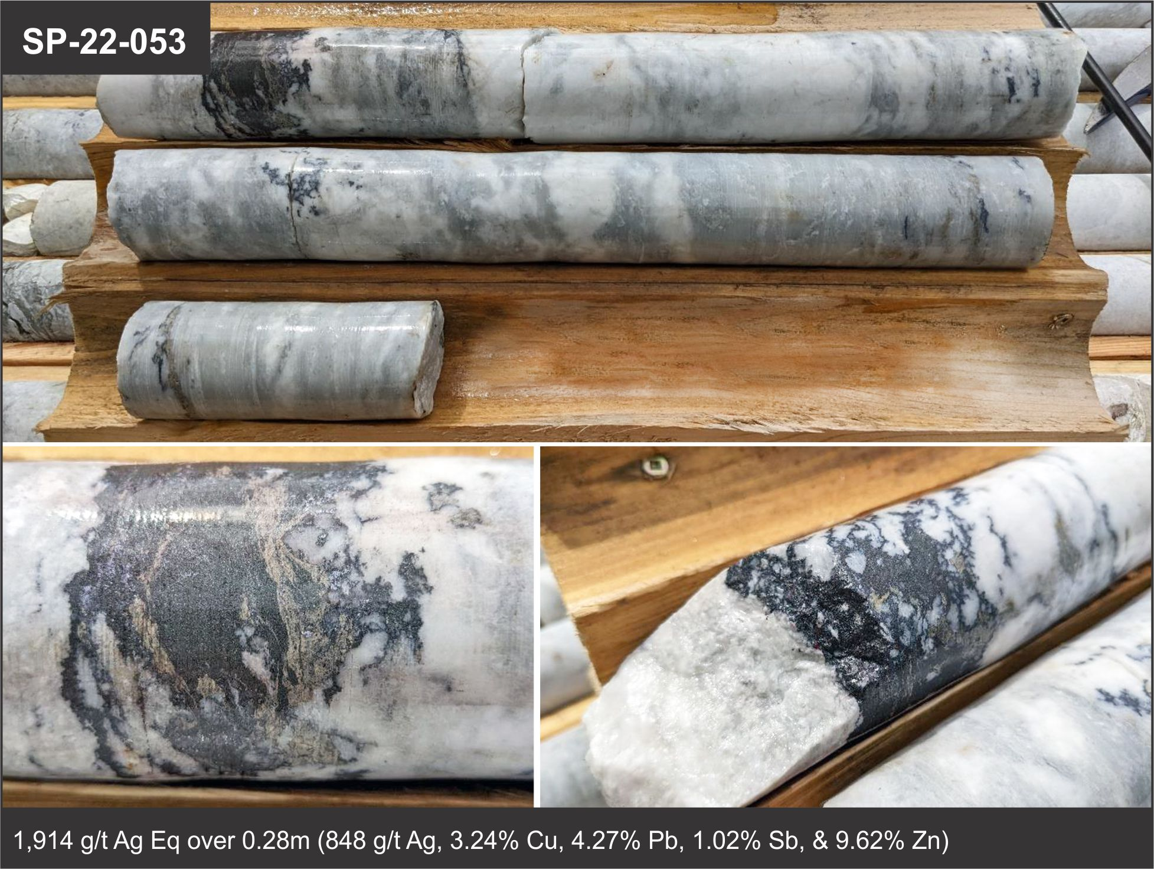
Figure 2. High grade mineralization in hole SP-22-053 from 223m to 224m

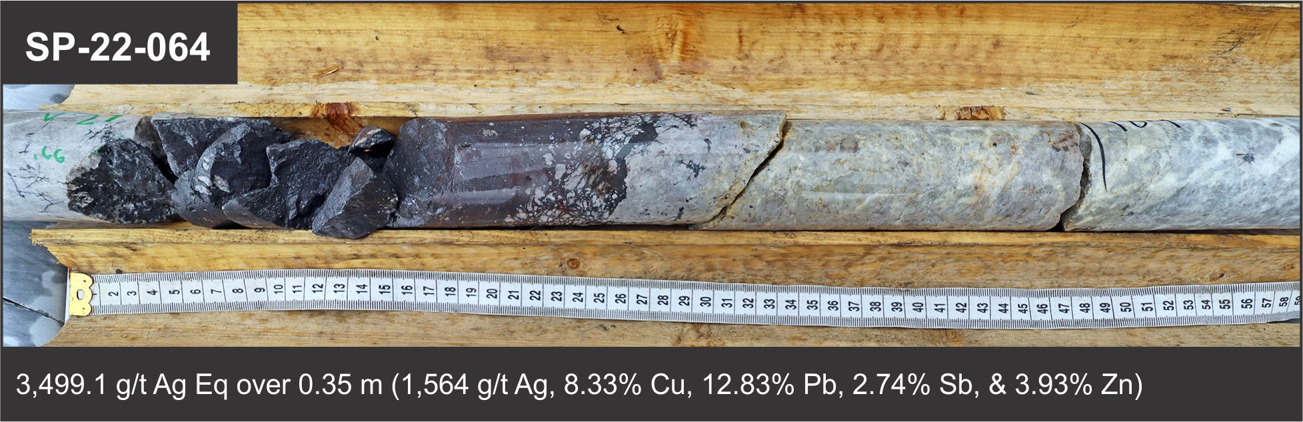
Figure 3. Massive sulphide high grade mineralization in hole SP-22-064 at depth of 183.9m
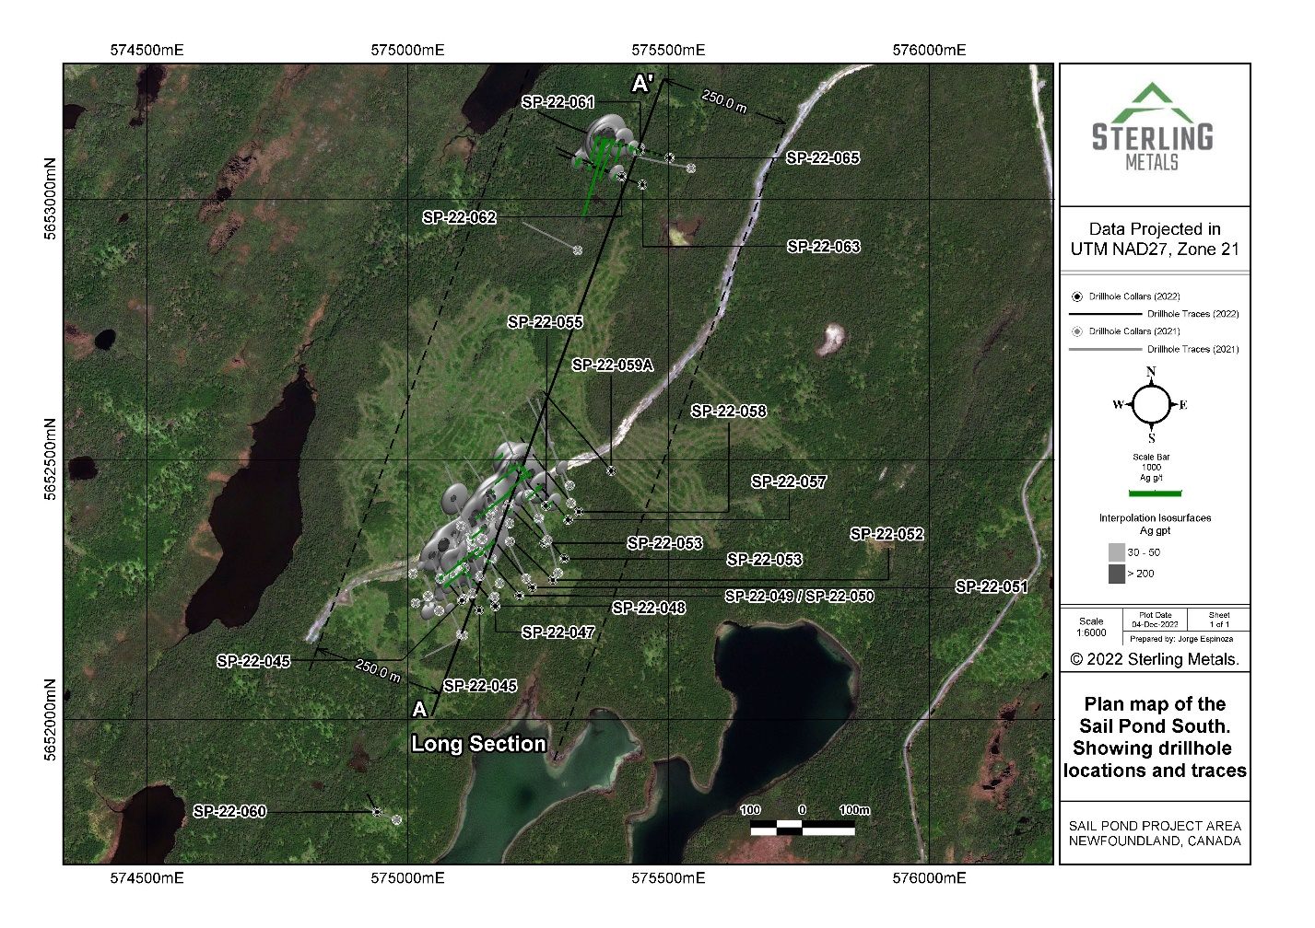
Figure 4. Plan map showing drilling locations at Heimdall Zone and new zone to the north.

Table 1. Initial reported assay intervals from Sail Pond 2022 drilling.
Drillhole | Zone | From (m) | To (m) | Length (m) | AgEq (g/t) | Ag (g/t) | Cu (%) | Pb (%) | Sb (%) | Zn (%)
SP-22-045 | South | 56.71 | 57.5 | 0.79 | 209.6 | 113 | 0.48 | 0.58 | 0.062 | 0.34
and |  | 81.75 | 86.1 | 4.35 | 30.5 | 16.6 | 0.067 | 0.036 | 0.016 | 0.063
inc |  | 81.75 | 82 | 0.25 | 175.6 | 78 | 0.35 | 0.29 | 0.094 | 0.82
inc |  | 85.55 | 86.1 | 0.55 | 146.1 | 88 | 0.35 | 0.041 | 0.067 | 0.090
SP-22-046 | South | 111.25 | 111.55 | 0.3 | 92 | 28 | 0.12 | 0.12 | 0.037 | 0.96
SP-22-047 | South | 112.63 | 112.88 | 0.25 | 100.6 | 51 | 0.20 | 0.44 | 0.051 | 0.13
and |  | 125.47 | 131.05 | 5.58 | 179.8 | 63.3 | 0.22 | 0.84 | 0.071 | 1.29
inc |  | 125.47 | 126.1 | 0.63 | 1485.3 | 520 | 1.81 | 6.93 | 0.57 | 10.86
and |  | 154.9 | 155.15 | 0.25 | 99.8 | 53 | 0.26 | 0.017 | 0.075 | 0.11
SP-22-048 | South | 26.8 | 27.1 | 0.3 | 186 | 56 | 0.29 | 0.63 | 0.059 | 1.61
and |  | 102.8 | 103.25 | 0.45 | 285.8 | 90 | 0.37 | 1.94 | 0.093 | 1.88
and |  | 124.8 | 137.05 | 12.25 | 20.6 | 7.6 | 0.032 | 0.082 | 0.01 | 0.12
inc |  | 125.2 | 125.6 | 0.4 | 130.2 | 57 | 0.25 | 0.83 | 0.072 | 0.18
inc |  | 135.53 | 135.78 | 0.25 | 347.4 | 68 | 0.23 | 1.30 | 0.071 | 4.79
SP-22-049 | South | 168 | 170 | 2 | 392 | 187.7 | 1.01 | 0.64 | 0.28 | 0.62
inc |  | 169 | 169.45 | 0.45 | 1703.8 | 821 | 4.41 | 2.74 | 1.21 | 2.49
and |  | 193.24 | 193.64 | 0.4 | 127.6 | 42 | 0.089 | 1.47 | 0.028 | 0.64
SP-22-050 | South | 151.2 | 152 | 0.8 | 121.4 | 62 | 0.27 | 0.28 | 0.068 | 0.23
and |  | 162.05 | 162.45 | 0.4 | 137.8 | 72 | 0.28 | 0.33 | 0.101 | 0.21
and |  | 194.7 | 202 | 7.3 | 115.4 | 35.9 | 0.17 | 0.41 | 0.048 | 0.95
inc |  | 197.37 | 198.3 | 0.93 | 530.8 | 162.6 | 0.79 | 1.46 | 0.22 | 4.71
SP-22-051 | South | 163.45 | 166 | 2.55 | 141.7 | 73 | 0.38 | 0.32 | 0.082 | 0.068
inc |  | 163.45 | 163.7 | 0.25 | 421.8 | 224 | 1.06 | 0.93 | 0.26 | 0.18
inc |  | 165.55 | 166 | 0.45 | 563.4 | 287 | 1.55 | 1.28 | 0.31 | 0.27
and |  | 211.5 | 211.75 | 0.25 | 689.5 | 314 | 1.20 | 1.52 | 0.40 | 3.05
SP-22-052 | South | No Significant Results
SP-22-053 | South | 121 | 121.83 | 0.83 | 140.3 | 43 | 0.14 | 1.59 | 0.04 | 0.64
and |  | 219 | 225.74 | 6.74 | 173.8 | 77.2 | 0.29 | 0.69 | 0.088 | 0.61
inc |  | 222.47 | 225.74 | 3.27 | 339.6 | 153.9 | 0.59 | 1.27 | 0.18 | 1.23
inc |  | 223.14 | 223.39 | 0.25 | 1072 | 523 | 2.14 | 4.46 | 0.56 | 1.93
inc |  | 224 | 224.28 | 0.28 | 1914 | 848 | 3.24 | 4.27 | 1.02 | 9.62
SP-22-054 | South | 124.65 | 124.95 | 0.3 | 342 | 116 | 0.52 | 2.02 | 0.13 | 2.02
and |  | 191.35 | 191.65 | 0.3 | 123.2 | 56 | 0.21 | 0.82 | 0.044 | 0.26
SP-22-055 | South | 106.75 | 107 | 0.25 | 116.5 | 32 | 0.16 | 0.11 | 0.04 | 1.34
and |  | 128.45 | 128.7 | 0.25 | 413 | 123 | 0.55 | 0.61 | 0.18 | 4.27
and |  | 131.25 | 132 | 0.75 | 101.3 | 42 | 0.15 | 0.56 | 0.05 | 0.44
and |  | 140.85 | 141.2 | 0.35 | 193.1 | 89 | 0.45 | 0.30 | 0.12 | 0.59
and |  | 175.85 | 180.85 | 5 | 121 | 38.9 | 0.15 | 0.57 | 0.045 | 0.96
inc |  | 178.28 | 178.85 | 0.57 | 741.5 | 211 | 0.82 | 2.38 | 0.26 | 7.67
SP-22-056 | South | 12 | 12.25 | 0.25 | 443.4 | 94 | 0.47 | 0.046 | 0.104 | 6.56
and |  | 167.85 | 168.1 | 0.25 | 471.5 | 196 | 0.64 | 5.12 | 0.205 | 0.36
and |  | 174.77 | 175.05 | 0.28 | 134.4 | 69 | 0.32 | 0.38 | 0.092 | 0.069
and |  | 180 | 185.7 | 5.7 | 43.1 | 18.5 | 0.072 | 0.27 | 0.02 | 0.102
inc |  | 185.1 | 185.7 | 0.6 | 173.1 | 84 | 0.38 | 0.64 | 0.088 | 0.30
and |  | 197.51 | 197.76 | 0.25 | 1535 | 635 | 1.97 | 0.84 | 0.98 | 11.73
SP-22-057 | South | 51.2 | 51.5 | 0.3 | 130 | 35 | 0.17 | 0.43 | 0.041 | 1.33
and |  | 76.4 | 77.2 | 0.8 | 136.6 | 52.8 | 0.31 | 0.35 | 0.072 | 0.57
and |  | 135.56 | 135.81 | 0.25 | 771.5 | 392 | 1.97 | 1.47 | 0.49 | 0.75
and |  | 142.85 | 143.1 | 0.25 | 236 | 112 | 0.52 | 0.31 | 0.14 | 0.80
and |  | 186.15 | 193.2 | 7.05 | 59 | 27.1 | 0.11 | 0.25 | 0.032 | 0.15
inc |  | 191.35 | 191.65 | 0.3 | 1075.8 | 519 | 2.06 | 4.78 | 0.58 | 2.01
SP-22-058 | South | 223.5 | 223.75 | 0.25 | 90.7 | 39 | 0.19 | 0.045 | 0.052 | 0.48
SP-22-059A | South | No Significant Results
SP-22-060 | South | No Significant Results
SP-22-061 | South | 3.9 | 4.15 | 0.25 | 173.4 | 82 | 0.35 | 0.12 | 0.019 | 1.03
and |  | 24.88 | 25.2 | 0.32 | 173.5 | 96 | 0.29 | 0.95 | 0.072 | 0.093
and |  | 27.7 | 28 | 0.3 | 114.4 | 35 | 0.15 | 0.61 | 0.029 | 0.92
and |  | 69.75 | 70 | 0.25 | 166 | 52 | 0.04 | 3.50 | 0.014 | 0.014
and |  | 105.3 | 107.5 | 2.2 | 328.8 | 183.7 | 0.71 | 0.53 | 0.22 | 0.32
inc |  | 105.79 | 106.51 | 0.72 | 975 | 545 | 2.11 | 1.51 | 0.65 | 0.97
SP-22-062 | South | 16.12 | 16.38 | 0.26 | 668 | 118 | 0.32 | 2.58 | 0.07 | 10.02
and |  | 118.25 | 127 | 8.75 | 47.3 | 21.1 | 0.062 | 0.33 | 0.02 | 0.14
inc |  | 122.42 | 122.67 | 0.25 | 341.8 | 158 | 0.44 | 2.14 | 0.14 | 1.12
SP-22-063 | South | 153 | 167 | 14 | 17.6 | 9.3 | 0.032 | 0.069 | 0.011 | 0.022
inc |  | 153.5 | 154 | 0.5 | 149.3 | 95 | 0.33 | 0.033 | 0.083 | 0.064
and |  | 193 | 193.25 | 0.25 | 266 | 134 | 0.60 | 0.048 | 0.13 | 0.95
SP-22-064 | South | 139 | 141 | 2 | 122.5 | 60 | 0.25 | 0.11 | 0.067 | 0.47
inc |  | 139.77 | 140.08 | 0.31 | 784.4 | 386 | 1.60 | 0.71 | 0.42 | 3.03
and |  | 179.23 | 183.9 | 4.67 | 294 | 129 | 0.66 | 1.19 | 0.22 | 0.45
inc |  | 179.23 | 179.68 | 0.45 | 160.3 | 64 | 0.17 | 2.23 | 0.045 | 0.051
inc |  | 182.9 | 183.15 | 0.25 | 273.3 | 96 | 0.42 | 0.027 | 0.11 | 2.62
inc |  | 183.55 | 183.9 | 0.35 | 3499.1 | 1564 | 8.33 | 12.83 | 2.74 | 3.93
and |  | 204.38 | 209.48 | 5.1 | 125.2 | 61.2 | 0.28 | 0.078 | 0.066 | 0.47
inc |  | 208.92 | 209.48 | 0.56 | 1013.2 | 502 | 2.29 | 0.53 | 0.52 | 3.54
SP-22-065 | South | 207 | 215.2 | 8.2 | 70.6 | 33.2 | 0.12 | 0.32 | 0.034 | 0.205
inc |  | 207 | 207.25 | 0.25 | 249.6 | 96 | 0.29 | 1.51 | 0.093 | 1.42
inc |  | 208.55 | 208.8 | 0.25 | 1406 | 817 | 3.2 | 1.64 | 0.73 | 1.37

Table 2. Reported Sail Pond drillhole locations and orientations.
HoleID | Easting | Northing | Elevation | Azimuth | Dip | Final Depth (m) | Target
SP-22-045 | 575,104 | 5,652,229 | 82.94 | 320 | -45 | 119 | Heimdall
SP-22-046 | 575,137 | 5,652,210 | 84.98 | 320 | -45 | 167 | Heimdall
SP-22-047 | 575,168 | 5,652,218 | 83.98 | 320 | -45 | 182 | Heimdall
SP-22-048 | 575,168 | 5,652,218 | 83.98 | 320 | -55 | 176 | Heimdall
SP-22-049 | 575,214 | 5,652,238 | 81.56 | 320 | -45 | 221 | Heimdall
SP-22-050 | 575,214 | 5,652,238 | 81.56 | 320 | -55 | 209 | Heimdall
SP-22-051 | 575,239 | 5,652,254 | 80.85 | 320 | -45 | 227 | Heimdall
SP-22-052 | 575,278 | 5,652,268 | 81.88 | 320 | -45 | 245 | Heimdall
SP-22-053 | 575,300 | 5,652,309 | 84.38 | 320 | -45 | 254 | Heimdall
SP-22-054 | 575,262 | 5,652,339 | 88.59 | 320 | -45 | 224 | Heimdall
SP-22-055 | 575,265 | 5,652,411 | 90.72 | 320 | -45 | 197 | Heimdall
SP-22-056 | 575,307 | 5,652,384 | 86.75 | 320 | -45 | 245 | Heimdall
SP-22-057 | 575,307 | 5,652,384 | 86.75 | 320 | -55 | 293 | Heimdall
SP-22-058 | 575,328 | 5,652,399 | 83.61 | 320 | -45 | 254 | Heimdall
SP-22-059A | 575,390 | 5,652,478 | 78.46 | 320 | -45 | 284 | Heimdall
SP-22-060 | 574,941 | 5,651,823 | 72 | 330 | -45 | 59 | Heimdall
SP-22-061 | 575,446 | 5,653,093 | 66.6 | 290 | -45 | 301 | Heimdall North
SP-22-062 | 575,410 | 5,653,043 | 68.37 | 290 | -45 | 199 | Heimdall North
SP-22-063 | 575,455 | 5,653,025 | 68.08 | 290 | -45 | 250 | Heimdall North
SP-22-064 | 575,502 | 5,653,079 | 66.18 | 290 | -46 | 244 | Heimdall North
SP-22-065 | 575,502 | 5,653,079 | 66.18 | 290 | -55 | 250 | Heimdall North

Silver Equivalent Calculation
Silver equivalent (Ag Eq) values were calculated using the following formula: ((Ag_oz*$USAg_price/oz)+(Cu_lb*$USCu_price/lb)+(Pb_lb*$USPb price/lb)+(Sb lb*$USSb_price/lb)+(Zn_lb*$USZn_price/lb))/$USAg_price/oz.
Silver equivalent grade calculations are based on the current spot metal prices and are provided for comparative purposes only. This approach reflects the polymetallic nature of the mineralization. Recovery factors of 100% have been assumed for all metals. Metallurgical tests will be required to establish recovery levels for each element reported. Metal spot prices as at the close of the London Metals Exchange December 7th, 2022 were applied and include: Ag – $US 22.70/oz;, Cu – $US3.83/lb; Zn – $US1.40/lb; Pb – $US 1.00/lb. The Sb – $US 5.04/lb price applied was sourced from Argus Media, a recognized provider of energy and commodity price benchmarks.
Qualified Person
Jeremy Niemi, P.Geo., Director of Exploration for Sterling Metals has reviewed and approved the technical information presented herein.
Laboratory Technical Note
Analytical services were provided by SGS Canada Inc. , which is an independent, CALA-accredited analytical services firm registered to ISO 17025 standard. Drill core was halved by sawing at the Sterling core facility and half-core samples were securely stored at the facility until being delivered to SGS Grand Falls site by commercial transport. Samples were crushed to 80% passing 10 mesh, split to 250g, and pulverized to 95% passing 150 mesh. Multi-element analyses, including base metals, were conducted on pulverized material using the ICP method for 34 elements. Laboratory over-limits analysis methods were applied as required. A systematic QAQC protocol was employed that includes systematic insertion in the sample stream of certified reference materials and blank samples, plus analysis of duplicate pulp splits.
About Sterling Metals
Sterling Metals (TSXV: SAG) is a mineral exploration company focused on Canadian exploration opportunities. The company is currently exploring for silver and base metals at the Sail Pond project in Northwestern Newfoundland. Sterling has recently fulfilled its obligations to acquire 100% of the 13,500 Ha Project from Altius Resources, Inc.
For more information, please contact:
Sterling Metals Corp.
Mathew Wilson, President & CEO
Tel: (416) 643-3887
Email: info@sterlingmetals.ca
Website: www.sterlingmetals.ca
Neither the TSX Venture Exchange nor its Regulation Services Provider (as that term is defined in the policies of the TSX Venture Exchange) accepts responsibility for the adequacy or accuracy of this release.
This news release contains certain “forward-looking information” within the meaning of applicable securities laws. Forward looking information is frequently characterized by words such as “plan”, “expect”, “project”, “intend”, “believe”, “anticipate”, “estimate”, “may”, “will”, “would”, “potential”, “proposed” and other similar words, or statements that certain events or conditions “may” or “will” occur. These statements are only predictions. Forward-looking information is based on the opinions and estimates of management at the date the information is provided, and is subject to a variety of risks and uncertainties and other factors that could cause actual events or results to differ materially from those projected in the forward-looking information. For a description of the risks and uncertainties facing the Company and its business and affairs, readers should refer to the Company’s Management’s Discussion and Analysis. The Company undertakes no obligation to update forward-looking information if circumstances or management’s estimates or opinions should change, unless required by law. The reader is cautioned not to place undue reliance on forward-looking information.

