

Safe Pro Group Completes Follow-On Deliveries and Testing of Demining and Counter IED Products with Bangladesh Ministry of Defense

- Latest Deliveries Include Full Range of Explosive Ordinance Disposal, UXO and Ballistic Protection Solutions Supporting the United Nations’ Ongoing Humanitarian Missions -

AVENTURA, FL – December 14, 2022 – Safe Pro Group Inc. ("Safe Pro" or the "Company"), a U.S.-based developer of safety and security solutions for people and infrastructure, today announced that’s its ballistics protection unit, Safe Pro USA LLC has completed additional deliveries of its demining, counter improvised explosive device (“IED”), unexploded ordinance (“UXO”) and ballistic protection solutions to the Bangladesh Ministry of Defense (“MOD”) and successfully passed functional, in-country testing. The latest deliveries reflect the fulfillment of multiple follow-on orders received by the Company which has already delivered on more than $2 million of contract awards this year.
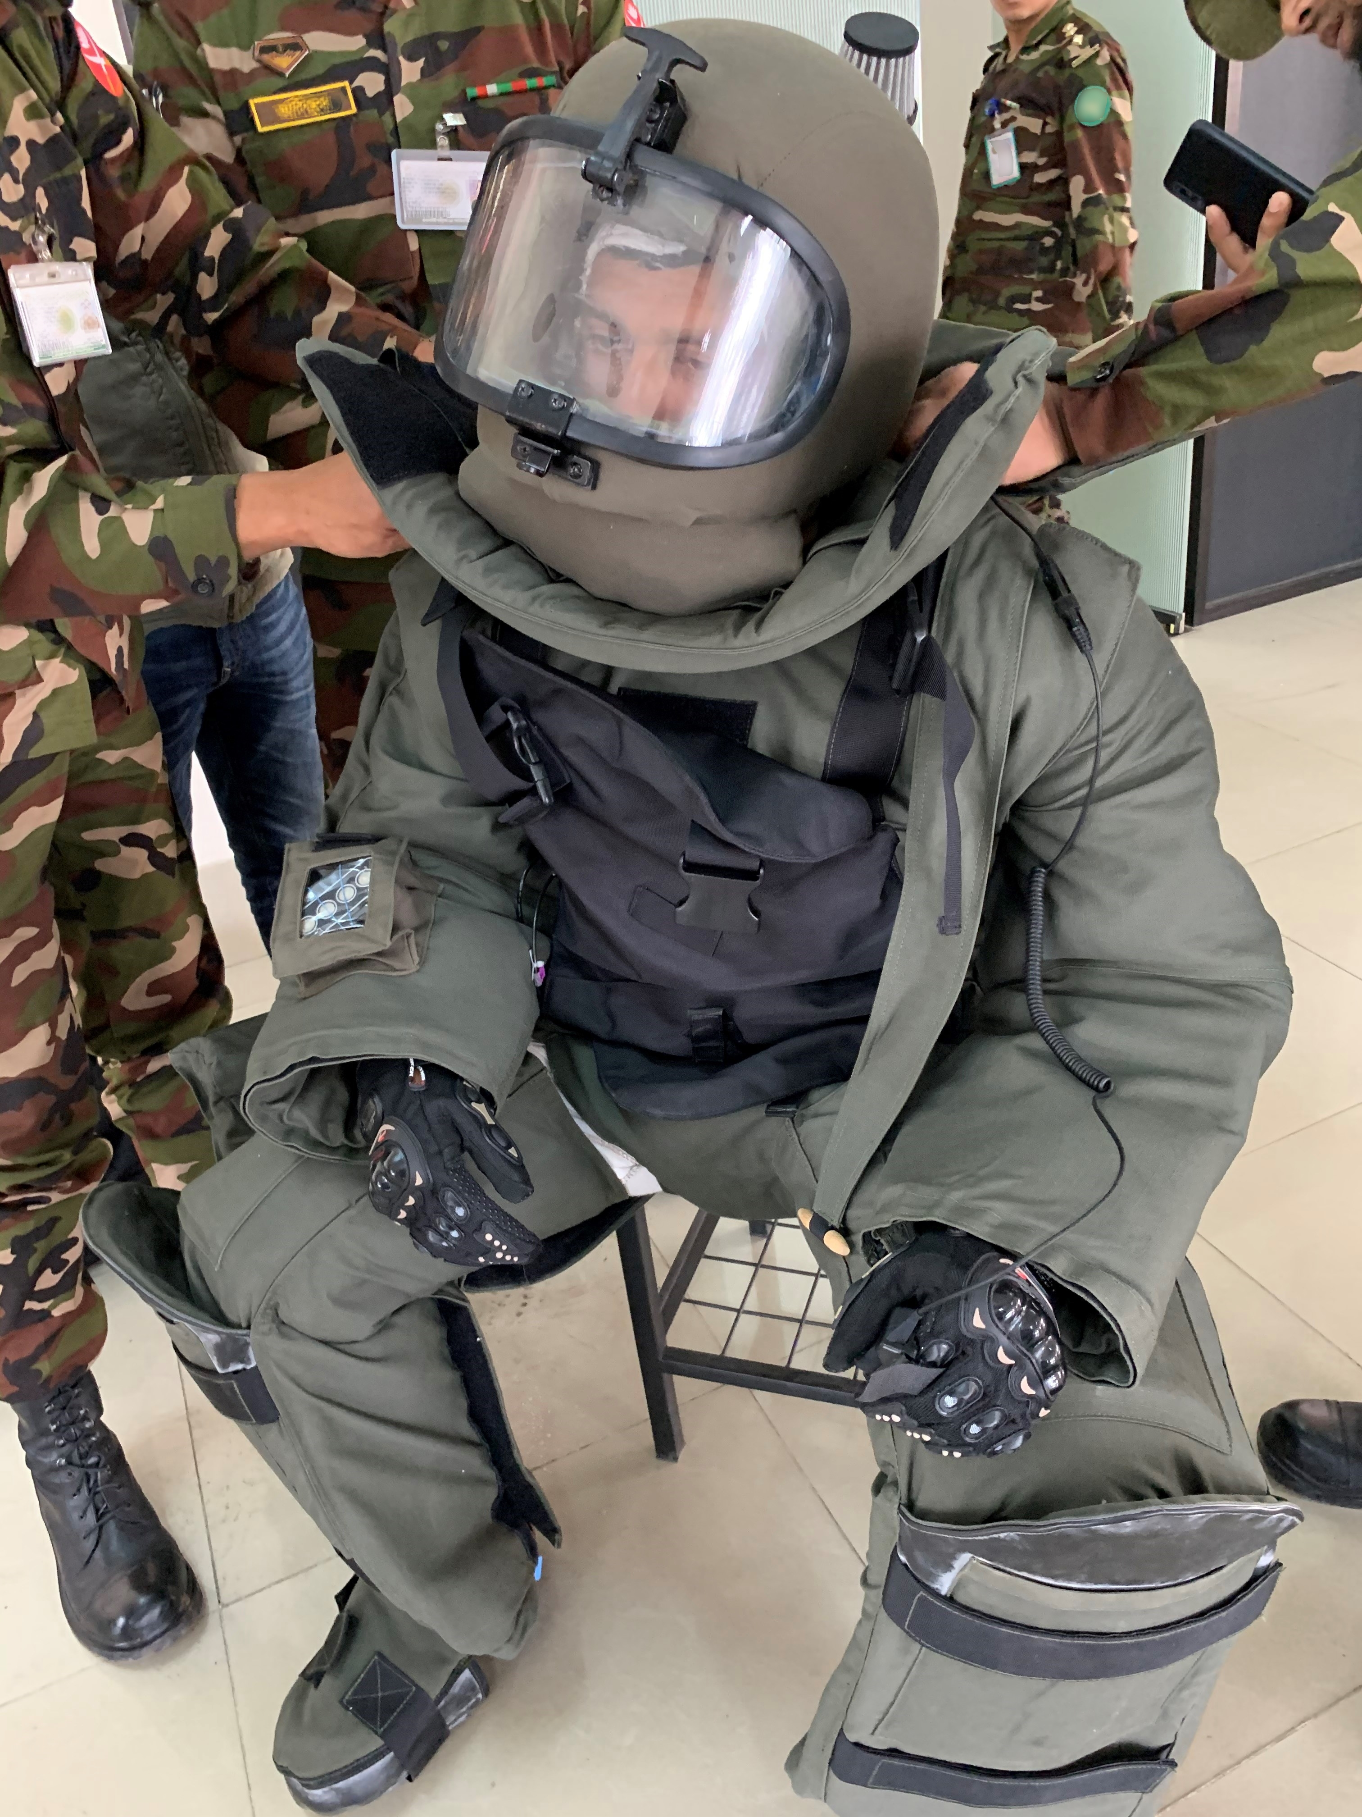
CAPTION: Members of the Bangladesh Ministry of Defense undergoing a recent training session with Safe Pro Group’s new Explosive Ordinance Disposal (EOD) suit

Under multiple contract awarded by the Bangladesh MOD, Safe Pro has manufactured and delivered an array of high performance, proprietary demining and counter IED products including Bomb Locators, Distruptors, Explosive Ordinance Disposal (“EOD”) suits, Blast containment, Fragmentation Blanket Systems, and Body Shields. These products were supplied to the Bangladesh Army in support of the United Nations Peacekeeping mission. Currently Bangladesh is the largest contributor in the UN peacekeeping mission.

“Safe Pro continues to successfully execute against multiple contracts awarded by the Bangladesh MOD, a strong demonstration of our capacity to manufacture and deliver a full range of demining, and ballistic protection products. We are especially proud that we continue to expand our relationship with this customer and that the strength and performance of our products are enabling their personnel to complete their life-saving humanitarian missions,” said Dan Erdberg, Chairman and CEO of Safe Pro Group.

“The Safe Pro team is proud to have completed these deliveries and follow-up in-country inspection, functional testing, and training of the demining personnel in Bangladesh. Deliveries against these multiple awards represents the extension of our multi-year relationship with our customer and we look forward to continuing to assist the brave men and women of the Bangladesh MOD in their ongoing demining missions,” added Pravin Borkar, Founder and President of Safe-Pro USA LLC.

The recent Bangladesh MOD awards were part of a series of competitive solicitations for EOD systems in support of the United Nations’ ongoing peacekeeping and demining programs. All Safe Pro EOD products are made in the United States. As a specialist in the design and manufacture of lightweight and rugged fragmentation and blast resistant products, Safe Pro has worked closely with the Bangladesh Army to develop customized EOD solutions for their evolving needs while incorporating advanced materials and additional functional capabilities. Safe Pro’s EOD suit features full body protection complying with MIL-STD-662F and STANAG 2920 standards for fragmentation resistance and includes fully integrated cooling and communications systems.

About Safe Pro Group Inc.
Safe Pro Group Inc. was formed by a team of executives and subject matter experts drawn from the Intelligence Community, Department of Homeland Security, Department of Defense, and commercial sectors to assess and help Government and Enterprise clients respond to disruptive new technologies and new threats. Safe Pro Group, through its portfolio of safety and security companies is currently serving the needs of domestic and international organizations in the Commercial, Military, Law Enforcement and Humanitarian sectors. For more information on Safe Pro Group Inc., please visit https://safeprogroup.com/.

Media Relations for Safe Pro Group Inc.:
Michael Glickman
MWGCO, Inc.
917-397-2272
mike@mwgco.net

