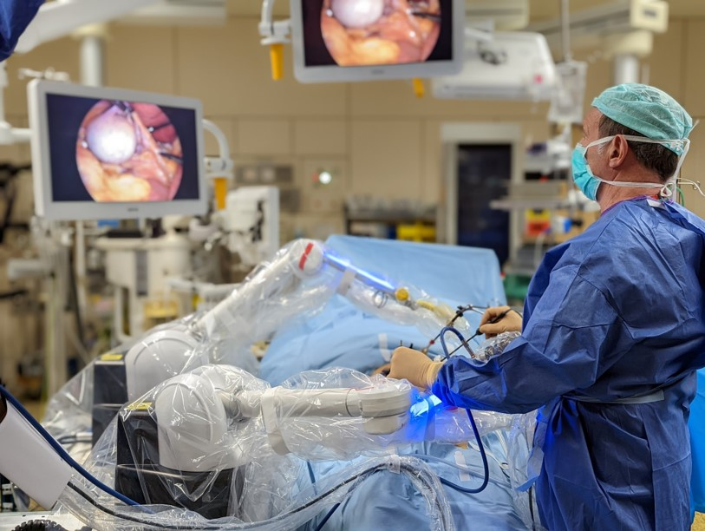

Moon Surgical Completes
First-in-Human Clinical Study with its Maestro™
Surgical Robotics System

PARIS and SAN FRANCISCO, December 13th, 2022 -- Moon Surgical, a French-American pioneer in accessible surgical innovation, today announced the successful completion of 30 First-in-Human laparoscopy procedures using its Maestro System at CHU Saint-Pierre, a public university hospital in Brussels, Belgium.

Maestro is designed for surgeons and patients in the 18.8 million annual soft tissue surgical procedures not currently supported by telerobotic systems. The system is small, adaptable, and can be integrated into existing clinical workflows while providing the surgeon more control throughout a procedure.

“I am thrilled to be part of this monumental accomplishment by Moon Surgical,” explained Pr. Guy-Bernard Cadière, former Head of Surgery at CHU Saint-Pierre and a legendary laparoscopic and robotic surgeon, who performed all 30 laparoscopic surgeries using the Maestro System. “This technology is brilliant; it gave me more control throughout the procedure, keeping me confident and less fatigued by the end. Maestro is a great benefit for any surgeon, giving them the freedom to conduct each surgery in the most efficient manner.”

The Maestro System aims to increase operating room efficiency by enhancing existing surgical instruments and techniques while minimizing the impact on operating room turnover time. These attributes are particularly valuable in high-volume procedures or facilities focused on maintaining procedure volume.

The 30 procedures were performed in 11 days and covered seven different clinical indications. This demonstrated the Maestro System’s adaptability for use in diverse procedures and its minimal impact on operating room volume. In each of the procedures, as a result of the Maestro System’s support, the surgeon did not need a surgical assistant to hold and manipulate instrumentation.

Fourteen of the completed procedures were laparoscopic cholecystectomies (removal of the gallbladder to treat symptomatic gallstone disease). In the United States, there are more than 700,000 cholecystectomy procedures annually, making it one of the most common surgical procedures in the world.

The procedures also included bariatric interventions, hernia repairs, colorectal surgeries, and gastric reflux surgery.

“This is another testament to how much the Maestro System can improve a surgeon’s experience,” said Anne Osdoit, Chief Executive Officer of Moon Surgical, and a Partner in Sofinnova Partners' medtech accelerator, MD Start. “The results of our First-in-Human trial are a great validation of the value of the Maestro System in a real-life surgical setting. It is simply fantastic to see our system providing treatments to patients. There is no greater reward than this.”

About Moon Surgical
Moon Surgical, based in Paris, France, and in San Francisco, California, believes the future of the operating room lies in the hands of the empowered surgeon.

By equipping surgeons with complete control, renewed confidence, and technology adaptable to any situation they encounter, Moon Surgical strives to improve efficiency in operating rooms and provide better surgical care for patients. The minimalistic, co-manipulation Maestro Robotic System uses tomorrow's technology to deliver these vital skills to surgeons, today.

The company was founded in 2019 by Pr. Brice Gayet and incubated by Sofinnova MD Start.

www.moonsurgical.com

Contact
Investors and Media: info@moonsurgical.com

