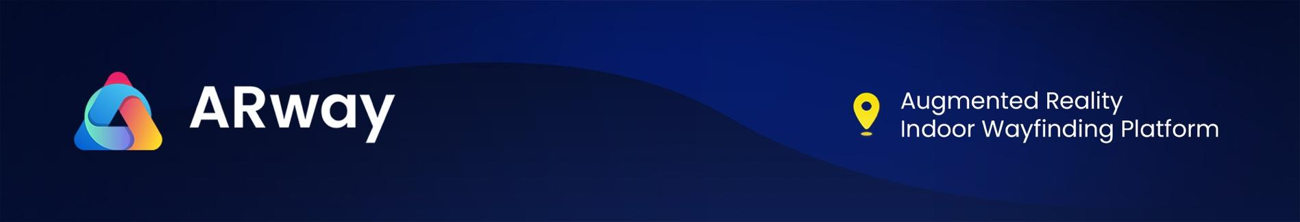
5

ARway CEO Joins BTV Business Television to Discuss Augmented Reality Navigation
ARway is disrupting $44 Billion Global Indoor Positioning and Navigation (IPIN) Market

TORONTO, O.N, Canada – February 16, 2023 - ARway Corporation (“ARway” or the “Company”) (CSE: ARWY), (OTC: ARWYF) (FSE: E65) is an AI powered Augmented Reality Navigation platform with a disruptive no-code, no beacon spatial computing solution enabled by visual marker tracking with centimeter precision.
The Company is pleased to announce that CEO, Evan Gappelberg joined BTV Business Television for an exclusive CEO clip to discuss the Company’s massive potential.
Watch the segment:
https://www.b-tv.com/post/cse-arwy-ceo-clips-arway-technological-advancement-disrupting-the-ar-market-60sec
Learn more about ARway
https://www.arway.ai/investors
About CEO Clips:
CEO Clips – are short company video profiles broadcast to a large audience of investors on TV and 15+ financial sites including Reuters, Yahoo!Finance, and Wall Street Journal.

To learn more about ARway, please follow on Social Media: Twitter, YouTube, Instagram, LinkedIn, and Facebook, and visit our website: www.arway.ai
For further information, please contact:
Investor Relations Contact
Julia Viola
investor.relations@arway.ai
ARway Corporation
Evan Gappelberg
CEO and Director
866-ARITIZE (274-8493)
About ARway Corp

ARway is an AI powered augmented reality navigation platform for the real-world metaverse. It enables AR-enhanced indoor navigation and wayfinding solutions for large, multi-purpose venues enabled by marker-based tracking using QR codes. Visitors can access a venue map by scanning a QR code with their smartphone upon entering the venue to navigate to any Point of Interest (POI) with step by step directions, learn information about those POIs, and interact with rich AR content and experiences along the way.

The ARway offering has an unlimited number of use cases for augmenting physical spaces in the metaverse, consisting of indoor navigation with AR activations to improve the visitor experience in large and complex spaces. With value propositions spanning multiple industries and use cases, ARway leverages Nextech’s 3D/AR technology solutions to new substantial markets, for use by creators, brands, and companies.

The ARway Platform Includes:
Web Creator Platform
The Web-Based Creator Platform provides 'advanced' authoring capabilities compared to the mobile app, including the ability for creators to upload their own OBJ/GLB files, and create their own 3D objects. Placing content in a large area using only mobile app required the user to physically be in the specific location which was unscalable. The web studio allows the user to place and author content remotely and at scale.
Mobile App
With the ARway mobile app, anyone can spatially map their location within minutes using their smartphone, and populate it with interactive 3D content, augmented reality wayfinding, audio, text, images, and more. Nextech AR provides several pre-loaded 3D objects which creators can leverage to populate their metaverse.
Download the Mobile App
Apple iOs - click here
Google Play Store - click here
ARwayKit SDK
The Software Development Kit contains code libraries and API information that allows developers to build their own white label & private label mobile apps on both iOs and Android leveraging ARway's technology and creator tools to build AR wayfinding and spatial experiences. Creators will be able to develop white label and private label apps and access ARway APIs to author maps using the Web Creator Portal. The SDK features the latest and greatest of the ARway mobile app.
Nextech AR Solutions
On October 26, 2022, ARway Corp. was spun-out from its parent Company, Nextech AR Solutions (OTCQX: NEXCF) (CSE: NTAR) (FSE: EP2). Nextech AR retained a control ownership in ARway Corp. with 13 million shares, or a 50% stake. Nextech AR Solutions is a Metaverse Company and leading provider of augmented reality (“AR”) experience technologies and 3D model services. Nextech’s AI-powered 3D modeling platform, “ARItize3D '' has contracts with; AMZN, KSS, CB2, Genuine Parts & many others. To learn more about Nextech AR, visit www.nextechar.com

Forward-looking Statements
The CSE has not reviewed and does not accept responsibility for the adequacy or accuracy of this release.

Certain information contained herein may constitute “forward-looking information” under Canadian securities legislation. Generally, forward-looking information can be identified by the use of forward-looking terminology such as, “will be” or variations of such words and phrases or statements that certain actions, events or results “will” occur. Forward-looking statements regarding the completion of the transaction are subject to known and unknown risks, uncertainties and other factors. There can be no assurance that such statements will prove to be accurate, as future events could differ materially from those anticipated in such statements. Accordingly, readers should not place undue reliance on forward-looking statements and forward-looking information. ARway Corp. will not update any forward-looking statements or forward-looking information that are incorporated by reference herein, except as required by applicable securities laws.

