Gamelancer Media Amplifies Partnership with Snap Inc.

Expanding upon Gamelancer Media’s Current presence on Snapchat with additional programs and creator partnerships

NEWS PROVIDED BY:Gamelancer Media Corp
Gamelancer.com
February 22, 2023, 8:50 ET
Toronto, Ontario - February 22, 2023, Gamelancer Media Corp. (CSE: GMNG) (OTCQB: GAMGF) (FRA: P93) (“Gamelancer” or the “Company”) a leading media-production and entertainment company that creates custom short-form video content for brands, announces today that it has broadened the scope of its current media partnership with technology company, Snap Inc. With numerous popular short-form video programs currently hosted on Snapchat’s Stories page (the 4th tab) within the Discover feed, Gamelancer Media aims to include additional programs and creator partnerships through the deepened engagement across its 29 Snapchat channels. With subscribers and revenues continually increasing, growing the existing partnership is a natural next step.


Snapchat’s Stories page provides made-for-mobile content including shows, news reports, creator content and more. With a specific focus on producing short-form series that resonate with Gen Z and young Millennials, Gamelancer Media will expand upon its original content with new series and creators covering topics such as beauty, fashion, crime stories, cooking and more.

The Company’s Snapchat Shows are popular OTT (over the top) short-form video programs that engage younger audiences. Gamelancer Media’s total Snapchat presence sits at just over 3.7 million subscribers to date and generates over $440,000 in recurring monthly revenue across 23 channels. This is in addition to Gamelancer Media’s core ad-sales business, as noted HERE in a press release dated December 12, 2022. Added programming along with 6 new channels, now a combined 29 channels, is anticipated to have a direct and positive impact on the Company’s monthly OTT earnings.

Gamelancer Media offers expertise in building loyal and engaging online communities and as a modern media enterprise, the Company provides a unique opportunity for brands to create authentic connections with its extensive Gen Z and younger Millennial audiences through full-production and/or broadcasting opportunities across its owned and operated network of 44 social media channels. With over 37 million total followers and subscribers and over 2 billion monthly views across its combined social media platforms, brands have a unique advantage in making authentic connections with their desired demographic through custom branded short-form content that resonates with target audiences.

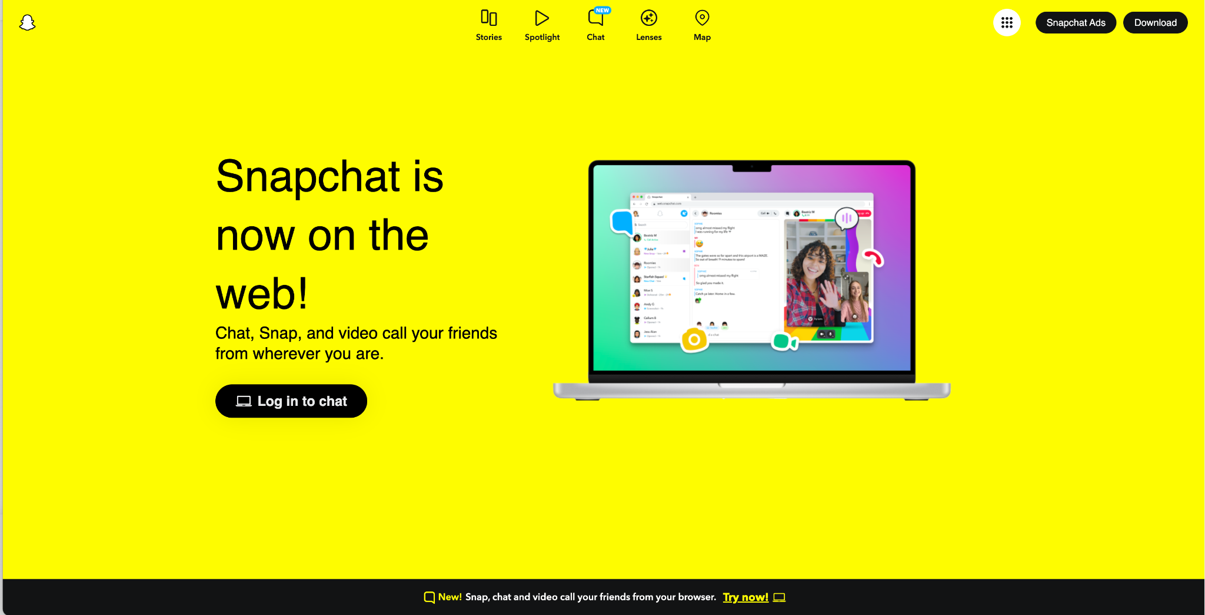

Snapchat boasts over 375 million daily users as of Q4, 2022, a 17 percent year over year (YoY) increase and recently announced that the platform reaches a global community of 750 million monthly active users. The technology company reaches over 75 percent of 13 to 34 year olds and 90 percent of 13 to 24 year olds in over 20 countries, including Canada. Snapchat draws a unique, mobile-first audience who gravitate toward engaging and short-form videos and partnered content, such as Spotlight and Stories, the former being the place within Snapchat that allows anyone to potentially reach a massive audience through a Snap. The app has seen over 100% increase in total time spent watching Spotlight content compared to Q4, 2021. Spotlight is available in more than 150 countries. With plans to increase market share in key global areas, Snapchat supports over 40 languages and has established important partnerships with major handset original equipment manufacturers (OEMs) and local telecommunication companies.
"Snapchat’s Stories page is the best way for the community to discover creative, diverse content from Canadian publishers and content partners around the world. We’re excited to continue working with Gamelancer as they continue to build their presence, tapping into the unique and highly engaged audience on Snapchat, and grow to new and exciting levels in 2023,” said Nader Mohamed, Media Partnerships Lead, Canada, at Snap Inc.
“Our current partnership with Snap Inc. has been very successful and we are thrilled to broaden the scope of our existing arrangement, which first began March 29, 2021. The collaboration has been such a great experience and our Shows on Snapchat have amassed a combined total of over 3.7 million subscribers to date. We look forward to cultivating new and exciting content and amplifying our partnership with Snap Inc.,” said Gamelancer Media Chairman and CEO, Jon Dwyer.
About Snap Inc.
Snap is a technology company. We believe the camera presents the greatest opportunity to improve the way people live and communicate. Snap contributes to human progress by empowering people to express themselves, live in the moment, learn about the world, and have fun together. The Company’s three core products are Snapchat, a visual messaging app that enhances your relationships with friends, family, and the world; Lens Studio, an augmented reality platform that powers AR across Snapchat and other services; and its AR glasses, Spectacles. For more information, visit snap.com.
About Gamelancer
Acquired by Wondr Gaming, Gamelancer Media Corp. is a media & entertainment company producing short-form video content for brands, with broadcast on its owned and operated TikTok, Snapchat, and Instagram channels. Gamelancer Media will focus on developing new brand, agency, and creator relationships and new opportunities for existing associates through its strategic partnerships with TikTok North America and Snap Inc. The media company currently works with companies such as Samsung, Belkin, RBC, Celsius, and several other notable brands. The company produces and distributes content across its 44 owned-and-operated channels to over 37 million followers & subscribers, generating over 2 billion monthly video views. A majority of the Gamelancer's audience are located in the USA, Canada, the UK, and Australia.

With advanced user data analytics, Gamelancer provides its audience with content relevant to the GenZ & Millennial respective communities. Gamelancer owns the largest gaming media inventory on TikTok. Gamelancer also monetizes across its Snapchat Discover channels in partnership with Snapchat.

Gamelancer is 53% insider owned.

Visit us at Gamelancer.com to join our email subscribers list and receive press releases and newsletters directly to your inbox.

For further information, please contact:
Jon Dwyer, Chairman and Chief Executive Officer
Tel: (416) 627-8868
Email: ir@gamelancer.com
IR Email: info@gamelancer.com
Neither the Canadian Securities Exchange nor its Market Regulator (as that term is defined in the policies of the Canadian Securities Exchange) accepts responsibility for the adequacy or accuracy of this release.
Forward Looking Information
This news release contains forward‐looking statements and forward‐looking information within the meaning of applicable securities laws. These statements relate to future events or future performance. All statements other than statements of historical fact may be forward‐looking statements or information. The forward‐looking statements and information are based on certain key expectations and assumptions made by management of the Company. Although management of the Company believes that the expectations and assumptions on which such forward-looking statements and information are based are reasonable, undue reliance should not be placed on the forward‐looking statements and information since no assurance can be given that they will prove to be correct.
Forward-looking statements and information are provided for the purpose of providing information about the current expectations and plans of management of the Company relating to the future. Readers are cautioned that reliance on such statements and information may not be appropriate for other purposes, such as making investment decisions. Since forward‐looking statements and information address future events and conditions, by their very nature they involve inherent risks and uncertainties. Actual results could differ materially from those currently anticipated due to a number of factors and risks. Accordingly, readers should not place undue reliance on the forward‐looking statements and information contained in this news release. Readers are cautioned that the foregoing list of factors is not exhaustive. The forward‐looking statements and information contained in this news release are made as of the date hereof and no undertaking is given to update publicly or revise any forward‐looking statements or information, whether as a result of new information, future events or otherwise, unless so required by applicable securities laws. The forward-looking statements or information contained in this news release are expressly qualified by this cautionary statement.

SOURCE: Gamelancer Media Corp.

