Informa Markets Fashion Celebrates International Women’s Day to Inspire the Next Generation of Female Leaders

New York, NY (March 8, 2023) Informa Markets Fashion, the industry leader in wholesale fashion events including MAGIC, PROJECT, COTERIE and Sourcing at MAGIC, today celebrates International Women’s Day by sharing their sources of inspiration in their careers, how they are supporting their female colleagues and why it is important to shine a light on International Women’s Day.
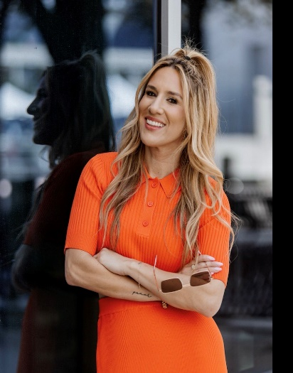
Kelly Helfman, President of Informa Markets Fashion
Why is it important that we recognize International Women’s Day?
K.H. It is crucial to not only celebrate how far we have come as women and all our achievements, but also to bring awareness to how far we still must go for true equality. Today is about empowering, supporting and uplifting one another as a community of women everywhere, from all places and backgrounds.
What women have inspired you in your path to success?
K.H. I have had two female bosses who have shown me what it means to be a strong female leader and how to navigate headways in a predominantly male industry. I also look up to hard working, authentic public figures who mentor such as Brene Brown and Oprah.
What ways can you support the younger generations of females on your team in their career growth?
K.H. As leaders in our business, we need to take the time to coach and mentor the next generation to be our successors. I find that asking questions on where they are having challenges is key so you can understand how you can best support them and share the tips we wish we knew when we were in their shoes. There must be an open-door policy to always be available to meet with those in your organization and give them opportunities to shadow/learn from you. But the most important way to support the new generation of females is to lead by example as that is how they best learn, by watching and picking up on work ethic and leadership styles they admire. It is our job as well to do the work to pave the way for them to have great opportunities.

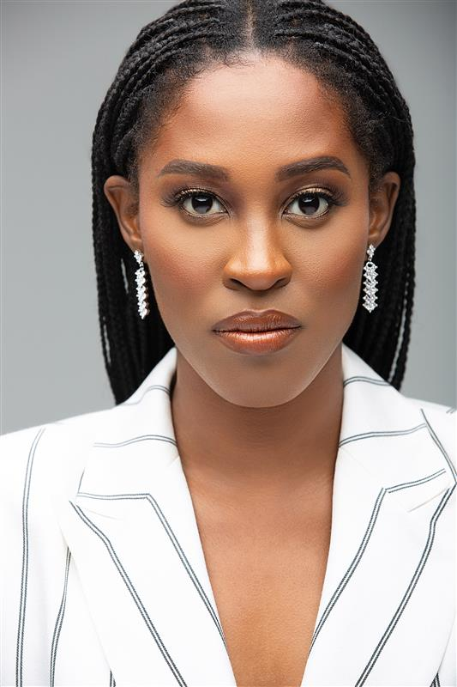
Edwina Kulego, Vice President of International & Men’s at Informa Markets Fashion
Why is it important that we recognize International Women’s Day?
E.K. Although many strides have been made, equity for women in society and in business remains any issue. Celebrating International Women’s Day allows for women’s voices, that are often silenced to be heard and for honest conversations to take place in order to move women forward.
What women have inspired you in your path to success?
E.K. My mother, Beatrice Morton who is an incredible entrepreneur and inspiration, Oprah Winfrey and Myleik Teele, Founder of CURLBOX.
What ways can you support the younger generations of females on your team in their career growth?
E.K. Sharing my story and creating a safe space for young women to share their journey provides an opportunity for me to provide support and useful tools that can benefit their path and growth. Being accessible and being open to making connections allows for these important conversations to take place.


Jordan Rudow, Vice President of MAGIC Fashion Events
Why is it important that we recognize International Women’s Day?
J.R. International Women’s Day is a time to reflect on the past generations who have paved the way for female leaders today and to celebrate achievements from women all over the world making an impact in our day to day lives.
What women have inspired you in your path to success?
J.R. There have been several strong women who have been trailblazers of their times that have inspired me in my career from Coco Chanel, Michelle Obama, Oprah Winfrey, Princess Diana, Stella McCartney and of course Kelly Helfman, the President of Informa Markets Fashion.
What ways can you support the younger generations of females on your team in their career growth?
J.R. I choose a leadership style with empathy and understanding but also it is important to stay authentic, be bold and take risks. I have found that setting short- and long-term goals will empower the team to be accountable, decisive and resilient. During my tenure in the fashion industry, I have learned that consistency and integrity, with a little bit of grit will set you up for success. It important for my team and younger generations to learn into these qualities to grow in their career.

IWD is a day dedicated to celebrating the social, economic, cultural, and political achievements of women. Originally started in 1911 in Austria, Denmark, Germany and Switzerland, has grown to a global celebration of women.

ABOUT INFORMA MARKETS FASHION
Informa Markets Fashion a division of Informa Markets, a subsidiary of Informa plc, (LON:INF), connects and inspires the global fashion community through online experiences, industry insights, and worldwide fashion trade events, including MAGIC, COTERIE, PROJECT, and SOURCING at MAGIC. From more effective manufacturing and supply chain opportunities to creative design inspiration and retail on the wholesale floor, Informa Markets Fashion's diverse portfolio supports the entire fashion ecosystem - fostering innovation and driving creativity year-round. For more information on upcoming events, please visit: www.findfashionevents.com
MEDIA CONTACTS:
Kristin Borland
Informa Markets Fashion
fashionpr@informa.com

