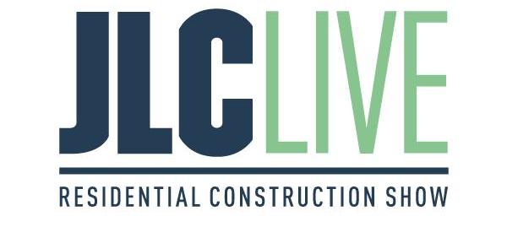
JLC LIVE New England Returns to Rhode Island for the 27th Edition Bringing Together Thousands of Industry Professionals and Top Brands in Residential Construction
Providence, Rhode Island (March 14, 2023) – JLC LIVE New England, the most anticipated construction tradeshow in the region, today announces event highlights and offerings for the 27th edition. JLC LIVE hosts live demonstrations, building clinics and top-notch educational content for all professionals in residential construction. The event is slated for March 24 - 25, with conference starting March 23 at the Rhode Island Convention Center in Providence, Rhode Island and will welcome thousands of builders, remodelers, contractors and crews from across the region.
The exhibit hall returns with feature interactive demonstrations and hands-on experiences for attendees including nine manufacturer-led tool demonstrations and 11 building clinics covering new technologies and innovations in areas such as interior and exterior air sealing, deck construction, home building, trim carpentry, flooring, roofing, stair building and indoor air quality.
“By providing interactive experiences and demonstrations during the conference, we show attendees what new technologies and innovations are available, as well enable them to apply what they've learned from the conference to their everyday practices,” says Sue Pino, Show Manager, JLC LIVE. “These live demonstrations and presentations from leading experts in different fields of construction offer attendees a unique chance to participate in the action while gaining valuable knowledge.”
New exhibitor demonstrations this year include Trus Joist Weyerhaeuser and Marvin Windows and Doors, along with select sponsors and exhibitors such as Andersen Windows & Doors, CertainTeed, Huber ZipSystem & Advantech, Milwaukee Tool, Westlake Royal Building Products, VERSATEX and more top brands in residential building.
Newly launched this year, JLC LIVE is seeking its next building clinic hosting professional through the Next Live Presenter Contest, giving skilled construction professionals the chance to join the Building Clinic Crew at JLC LIVE 2023 and compete for a $1,000 cash prize. The three finalists are Aron Jones, Sam Durdaller and Aaron Miiller. Finalists will join the Clinic Crew at the show as attendees will vote for the top deserving pro for the 2024 Building Clinic Stage.
To register for JLC LIVE, please visit jlclive.com. Those attending will be able to meet with more than 230 exhibitors, select from 40+ conference sessions, listen to nearly 30 speaker presentations and network with thousands of fellow builders and residential construction professionals.
About JLC LIVE
JLC LIVE is the most anticipated trade event of the year for residential construction. Remodelers, home builders, contractors, and other trade professionals learn from the leading industry experts through live on-floor building clinics, demonstrations and classroom-style conference sessions. Follow JLC LIVE on social at Facebook, Instagram, LinkedIn, Twitter and YouTube for the most up-to-date information on the 2023 show.
About Informa Markets

Informa Markets, a subsidiary of Informa plc (LON:INF), creates platforms for industries and specialist markets to trade, innovate and grow. We provide marketplace participants around the globe with opportunities to engage, experience and do business through face-to-face exhibitions, targeted digital services and actionable data solutions. We connect buyers and sellers across more than a dozen global verticals, including Pharmaceuticals, Food, Medical Technology and Infrastructure. As the world's leading market-making company, we bring a diverse range of specialist markets to life, unlocking opportunities and helping them to thrive 365 days of the year. For more information, please visit www.informamarkets.com.

Media Contact:

Abby Portwood
Informa Markets Infrastructure and Construction
IC.PR@informa.com

