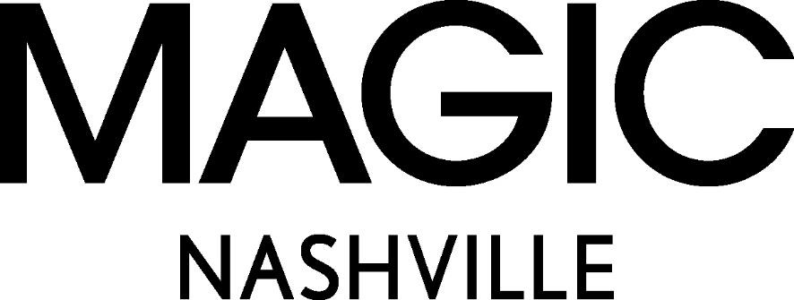

MAGIC Nashville Returns with Growth and Key Focus on Southern Regional Fashion

Over 475 brands with over 245+ new to show, daily live music and special guest Jessie James Decker will share her steps to launching a successful business in a panel discussion with Rachel McCord.
New York, NY (April 12, 2023) MAGIC Nashville is returning to the Music City for its second annual wholesale fashion event April 26-27. The April edition of MAGIC Nashville will take place at the Music City Center for two full days of fashion, music and immersive activations.
MAGIC Nashville showcases a curated assortment of brands and products from top selling categories including women’s sportswear, young contemporary and trend apparel, footwear and accessories brands. Delivering the experience MAGIC is known for with a Nashville twist with new and influential retailers from boutique and specialty stores to big box, online and key regional retailers can explore the latest trends, discover differential product offerings to meet demand for incremental revenue and connect with the MAGIC community of established and emerging brands.

MAGIC Nashville will host daily panel sessions at the MAGIC Social House, where experts will speak on current topics facing the fashion industry including the “2023 Trend Presentation” hosted by Kelly Helfman, President of Informa Markets Fashion, Jordan Rudow, Vice President of MAGIC and Rachel McCord, Founder of the McCord List. Country music star, author, and fashion innovator Jessie James Decker and Rachel McCord will host a panel in which Jessie James Decker shares her thoughts on launching a business on April 26th at 1:00 P.M.*
“Nashville and MAGIC are both known for their vibrant energy, and we aim to capture the opportunity the unique southern market has to offer with a mid-season meeting point to do business. MAGIC Nashville has doubled in size in just one year and we anticipate the momentum to continue.” Says Kelly Helfman, President of Informa Markets Fashion “The show is growing, and so is the expanding list of top-tier international and domestic retailers.”
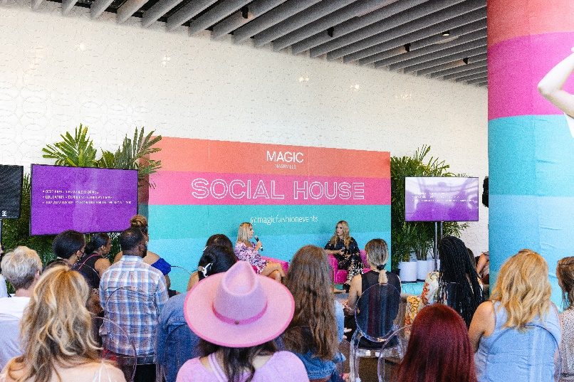

Twice the footprint of its inaugural show, MAGIC Nashville is expecting over 200 new to show brands and a 91% increase in women owned collections expected on the show floor in the apparel, footwear, accessories, home, gift and beauty categories. Mink Pink, Driftwood, Z Supply, Bobi, Barefoot Dreams, Dolma, Liverpool Jeans, Hobo, Steve Madden, Frye, Gigi Pip, Dolce Vita and Poppy & Pout will all be on-site along with international representation from Rolla’s of Australia, Spanner from Canada, Vero Moda of Denmark, Dantelle from Türkiye and Stivali from Columbia.

Top retailers registered include VICI, Apricot Lane, Dillard’s, Altar’d State, Free People, Zappos, Hemline, Fashion Nova and Lulus as well as international retailers from INA International, Island Activewear, Silver Icing, Amazon Mexico and Editorial Boutique.

“Over 430 brands are coming to MAGIC Nashville, which fills the need for the regional event where noteworthy retailers can find designers offering immediates for key holiday season demand.” says Jordan Rudow, Vice President of MAGIC. “The brand list offers everything Nashville is known for: charm, bright colors, boho feels, embellishment, all the high notes and international designers that capture this essence. Chic and trendy on-site experiences are going to keep our MAGIC community IMMERSED in the Nashville fashion scene and you are going to have so much fun while shopping the floor.”
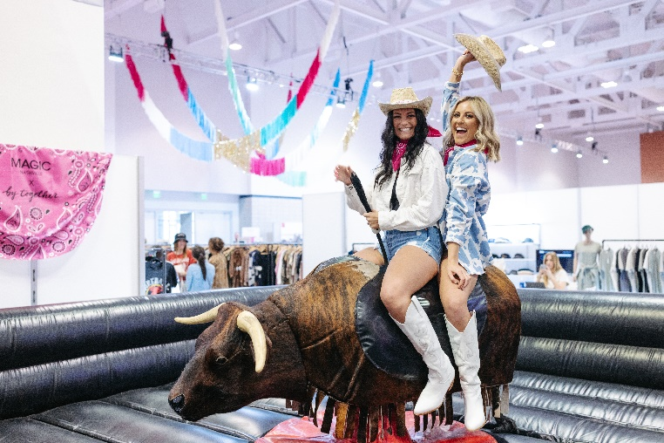

On-site activations will keep the MAGIC vibe going strong, in classic southern hospitality style, as attendees can take in the live music daily from local Nashville talent and gain access to the activation lounge where guests can get customized necklaces by Kinsey Designs, permanent jewelry by BRACHA and hair and makeup touch ups by Agency of Beauty. The opening night party sponsored by Fate on April 26th will be held at The Stage on Broadway from 6-10 pm with live music. Guests must present show badge for entry.

Register today at www.magicfashionevents.com.

* The appearance of Jessie James Decker made through UTA Speakers, New York, NY”
About MAGIC:
MAGIC is a high-energy fashion experience and home to the industry's largest selection of trend-driven and young contemporary apparel, footwear, and accessories. Fusing scale with curation to drive commerce, creativity, and connections, MAGIC joins a global audience of retail buyers – from big-box to boutique – with influencers, media, and industry thought leaders. More than just events, MAGIC is a deeply rooted community, and a place brands and retailers call home. For more information, please visit: www.magicfashionevents.com.
About Informa Markets:
Informa Markets, a subsidiary of Informa plc (LON:INF), creates platforms for industries and specialist markets to trade, innovate and grow. Our portfolio comprises more than 550 international B2B events and brands in markets including Engineering, Healthcare & Pharmaceuticals, Infrastructure, Construction & Real Estate, Fashion & Apparel, Hospitality, Food & Beverage, and Health & Nutrition, among others. We provide customers and partners around the globe with opportunities to engage, experience and do business through face-to-face exhibitions, specialist digital content and actionable data solutions. As the world's leading exhibitions organizer, we bring a diverse range of specialist markets to life, unlocking opportunities and helping them to thrive 365 days of the year. For more information, visit www.informamarkets.com.
Contacts:
Kristin Borland
Informa Markets Fashion
fashionpr@informa.com

