April 26, 2023 | CSE: FABL  FSE: XZ7

Fabled Copper Reports 23.40% Copper
on the south extension of the Eagle Creek Copper Occurrence

Vancouver, British Columbia – Fabled Copper Corp. (“Fabled Copper” or the “Company”) (CSE: FABL; FSE: XZ7) announces the results of 2022 surface field work on its Muskwa Copper Project. See Figure 1 below.

Figure 1 – General Property Location

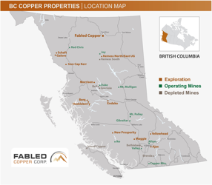

The Project is comprised of the Neil Property, the Toro Property and the Bronson Property all located in northern British Columbia. See Figure 2 below.

Figure 2 – Location Map

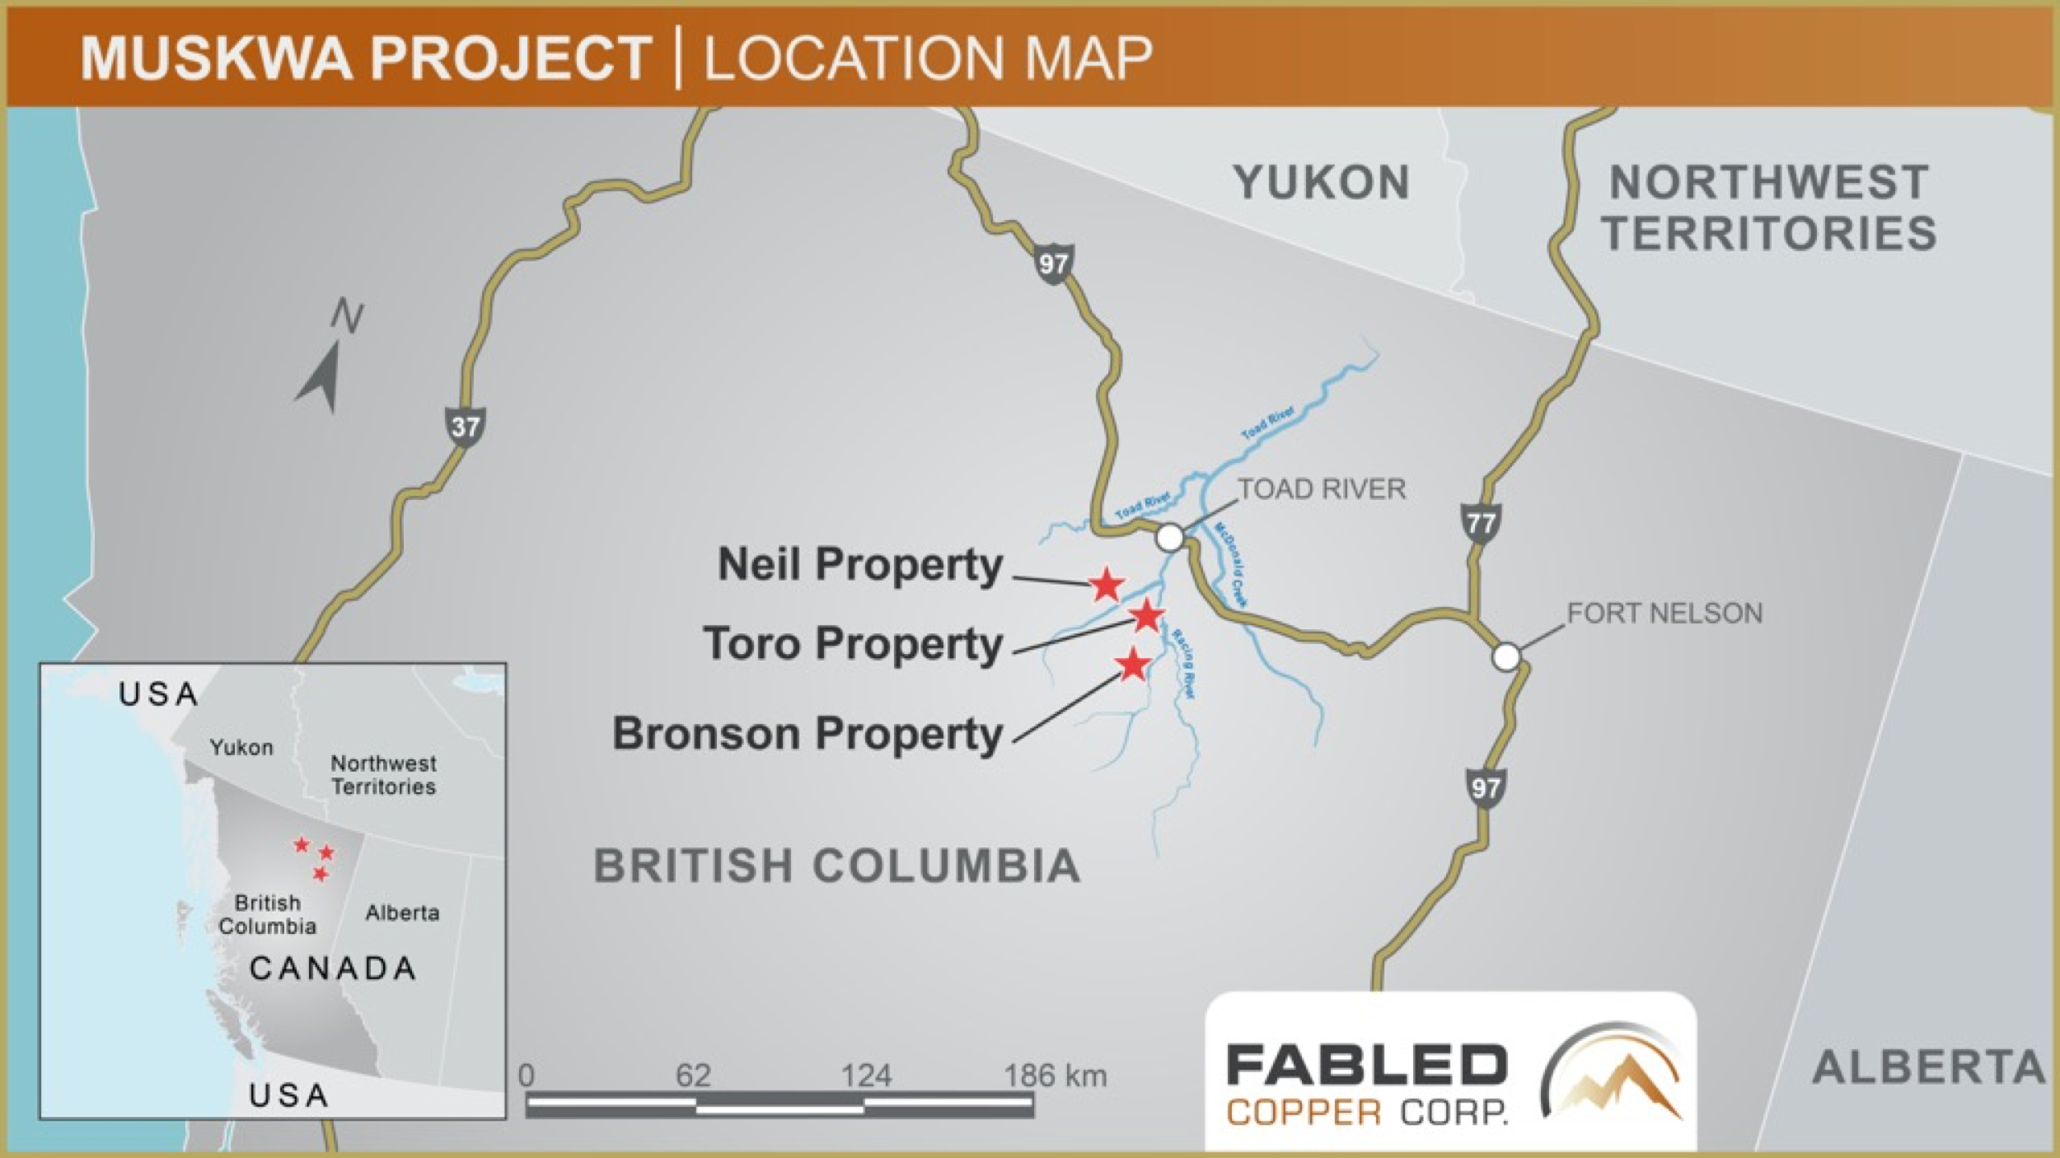
The north and south extension of the Eagle Creek copper occurrence is located on the Neil Property roughly 1-1.5 km east of the 6400 Eagle Vein adit where the 2022 underground LIDAR survey was completed. The Eagle creek flows northward into the Yedhe Creek and it is located in the same valley that contains the eastern end of the 6400 adit & Eagle Vein exposure that are located on the west cliff face of the valley. During the summer of 2022 the Eagle Creek (See Release dated February 7, 2023), east extension of the Eagle Creek copper occurrence (See Release dated March 1, 2023), the western extension (See Release dated April 12, 2023), north extension, southern extension and the backside of the Eagle vein were visited on sperate occasions.
This release pertains to the north and south extensions of the Eagle Creek Copper occurrence site visit, see Figure 3 below.
Figure 3 –North / South Part of Eagle Creek Copper Occurrence Location
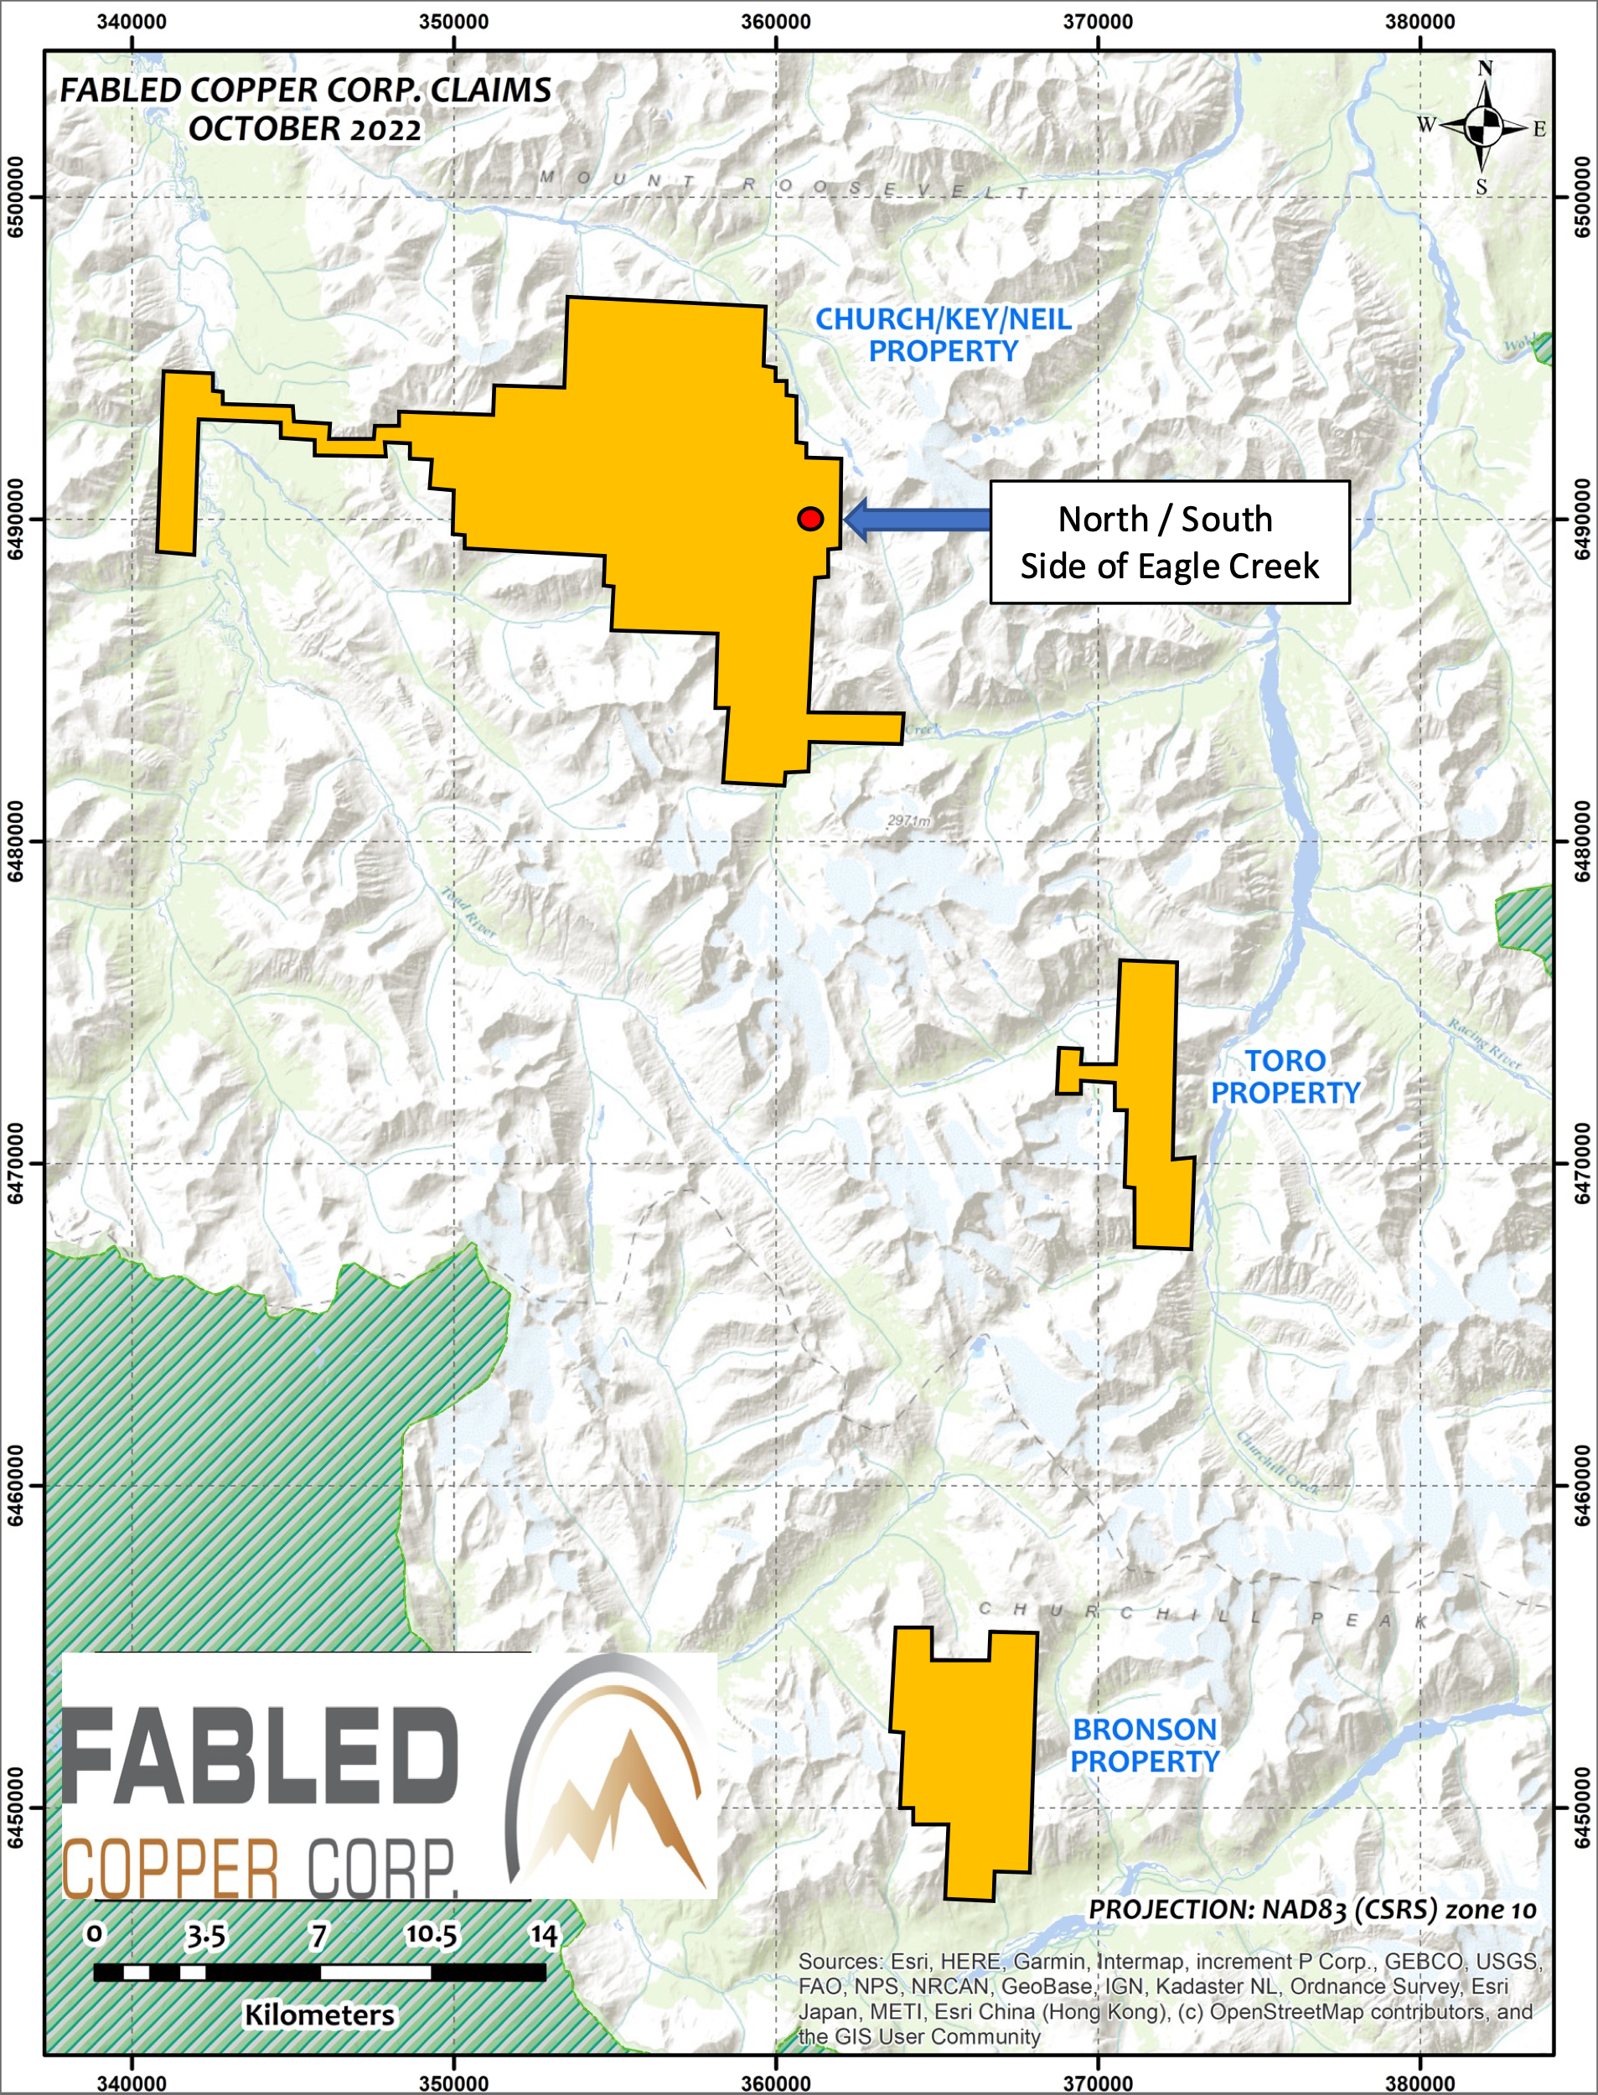

Peter Hawley, President, CEO reports; “The northern part of the Eagle Creek copper occurrence was visited by a 3-person field team consisting of two geologists and a geo technician on July 1st, 2022 during the summer field season. Over the course of the traverse a vertical altitude of 96 meters was examined and sampled. A total of 5 float samples were collected, of the samples collected, 4 assayed greater than 0.5%. See Table 1 below.

Float sample D-723639 taken at the 1,484-meter elevation consisted of quartz carbonate with black graphic shale with abundant malachite and 1-3% chalcopyrite. This sample returned 1.29 % copper. See Table 1 below.

Sample D-723640 taken 18 meters vertical below that of above consisted of 50% sheared siltstone and carbonate in a shear fabric with 50% carbonate and siltstone fragments contained 1% chalcopyrite and returned 0.50% copper. See Table 1, Photo 1 below.

Photo 1 – North Part of Eagle Creek, Float Sample D-723639 – 0.50% Copper

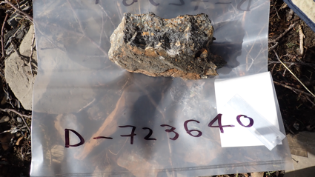

Whereas, sample D-723641 taken a further 25 meters below, of quartz carbonate with 1-2% chalcopyrite and moderate malachite alteration returned 1.51% copper. Float sample D-723642 taken at 1,423 meters of quartz carbonate with trace of chalcopyrite assayed 0.25% copper and the last sample taken on this daily traverse was D-723643 of dark brown weathered quartz carbonate with abundant malachite and 3% chalcopyrite returned 3.79% copper. See Table 1 below.

Table 1- North Side of Eagle Creek Occurrence Sample Results

Sample No. | Elevation  (m) | Copper  % | Sample Type
D-723639 | 1,484 | 1.29 | Float
D-723640 | 1,466 | 0.50 | Float
D-723641 | 1,441 | 1.51 | Float
D-723642 | 1,423 | 0.25 | Float
D-723643 | 1,388 | 3.79 | Float
- 1% copper = 22.2 pounds

On July 10th, 2022 the southern extension of the Eagle Creek copper occurrence was visited by a 3-person field team consisting of two geologists and a geo technician. During the traverse a vertical altitude of 207 meters was examined and sampled. A total of 9 float samples were collected and of the samples collected, 6 assayed greater than 0.5%. See Table 2 below.

Float sample D-723683 taken at the second highest elevation of 1,798 meters consisted of 50% quartzite and 50% quartz iron carbonate with 1% chalcopyrite and assayed 0.17% copper. At an elevation of 1,635 meters, down slope float sample D-723684 of quartz and shale fragments contained moderate malachite alteration with 1% chalcopyrite and returned 1.81% copper. At the highest elevation of 1,799 meters float sample D-723685 of buff colored quartz iron carbonate with less than 0.5% chalcopyrite reported 0.21% copper. And the next sample taken 32 meters below of rusty brown quartz carbonate with 25% pyrite assayed trace at 0.01% copper.

Float sample D-723687 examined and taken at the1,616 meter elevation of massive sulphides with iron carbonate and weathered rusty brown with 95% chalcopyrite returned and impressive 17.15% copper. See Table 1 and Photo 2 below.

Photo 2 – South Extension of Eagle Creek Copper Occurrence, Sample D-723687 – 17.15% copper.
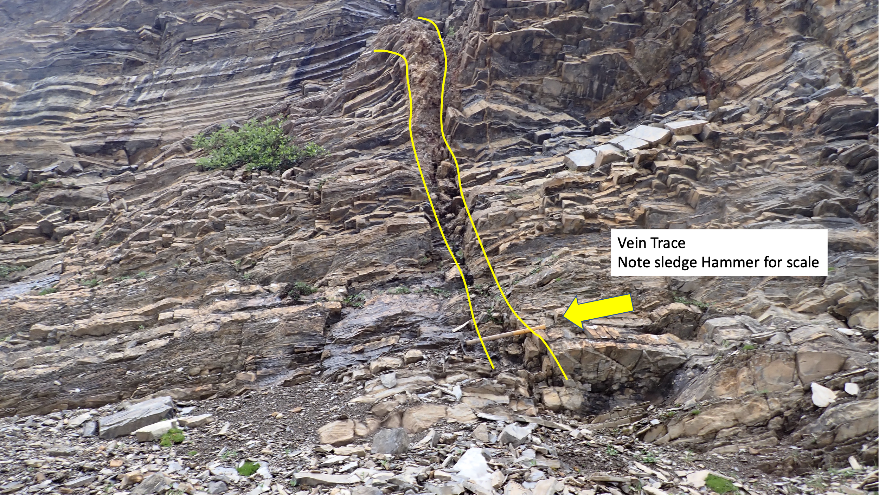

At the 1,604 meter altitude, float sample D–723688 was taken and consisted of quartz with iron carbonate with 5-5% chalcopyrite and assayed 6.22% copper.

Float sample D-723689 taken 13 meters above consisted of semi massive sulphides and quartz veining with 60% chalcopyrite and a 3% bornite returned an impressive 23.40% copper. See Table 2, Photo 3 below. Note the intense folding cross cut by the quartz veining clearly defining it as post date folding.

Photo 3 – South Extension of Eagle Creek Copper Occurrence, Sample D-723689 – 23.40% copper.
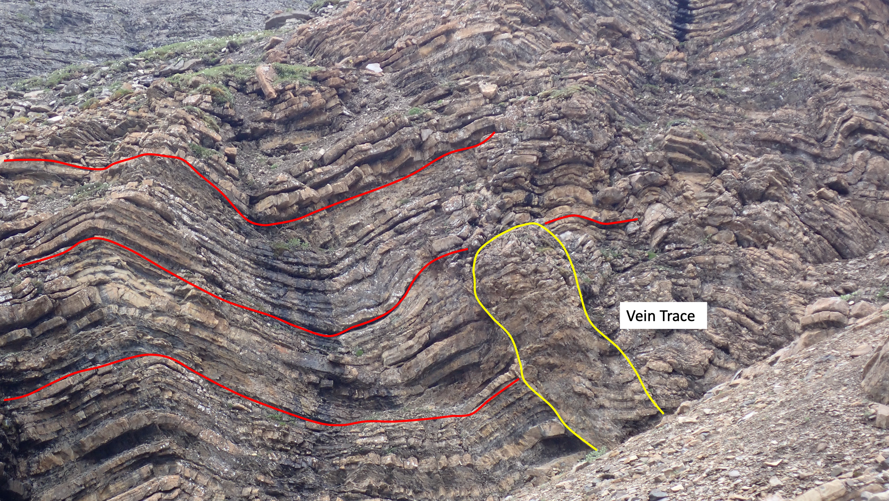

At an elevation of 1,745 meters, 128 meters vertically above the sample described above, float sample D-723690 consisted of quartz carbonate with 20% chalcopyrite and 2% bornite. This sample assayed 10.45% copper. See Table 2, Photo 3 below. Note the pinnacle of quartz standing out against the country rock.

Photo 3 – South Extension of Eagle Creek Copper Occurrence, Sample D-723690 – 10.45% copper.
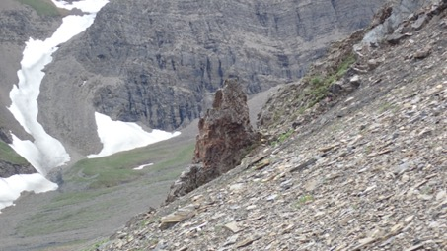

The final sample was taken down slope at an elevation of 1,592 meters and float sample D-723691 consisted of white to buff colored quartz veining with 5% disseminated pyrite and 1% bornite and assayed 2.15% copper. See Table 2 below.

Table 1- South Portion of Eagle Creek Occurrence Sample Results

Sample No. | Elevation  (m) | Copper  % | Sample Type
D-723683 | 1,798 | 0.17 | Float
D-723684 | 1,635 | 1.81 | Float
D-723685 | 1,799 | 0.21 | Float
D-723686 | 1,767 | 0.01 | Float
D-723687 | 1,616 | 17.15 | Float
D-723688 | 1,604 | 6.22 | Float
D-723689 | 1,617 | 23.40 | Float
D-723690 | 1,745 | 10.45 | Float
D-723691 | 1,592 | 2.15 | Float
- 1% copper = 22.2 pounds

As per protocol, all sample locations were taken with GPS along with GPS enabled field cameras of photos of the sampled units. The photos, sample locations and all assay data pertaining to the assay taken, (36 elements were assayed) were tagged in a geo tag format for plotting in .kml / .kmz GIS systems such as Google Earth.

An additional release on the 2022 exploration of the Eagle Vein “proper” of the Muskwa Project will be forth coming in the following weeks and will conclude the field work of this area.

QA QC Procedure

Analytical results of sampling reported by Fabled Copper Corp represent rock samples submitted by Fabled Copper Corp staff directly to ALS Chemex, Vancouver, British Columbia Canada. Samples were crushed, split, and pulverized as per ALS Chemex method PREP-31, then analyzed for ME-ICP61 33 element package by four acid digestion with ICP-AES Finish. ME-GRA21 method for Au and Ag by fire assay and gravimetric finish, 30g nominal sample weight.
Over Limit Methods
For samples triggering precious metal over-limit thresholds of 10 g/t Au or 100 g/t Ag, the following is being used:
Au-GRA21 Au by fire assay and gravimetric finish with 30 g sample.
Ag-GRA21 Ag by fire assay and gravimetric finish.
Fabled Copper Corp. monitors QA/QC using commercially sourced standards and locally sourced blank materials inserted within the sample sequence at regular intervals.

About Fabled Copper Corp.

Fabled Copper is a junior mining exploration company. Its current focus is to creating value for stakeholders through the exploration and development of its existing copper properties located in northern British Columbia. The Muskwa Project is located in the Liard Mining Division in northern British Columbia. In addition, Fabled has the newly acquired Volt 1, 2 and OHM lithium properties in the Abitibi area of Quebec.

Mr. Peter J. Hawley, President and C.E.O.
Fabled Copper Corp.
Phone: (819) 316-0919
peter@fabledcopper.org

For further information please contact:

info@fabledcopper.org

The technical information contained in this news release has been approved by Peter J. Hawley, P.Geo. President and C.E.O. of Fabled, who is a Qualified Person as defined in National Instrument 43-101 - Standards of Disclosure for Mineral Projects.

The Canadian Securities Exchange does not accept responsibility for the adequacy or accuracy of this release.

Certain statements contained in this news release constitute "forward-looking information" as such term is used in applicable Canadian securities laws. Forward-looking information is based on plans, expectations and estimates of management at the date the information is provided and is subject to certain factors and assumptions, including, that the Company's financial condition and development plans do not change as a result of unforeseen events and that the Company obtains any required regulatory approvals.

Forward-looking information is subject to a variety of risks and uncertainties and other factors that could cause plans, estimates and actual results to vary materially from those projected in such forward-looking information. Some of the risks and other factors that could cause results to differ materially from those expressed in the forward-looking statements include, but are not limited to: impacts from the coronavirus or other epidemics, general economic conditions in Canada, the United States and globally; industry conditions, including fluctuations in commodity prices; governmental regulation of the mining industry, including environmental regulation; geological, technical and drilling problems; unanticipated operating events; competition for and/or inability to retain drilling rigs and other services; the availability of capital
on acceptable terms; the need to obtain required approvals from regulatory authorities; stock market volatility; volatility in market prices for commodities; liabilities inherent in mining operations; changes in tax laws and incentive programs relating to the mining industry; as well as the other risks and uncertainties applicable to the Company as set forth in the Company's continuous disclosure filings filed under the Company's profile at www.sedar.com. The Company undertakes no obligation to update these forward-looking statements, other than as required by applicable law.

