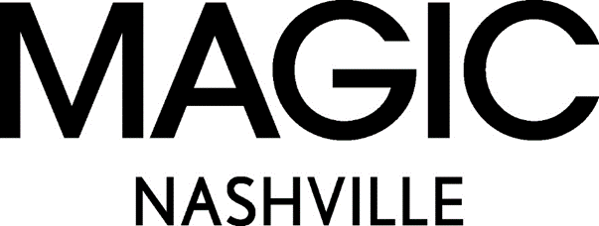

MAGIC Nashville Delivers on Demand for Mid-Season Shopping

Doubling in size and exhibitors, the latest in fashion was sure to be found with high-styled guests and vibrant energy on the show floor.

NEW YORK, NY / ACCESSWIRE / May 5, 2023 / MAGIC Nashville the young contemporary, modern sportswear and trend driven fashion event, completes its second annual tour to Music City. The April edition of MAGIC Nashville hosted large bustling buyer crowds for two full days of fashion, local music and fun-filled activations, at the Music City Center April 26-27.

MAGIC Nashville offered a curated assortment of brands across women’s apparel, footwear and accessories brands, with buyers raving for new finds, experience and unique discoveries. Top apparel brands included Dolce Vita, Aratta, Barefoot Dreams, Z-Supply, Free People, Minkpink and Rolla’s. Exhibiting footwear brands included Nashville native, Planet Cowboy and eco-conscious, Oncept. There was an assortment of accessories from handbags by Hobo to hats by Gigi Pip to jewelry by Brenda Grands Jewelry, there truly was something for everyone. Collaborations on the show floor included Flag & Anthem which highlighted the collection by Jessie James Decker and So Ill showcased the On The Roam footwear collection by Jason Mamoa.

"The April edition of MAGIC Nashville was vibrant and dynamic. You could feel the spirit of Nashville on the show floor from the beauty bar activations to the live music performances, attendees were engaged from the minute the show opened and stayed long after close." says Jordan Rudow, Vice President of MAGIC "Trends we saw on the show floor included denim on denim, biker girl, balletcore, vintage nostalgia wear and of course all types of boots. You can expect to see these trends hitting retail stores in Fall of 2023.”

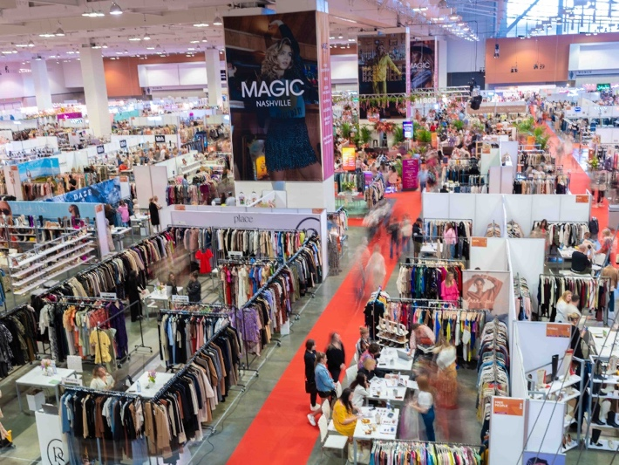
MAGIC Nashville, known for its community of influential retailers, boutique and specialty stores, delivered on brands’ demand for much-needed mid-season access to online and key regional retailers. Vici, Dillard’s, Lulu’s, Von Muar, Apricot Lane, Altar’d State, Everything but Water, Hemline Nashville, Scout and Molly’s and Tilly’s were in attendance among many other top retailers to shop upcoming collections for the Fall and Holiday deliveries.

“Thousands of buyers converged over the two-day MAGIC Nashville show.” says Kelly Helfman, President of Informa Markets Fashion “We have created a space unlike any other for MAGIC at this unique seasonal timing within the beautiful artistic city of Nashville and retailers and brands agree there is value at shopping mid-season in a more local, niche, intimate setting. This regional stop has quickly become the ‘must-attend’ event for a trend, young contemporary and modern sportswear fashion experience in the Southeast.”
MAGIC continues to provide the Nashville market with immersive entertainment, experiences and education with industry leaders like Jessie James Decker, Rachel McCord, founder of the McCord List, Kelly Helfman, President of Informa Markets Fashion and Jordan Rudow, Vice President of MAGIC all speaking on industry focused topics. To capture the full Nashville experience, MAGIC Nashville hosted live daily music from local performers on the stage in the heart of the show floor and attendees flooded the activation lounge for two full days to get makeup and hair touchups, permanent bracelets, custom hats and initial necklaces. MAGIC Nashville is where commerce, community and celebration truly come together.

MAGIC Nashville will return in the Spring of 2024 dates will be announced later this year. For more information on MAGIC fashion events, visit www.magicfashionevents.com

* The appearance of Jessie James Decker made through UTA Speakers, New York, NY.

About MAGIC:

MAGIC is a high-energy fashion experience and home to the industry's largest selection of trend-driven and young contemporary apparel, footwear, and accessories. Fusing scale with curation to drive commerce, creativity, and connections, MAGIC joins a global audience of retail buyers - from big-box to boutique - with influencers, media, and industry thought leaders. More than just events, MAGIC is a deeply rooted community, and a place brands and retailers call home. For more information, please visit: www.magicfashionevents.com.

About Informa Markets Fashion:
Informa Markets Fashion part of Informa Markets, a subsidiary of Informa plc (LON:INF) connects and inspires the global fashion community through online experiences, industry insights, and worldwide fashion trade events including MAGIC, COTERIE, PROJECT, and SOURCING at MAGIC. From more effective manufacturing and supply chain opportunities to a discovery of inspiring collections and the newest trends in apparel footwear and accessories, Informa Markets Fashion’s diverse portfolio supports the entire fashion ecosystem - fostering innovation and driving creativity year-round. For more information on upcoming events, please visit: www.findfashionevents.com

About Informa Markets:
Informa Markets, a subsidiary of Informa plc (LON:INF), creates platforms for industries and specialist markets to trade, innovate and grow. Our portfolio comprises more than 550 international B2B events and brands in markets including Engineering, Healthcare & Pharmaceuticals, Infrastructure, Construction & Real Estate, Fashion & Apparel, Hospitality, Food & Beverage, and Health & Nutrition, among others. We provide customers and partners around the globe with opportunities to engage, experience and do business through face-to-face exhibitions, specialist digital content and actionable data solutions. As the world's leading exhibitions organizer, we bring a diverse range of specialist markets to life, unlocking opportunities and helping them to thrive 365 days of the year. For more information, visit www.informamarkets.com.

Contacts:
Kristin Borland
Informa Markets Fashion
fashionpr@informa.com

