FireFox Gold Completes Step-out Drill Program and Reports Strong Cobalt Intercept at
Mustajärvi Gold Project, Finland

SODANKYLÄ, FINLAND – (June 14, 2023) – FireFox Gold Corp. (TSX.V: FFOX)(OTCQB: FFOXF)(“FireFox” or the “Company”) is pleased to announce that it has completed a drilling program at the newly discovered high-grade zone in the East Target of the Mustajärvi Project. The Company drilled nine (9) diamond core holes totalling 1540.6 metres during the short spring 2023 program. These drill holes were designed to infill gaps in the modelled near-surface gold shapes and test for significant extensions to the west and southwest (see Figure 1). The new holes included close offsets and downdip tests of the replacement style gold mineralization drilled in the East Target, but the drilling also included major step-outs of 80m and 220m along strike to the southwest. Assays of the drill core are in progress.
The Company has also received multielement geochemical analyses on the drill core from the fall 2022 drilling campaign. The most recent data are consistent with previous results from Mustajärvi drilling; the gold mineralization is consistently enriched in bismuth (Bi), tellurium (Te), molybdenum (Mo), selenium (Se), nickel (Ni), and cobalt (Co). Silver (Ag), arsenic (As), and copper (Cu) occur at relatively low levels at Mustajärvi. Cobalt is quite enriched at the East target, reaching maximum values of 0.497% and 0.461% over separate 1 metre samples in the 2022 drilling. Drill hole 22MJ021 recorded the strongest cobalt interval yet drilled, along with one of the best gold results as well (see Company news release dated January 18, 2023):
- 22MJ021: 15.5m at 13.09 g/t Au, 0.15% Co, and 143 ppm Te from 11.0m depth, including
  - 6.5m at 19.18 g/t Au, 0.27% Co, and 247 ppm Te from 20.0m depth.
FireFox’s CEO, Carl Löfberg, commented about the drilling at Mustajärvi, “This drill program is meant to reveal the potential scale of the gold system we have been drilling at Mustajärvi. The combination of careful structural measurements and detailed interpretation of geophysics directed the team to focus the step-out drilling along a northeast-southwest corridor. Our preliminary impressions are that the new drilling has been successful in extending the mineralized corridor to the southwest. The elevated cobalt that is associated with the gold is a recurring theme at Mustajärvi. While we know the cobalt occurs in pyrite, which is also correlated with the gold, there remains a lot of work to understand whether the cobalt could be economically recovered. We look forward to the receipt of the gold and multielement assays from this latest round of drilling.”
Mustajärvi Project and Drill Program Details
The Mustajärvi Project lies along the highway between the cities of Kittilä and Sodankylä, approximately 17 kilometres east of Kittilä. The property straddles the Mustajärvi Shear Zone (MSZ), a major right-lateral shear zone that has associated second and third-order structures which further dissect the project into separate structural zones. The Sodankylä Group rocks, which are primarily to the north of the shear zone in the footwall, include metamorphosed sedimentary and volcaniclastic rocks. Geophysics and drilling have identified an extensive corridor of albite – sericite alteration in the footwall along more than two kilometres of the structure. The project remains at an early stage as FireFox and predecessor companies have drilled approximately 14,158 metres to date.
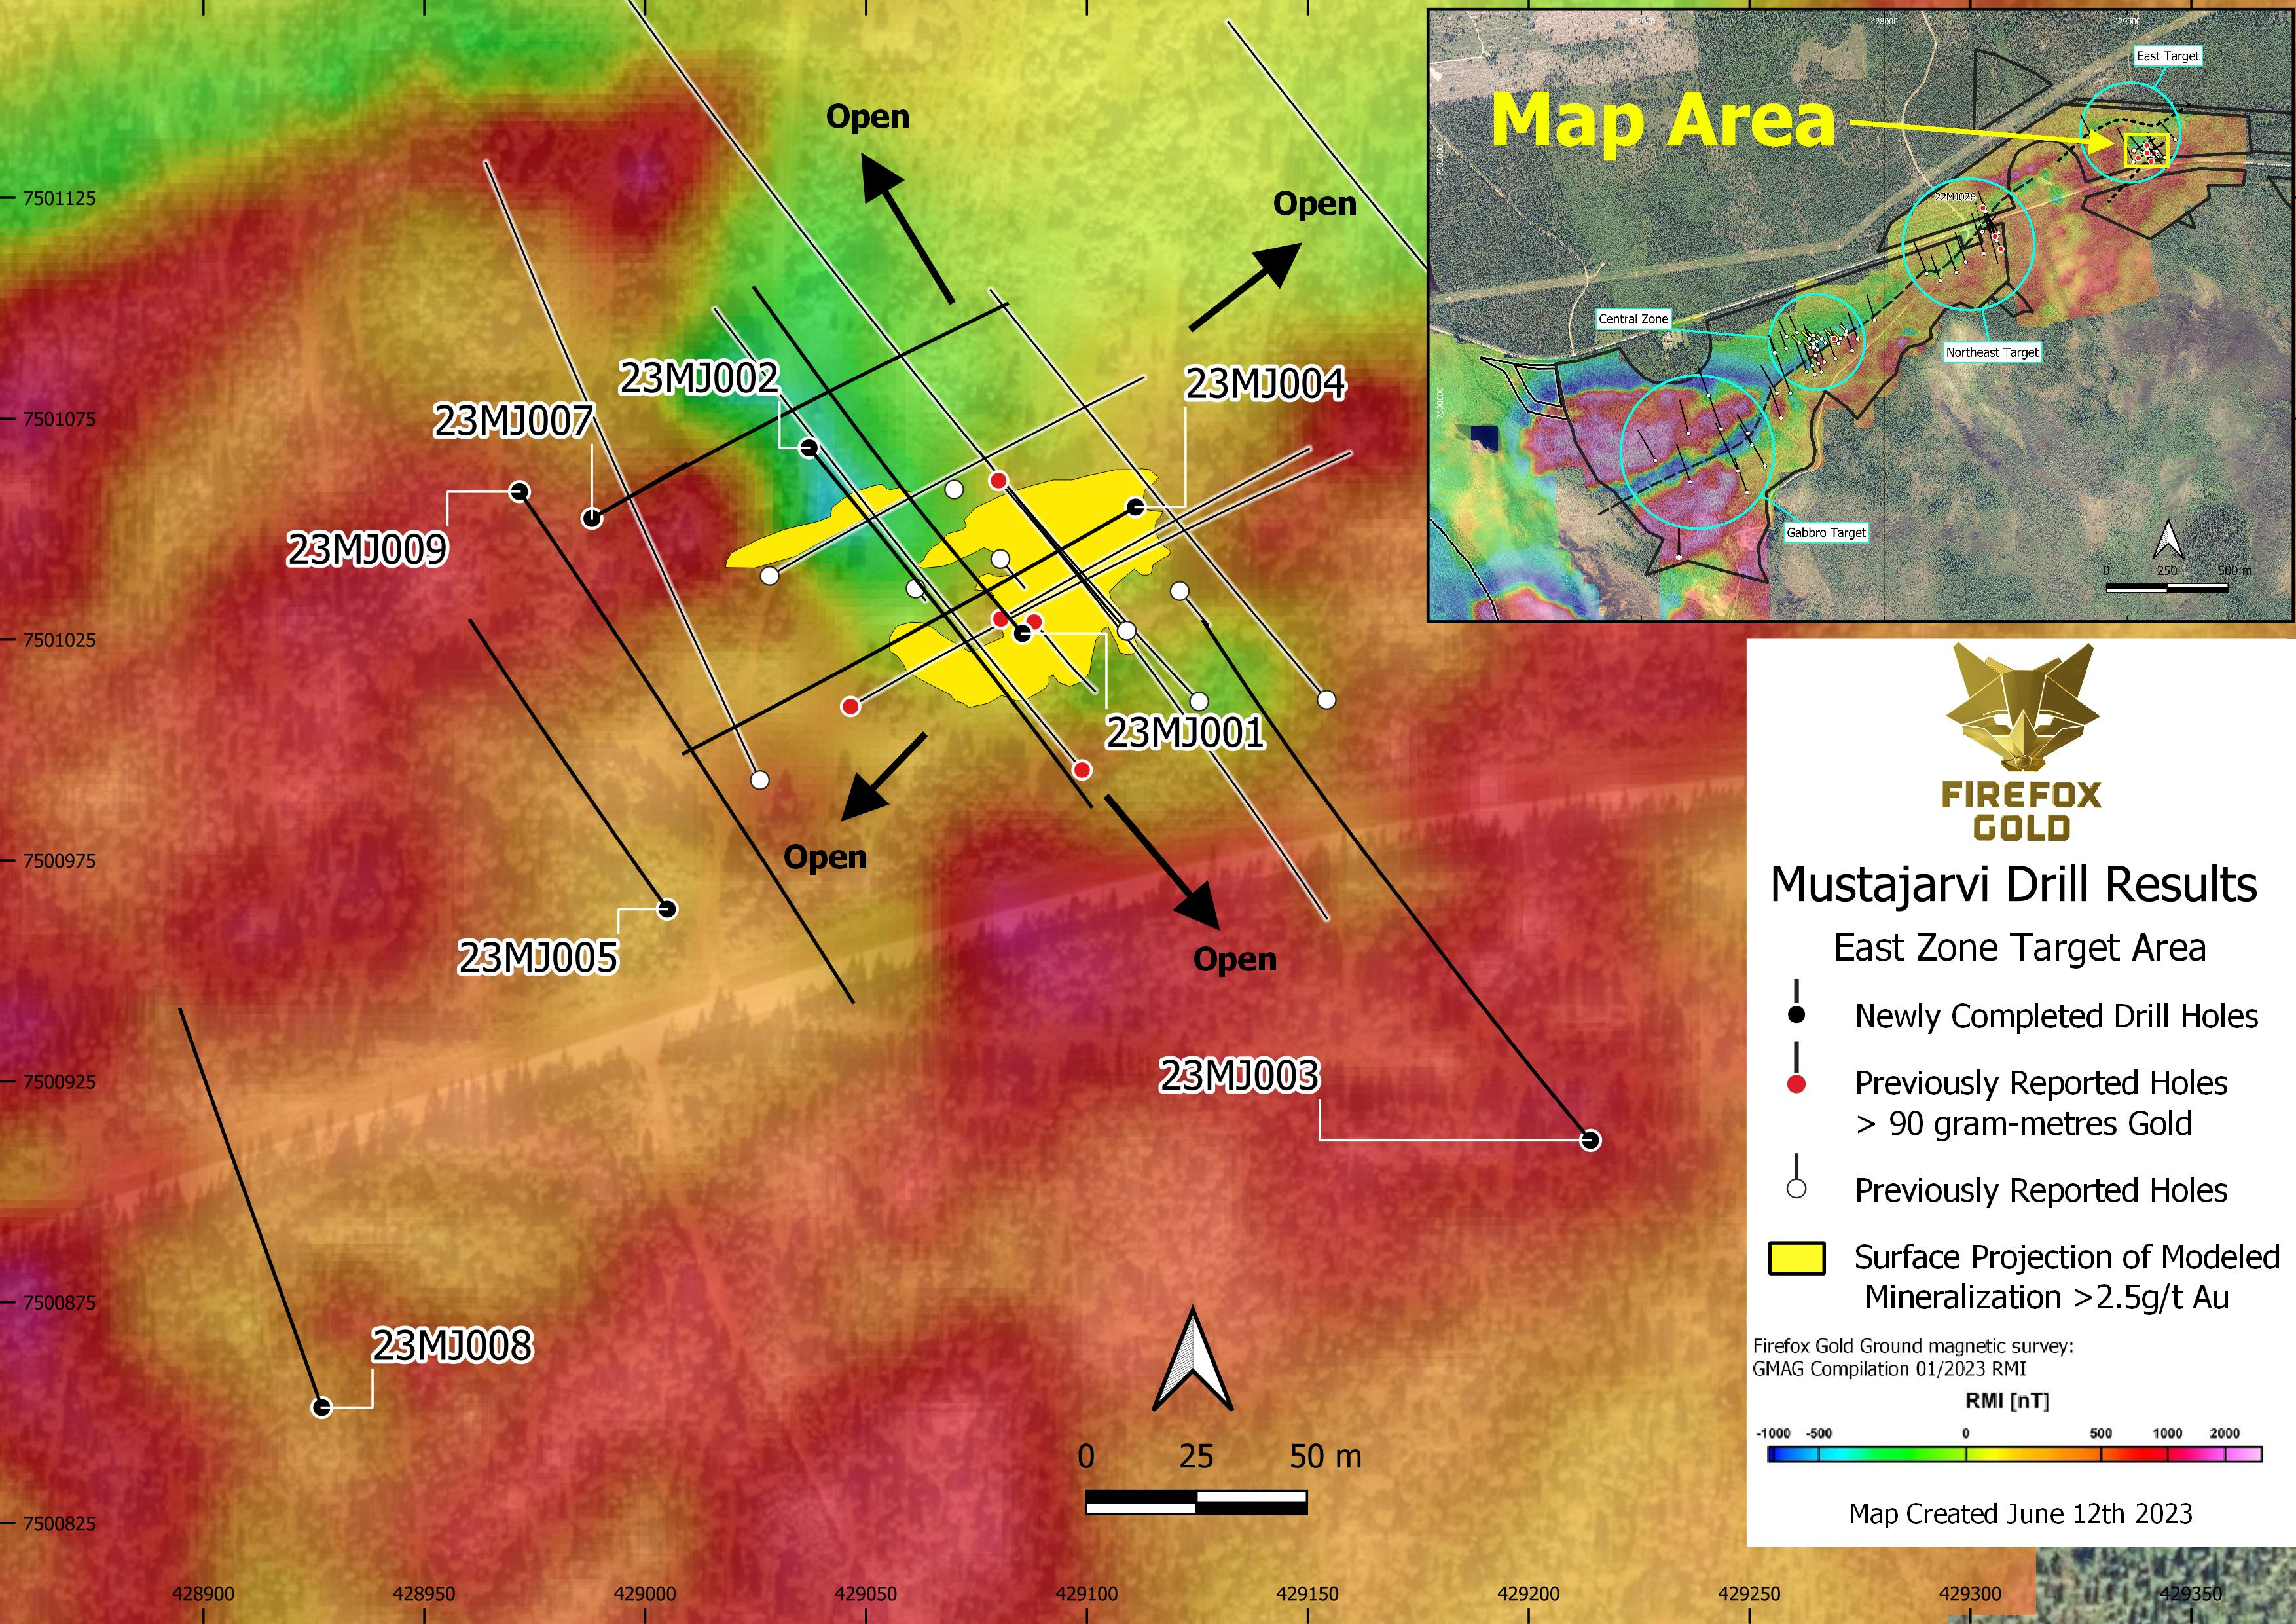
Figure 1 - Spring 2023 drilling campaign at Mustajärvi East Target - infill and step out holes.
FireFox’s structural model identified repetitive dilatant zones along the MSZ where vein swarms, replacement style, and higher-grade gold are concentrated. Three main areas of gold mineralization have been identified along a 2.1-kilometre segment of the MSZ, namely the Central Zone, the Northeast Target, and the East Target. The Central Zone and East Target have clear expressions of significant grade and thickness of gold mineralization at surface, whereas the gold at the Northeast Target is concentrated between 100 and 150 metres below surface. Folding and extensive faulting are in evidence, suggesting the potential for locating much more gold around and between these three widely spaced targets.
The spring 2023 drilling at Mustajärvi was focused on the East Target with a primary goal to extend known, shallow high-grade mineralization. FireFox geologists have collected structural geology evidence indicating that a primary control on the East Target mineralization trends to the southwest. The detailed ground magnetics also revealed a subtle corridor of less magnetic rocks trending to the southwest beneath the highway. There is also a chargeability anomaly in the area, immediately SW of the latest drilling, that may mark the presence of sulphide minerals. The high chargeability zone strikes northeast and dips to the southeast, subparallel with the inferred lithological contact and slightly oblique to the MSZ. The nature of the elevated chargeability was untested until this drill program. The drilling was targeted based on a combination of FireFox’s 3D geological model, structural geology, and geophysics. Due to the near-surface nature of the high-grade target in this area, most of the drill holes in this program were shallow (See Table 1).
Drill holes 23MJ001 and MJ002 were aimed at the western side of the shallow high-grade replacement style mineralization and downdip extensions of the Riedel veins that often host high-grade gold. 23MJ001 undercut a bonanza grade intercept in 22MJ024 (3.4m at 50.91 g/t Au from 91.8m depth), which was reported on February 15, 2023. Both of these holes evaluated the downdip continuation of the thicker replacement style zones of mineralization in the centre of the East Target.
The team stepped out over 100m to the south with drill hole 23MJ003, which was aimed back to the northwest to probe for a key lithologic contact and shear zone. Drill hole 22MJ025 had intercepted narrow intercepts of 14.53 and 8.75 g/t gold at depth, but it failed to reach the shear zone (see Company news release dated February 15, 2023). The FireFox geological model predicts that jogs in the sheared contact between the Sodankylä group and Savukoski group rocks are associated with the strongest gold occurrences along the shear zone. The new drill hole passed through the contact at the approximate depth predicted. The shear zone has now been drilled over a strike length of more than 2.2km despite numerous complex jogs and displacements in the feature.
Drill holes 23MJ004 and 23MJ007 are drilled along a northeast-southwest direction, roughly parallel to the MSZ. This alternative direction of drilling yielded excellent results during a first test, as reported in the January 2023 FireFox news release. In this area, there is a well-developed zone of thicker replacement style mineralization that comes very close to surface and is interpreted to plunge to the southwest. Drill hole 23MJ007 cuts across an interpreted structure and passes through a strong magnetic low on the northwest of the known gold zone. These holes could offer meaningful extensions to the heart of the East Zone mineralization. Drill hole 23MJ006 was lost due to drilling difficulties and replaced with 23MJ007.
Drill holes 23MJ005 and MJ009 were drilled along northwest-southeast section lines, separated by approximately 20 metres. One hole was aimed to the northwest and the other to the southeast in order to test both shallow and deeper portions of the combined IP chargeability and magnetic anomaly that extends west from the East Target.
The team executed a bold step-out drill hole with 23MJ008. It was collared approximately 120 metres southwest from 23MJ005 and more than 220 meters southwest from 22MJ022. The structural geology and apparent controls on the shallow high-grade parts of the East Target appear to indicate a southwest plunge. That pattern is echoed by the complex patterns seen in the detailed ground magnetics. This drill hole was directed at crosscutting the prevailing shear direction and testing a new corridor of low magnetics that may define another zone of alteration.
Firefox Gold geologists are actively working with the new drill core, logging geology, and making measurements. Samples are still being delivered to the laboratory and assays are pending for all of this drilling. More information can be expected during the coming weeks.

Table 1. Mustajärvi Spring 2023 Collar Information (coordinates presented in EPSG:3067).
Drill Hole | Easting | Northing | Azimuth (°) | Plunge (°) | Final Depth (m)
23MJ001 | 429085 | 7501026.4 | 320 | 60 | 188
23MJ002 | 429037 | 7501068.4 | 140 | 50 | 151.7
23MJ003 | 429214 | 7500911.7 | 320 | 60 | 284
23MJ004 | 429111 | 7501055 | 240 | 50 | 175.4
23MJ005 | 429005 | 7500964 | 325 | 60 | 152.1
23MJ006 | 428990 | 7501053.5 | 60 | 50 | 32.1 (failed)
23MJ007 | 428988 | 7501052.4 | 60 | 50 | 168.9
23MJ008 | 428927 | 7500851.2 | 340 | 60 | 194.4
23MJ009 | 428972 | 7501058.5 | 145 | 45 | 194

Methodology & Quality Assurance
The multielement analytical results reported herein are from drill core samples processed by ALS Laboratories. After receipt of gold assays, the FireFox team selects subsets of samples to be subjected to multielement geochemical analyses. These data are reported from ALS – Ireland using a four-acid digestion followed by ICP-AES and ICP-MS analyses (method ME-MS61).
ALS Laboratories is a leading international provider of assay and analytical data to the mining industry. All ALS geochemical hub laboratories, including the Irish facility, are accredited to ISO/IEC 17025:2017 for specific analytical procedures. The Firefox QA/QC program consists of insertion of blind certificated standard material and blanks into the analytical batches, and results reported here did not show deviations from recommended values.
Patrick Highsmith, Certified Professional Geologist (AIPG CPG # 11702) and director of the Company, is a qualified person as defined by National Instrument 43-101. Mr. Highsmith has helped prepare, reviewed, and approved the technical information in this news release.
Dr. Sven Hönig, Certified European Geologist (EFG EurGeol Title # 1789) and General Manager - Exploration of the Company, is a qualified person as defined by National Instrument 43-101. Dr. Hönig has supervised the field work reported herein and has helped to prepare and approves the technical information in this news release.
About FireFox Gold Corp.
FireFox Gold Corp is listed on the TSX Venture Stock Exchange under the ticker symbol FFOX. FireFox also trades on the OTCQB Venture Market Exchange in the US under the ticker symbol FFOXF. The Company has been exploring for gold in Finland since 2017 where it holds a huge portfolio of prospective ground.
Finland is one of the top mining investment jurisdictions in the world as indicated by its multiple top-10 rankings in recent Fraser Institute Surveys of Mining Companies. Having a strong mining law and long mining tradition, Finland remains underexplored for gold. Recent exploration results in the country have highlighted its prospectivity, and FireFox is proud to have a Finland based CEO and technical team.
For more information, please refer to the Company’s website and profile on the SEDAR website at www.sedar.com.

On behalf of the Board of Directors,

“Carl Löfberg”
Chief Executive Officer

CONTACT:
FireFox Gold Corp.

Email: info@firefoxgold.com

Telephone: +1-778-938-1994

Forward Looking Statements
The information herein contains forward looking statements that are subject to a number of known and unknown risks, uncertainties and other factors that may cause actual results to differ materially from those anticipated in our forward-looking statements. Factors that could cause such differences include changes in world commodity markets, equity markets, costs and supply of materials relevant to the mining industry, changes in government and changes to regulations affecting the mining industry.
Forward-looking statements in this release may include statements regarding: evolving geological interpretations; continuity of geological targets; timing for completion of assays; intent to conduct additional drilling; belief as to the location of the most prospective gold targets; the location of targets for future drill programs; and the scale and scope of the current and future work program, including the extent and nature of exploration to be conducted in 2023. Although we believe the expectations reflected in our forward-looking statements are reasonable, results may vary.
The forward-looking statements contained herein represent the expectations of FireFox as of the date of dissemination and, accordingly, are subject to change after such date. Readers should not place undue importance on forward-looking statements and should not rely upon this information as of any other date. FireFox does not undertake to update this information at any particular time except as required in accordance with applicable laws.

