$BioFi Interactive Announcement - BioFi and HVACRedu.net Introduce Groundbreaking HVACR Training Experience

20 June, 2023 6:00 AM
Share this Article

Topic:

Finnovant Develops Immersive HVACRedu.net training with BioFi Interactive

WELDON SPRING, MO / ACCESSWIRE / 20 June 2023 /
Finnovant Inc, parent of BioFi Interactive, and HVACRedu.net, join together to revolutionize virtual training and certification in the HVACR industry

Finnovant Inc, a leading fintech company specializing in biometric authentication solutions and hyper-detailed and lifelike 3D virtual spaces, has partnered with HVACRedu.net, the leading online training and certification program for heating, ventilation, air conditioning, and refrigeration (HVACR) in North America.

The launch of virtual lifelike education at HVACRedu.net, dubbed ‘BioFi Interactive’ will bring significant benefits to the HVACR technicians, by providing immersive training that is more effective and engaging with advances in innovation and technology. Student technicians will have the ability to conduct realistic diagnoses and repairs with their computer in a 3D environment before being deployed to the field, providing them with a realistic learning experience, and real-world machine-level knowledge.

“As the premier HVACR online training program in North America, we are thrilled to partner with Finnovant to deliver advanced immersive training in a 3D environment,” says Chris Compton, Founder and CEO HVACRedu.net. “This engaging and innovative training will make it much easier for students to learn how to diagnose and repair HVAC systems from the comfort of their own homes. Field work will be more productive and cost-effective as the student has previously mastered the diagnosis and repair in an immersive virtual environment.”

One of the key benefits of lifelike education will ensure the next crop of HVACR technicians are highly skilled and trained to be effective the first day they are hired. In addition to making training more effective and engaging, students will be encouraged to participate in the BioFi ecosystem which provides access to decentralized financial services through a digital wallet, named Krptic, and management of their most sensitive personal information on the blockchain with the UniSafeBox password manager. The current generation of HVACR technicians have grown up with mobile devices, PCs, and the internet and have expressed a keen interest in this new method of training, demonstrating the potential for the technology to transform the HVACR industry.

HVACRedu.net is planning to also leverage Finnovant's biometric enrollment during the student registration process and during HVACR module testing, which will help ensure that the student who registers is the same one who takes the exam, providing a secure and reliable certification process. Technicians who satisfactorily complete all educational and certification requirements will be issued a unique NFT (Non-fungible token) on the blockchain.

"We are excited to work with HVACRedu.net to revolutionize training in the HVACR industry," said Brian Maw, CEO of Finnovant. "By leveraging our expertise in biometric authentication and hyper-realistic 3D technology, we believe every person can benefit from an unparalleled training experience.” “HVACRedu.net's future generation of technicians will find this new learning environment quite engaging, and we are very excited that a whole new crop of technicians will join the HVACR industry to take advantage of this leap in innovation"

Calling all HVACR Technicians, educators, and virtual reality enthusiasts!

Don't miss out on an exciting opportunity to be part of the ESCO Institute launch of HVACRedu.net immersive training on the HVAC Show, "Did You Know?" hosted by Clifton Beck on June 22nd at 1 PM Eastern. We are thrilled to launch this game-changing platform that aims to revolutionize virtual training and certification in the HVACR industry. This auspicious event will bring together industry professionals to explore cutting-edge techniques, share knowledge, and shape the future of HVACR education. Join us as we embark on this transformative journey and unlock new possibilities for learning advancement. Mark your calendars and be ready to take part in this groundbreaking event!
https://www.youtube.com/live/7nNjaXUeltA?feature=share

For more detailed information regarding HVACR immersive training and landing pages, please visit:

HVACRedu.net website: https://www.hvacredu.net/
HVACRedu.net Landing page: https://www.hvacredu.net/3d-interactive-training/
Biometric Financial website: https://biometricfinancial.org/
BioFi HVACR Landing Page: https://interactive.biometricfinancial.org/
Finnovant website: https://www.finnovant.com/

About HVACRedu.net

About HVACRedu.net
Launched in 1997, HVACRedu.net leads the nation by providing quality online workforce training programs for the HVACR and related industries through structured effective student learning and prompt exceptional customer service. Our vision is to transform the HVACR and related industries into a learning community where state and nationally recognized industry licenses and certifications are achievable and maintained; where new workers enter the industry through a structured employer-sponsored corporate training program; and where technicians have a place to continue to upskill their knowledge in keeping with new equipment, energy efficiencies, methods, and technologies.
Follow HVACRedu.net online at HVACRedu.net, Instagram, Facebook, LinkedIn


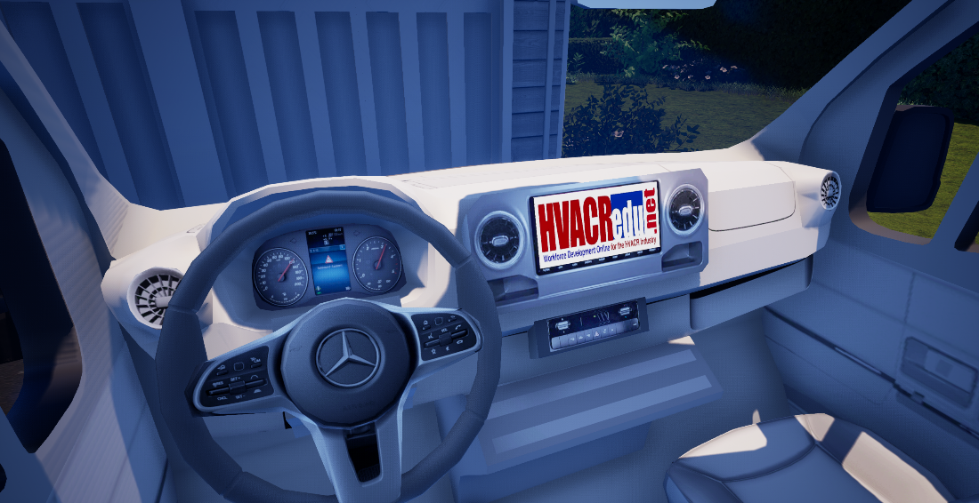
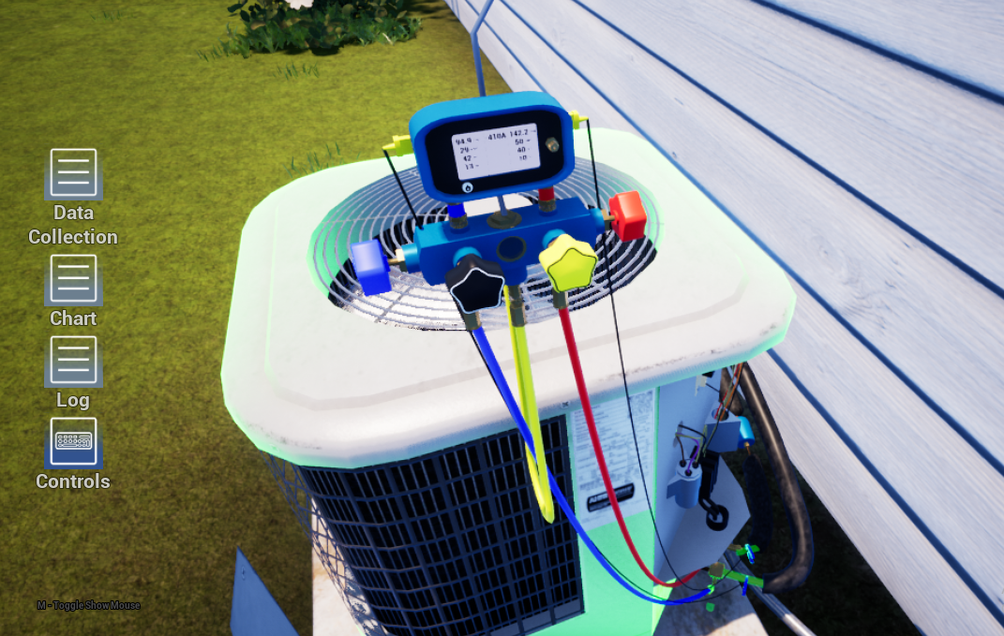
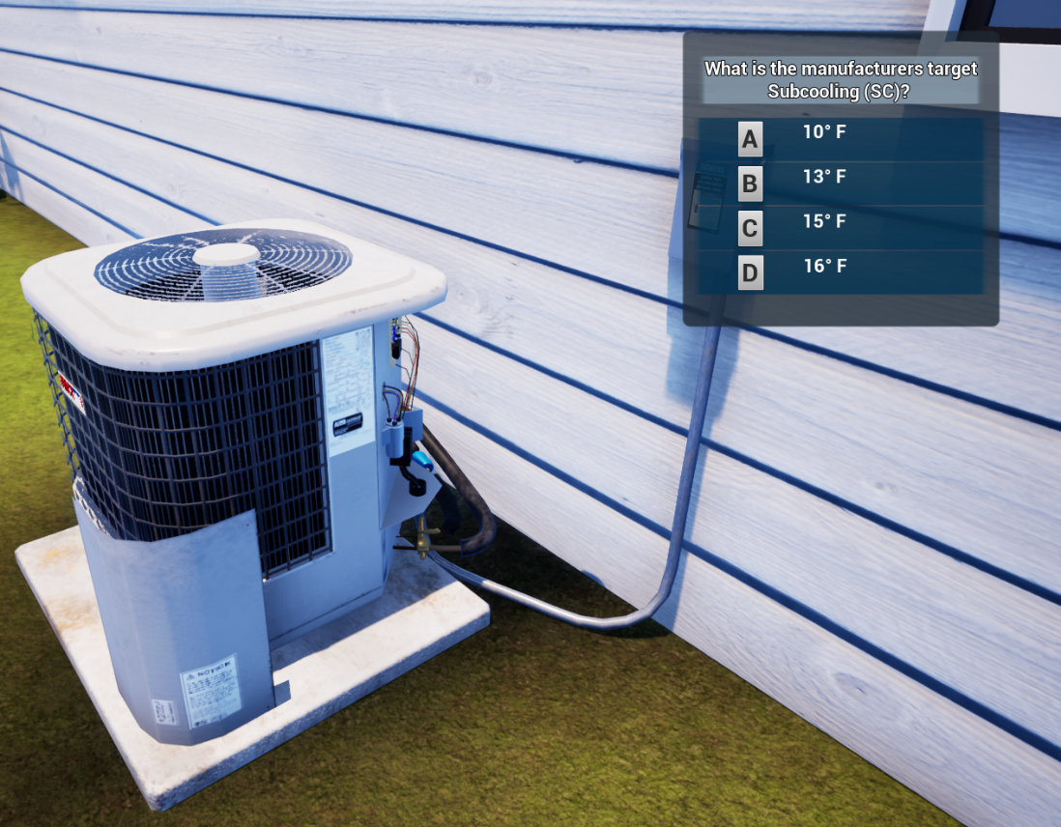
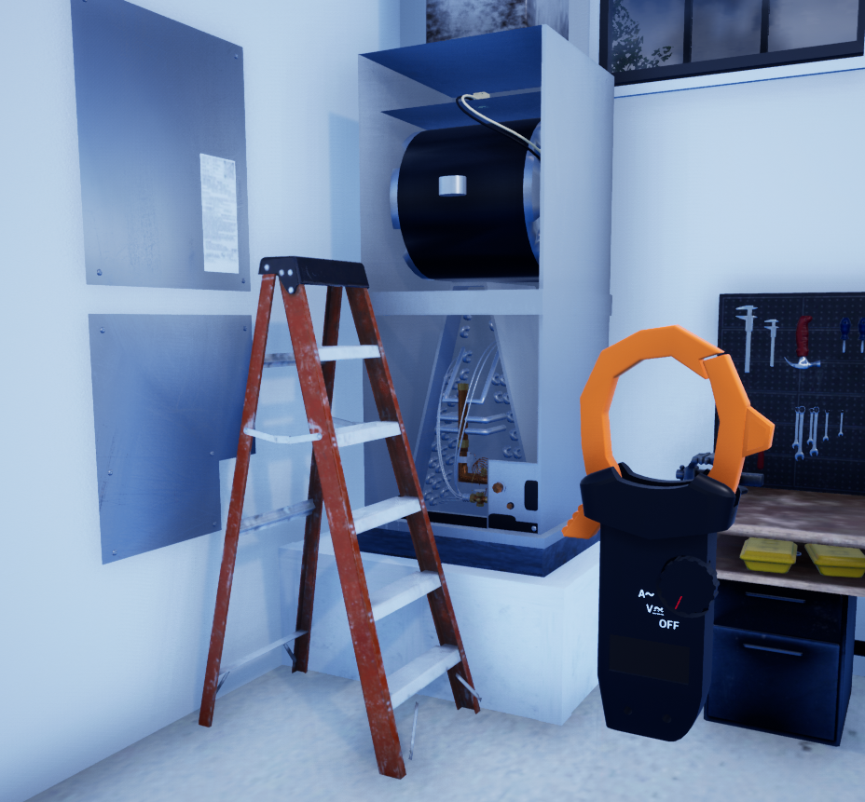

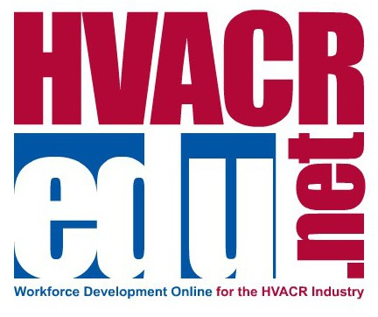


Biometric Financial website: https://biometricfinancial.org/home/

About Finnovant

Finnovant Inc. was founded with the vision of helping business leaders dramatically improve the way they interact with their critical information and customers. Our focus is on developing emerging technologies with secure blockchain solutions in the areas of Financial Services, Governance, IoT, Healthcare, and more and improving digital security for our customers. Finnovant provides biometric authentication which helps thwart Identity Theft and Fraud.

Follow Finnovant at Finnovant.com, Twitter, LinkedIn, Facebook, Instagram, Telegram, Discord

Chris Benedict
Finnovant, Inc.
1-844-724-8911
cbenedict@finnovant.com




