
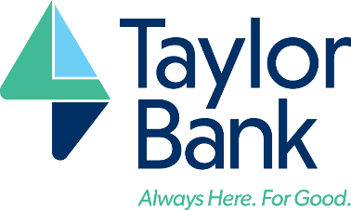

Calvin B. Taylor Bankshares, Inc. Reports Second Quarter 2023 Financial Results
Berlin, Maryland (September 12, 2023) – Calvin B. Taylor Bankshares, Inc. (the “Company”) (OTCQX: TYCB), the holding company of Calvin B. Taylor Bank (the “Bank”), today reported unaudited financial results for the second quarter ended June 30, 2023. Highlights of the Company’s financial results are noted below.
- Net income for the six months ended June 30, 2023 was $6.6 million which is a 33.0% increase compared to the same period in 2022.
- Quarterly net income increased 22.5% to $3.3 million for the 2nd quarter of 2023 as compared to the 2nd quarter of 2022 and was the same as the previous quarter.
- Net interest income increased by $3.3 million, or 29.1%, in the six months ended June 30, 2023 as compared to the same period in 2022.
- Net interest margin increased to 3.55% in the first quarter of 2023, as compared to 2.85% in the 2nd quarter of 2022 and 3.51% in the 1st quarter of 2023.
- Organic loan growth continued in 2023 with loans growing $47.0 million, or 9.2%, since December 31, 2022. Loans have increased $70.7 million, or 14.4%, in the twelve months ended June 30, 2023.
- Following several years of significant growth, deposits decreased by $43.0 million or 5.2% in the previous 12 months which resulted in total assets decreasing by $38.8 million, or 4.2% since June 30, 2022.
- Deposits decreased by $24.7 million or 3.0% since December 31, 2022 as a result of seasonal deposit decreases and outflows of other deposits that are earning higher interest rates currently offered by short term government bond investments. The Company did not experience any significant outflow of uninsured deposits during the six months ended June 30, 2023.
- On-balance sheet liquidity, as measured by cash and unencumbered available for sale debt securities, remains strong as of June 30, 2023 and equaled 29.0% of total deposits.
- Noncore funding sources including Federal Home Loan Bank borrowings, brokered deposits, and the recently created Federal Reserve Bank Term Funding Program were not utilized in the six months ended June 30, 2023.
President and Chief Executive Officer Raymond M. Thompson remarked, “The Company continued to demonstrate strong financial performance through the second quarter 2023. Year to date net income was $6.6 million, an increase of 33% over the prior year. The combination of ongoing organic loan growth and improvement in net interest margin are continuing to contribute to higher earnings. As of June 30, 2023, net loans had increased to $560 million or 14.4% over the prior year, and year to date net interest margin improved to 3.53% or 32.0% higher than last year. Due to modest deposit run-off, total assets decreased to $866.3 million at June 30, 2023, as compared to $925.1 million at June 30, 2022. While the bank offers competitive deposit rates as compared to the local market, as of the result of the current interest rate environment, some rate sensitive depositors have taken advantage of current yields offered through U.S. Treasury securities and other non-traditional investment options. On-balance sheet liquidity remained strong at 29% of total deposits as of June 30, 2023, and the bank had no need to access other non-core funding or other contingency funding sources during the period. We monitor this closely, and remain highly liquid, well-capitalized and ready to meet the loan and deposit needs of the communities we serve.”

Quarterly Results of Operations
Quarterly net income was $3.29 million for the second quarter ended June 30, 2023 (“2Q23”), as compared to $2.68 million for the second quarter ended June 30, 2022 (“2Q22”) and $3.33 million for the first quarter ended March 31, 2023 (“1Q23”). A summary of the quarterly results of operations are included in the table and comments that follow.
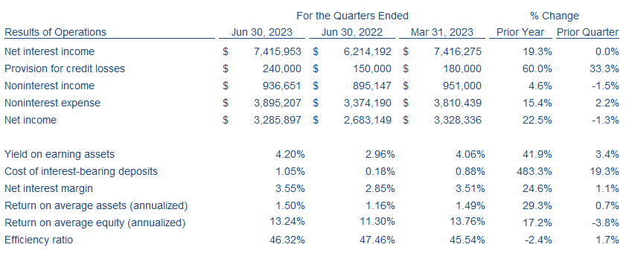

Net interest income increased $1.2 million or 19.3% in 2Q23, as compared to 2Q22, which is attributable to organic loan growth and higher yields on debt securities, fed funds sold and loans. The Federal Reserve Bank has increased fed funds rates 350 bps since June 30, 2022, which has increased yields on debt securities and fed funds sold from 1.12% in 2Q22 to 2.79% in 2Q23 and also increased yields on loans from 4.45% to 4.89% in the same period. Interest revenue from loans increased $1.5 million in 2Q23, as compared to 2Q22, due to higher yields and a 17.0% increase in average loan balances in the same period. Costs of interest-bearing deposits increased 87 bps in 2Q23 as compared 2Q22. Net interest income of $7.4 million was unchanged from the previous quarter as higher interest revenue from interest-earning assets in 2Q23 offset the increase in the costs of interest bearing deposits in the same period. Yields on earning-assets increased to 4.20% in 2Q23, as compared to 4.06% in 1Q23, as the Federal Reserve increased fed funds rates an additional 75 bps since March 23, 2023. Loan growth also contributed to the increase in the yield on earning-assets as debt securities and fed funds sold were redeployed into higher yielding loans during 2Q23.

On January 1, 2023 the Company adopted the current expected credit losses (“CECL”) model pursuant to ASU 2016-13. The estimate of expected credit losses considers historical information, current information, and supportable forecasts, including estimates of prepayments. The provision for credit losses of $240 thousand recorded in 2Q23 was primarily the result of growth in the loan portfolio during the same period. No significant changes in the economic indicators and related forecasts utilized in the CECL model were noted in 2Q23. The provision for credit losses of $150 thousand in 2Q22 and $180 thousand in 1Q23 were also the result of growth in the loan portfolio during those periods.

Noninterest income increased in 2Q23 by $42 thousand or 4.6%, as compared to 2Q22, due to a $69 thousand increase in income from bank owned life insurance. Noninterest income decreased in 2Q23 by $14 thousand or 1.5%, as compared to 1Q23, due to an increase in realized losses on available for sale debt securities. Realized losses of $58 thousand were recorded in 2Q23 related to the sale of lower-yielding debt securities at a loss so proceeds could be reinvested into new securities or fund loans at substantially higher yields to maximize future interest revenue.

Current quarter noninterest expense increased by $521 thousand or 15.4%, as compared to 2Q22, and is a result of increases in employee benefits expenses by $308 thousand. Employee health insurance is provided through a partially self-funded plan and claims incurred by the plan were higher in 2Q23, as compared to 2Q22, resulting in the increase in employee benefits costs. Noninterest expense increased in 2Q23 by $85 thousand or 2.2%, as compared to the previous quarter, which primarily relates to higher salaries and benefits expenses.

Quarterly per share data and repurchases of stock by the Company for each period is included in the following table. The stock repurchase plan previously adopted by the Board of Directors remains in place and as of June 30, 2023 has 53,628 shares available to be repurchased. The amount and timing of future stock repurchases will depend upon several factors including regulatory capital requirements, market value of the Company’s stock, general market and economic conditions, liquidity, and other relevant considerations, as determined by the Company.
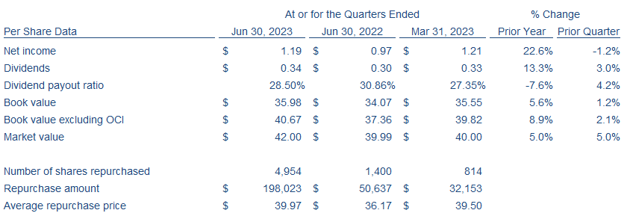
Year to Date Results of Operations
Net income was $6.6 million for the six months ended June 30, 2023 as compared to $5.0 million for the six months ended June 30, 2022, an increase of $1.6 million or 33.0%. A summary of the year to date results of operations are included in the table and comments that follow.
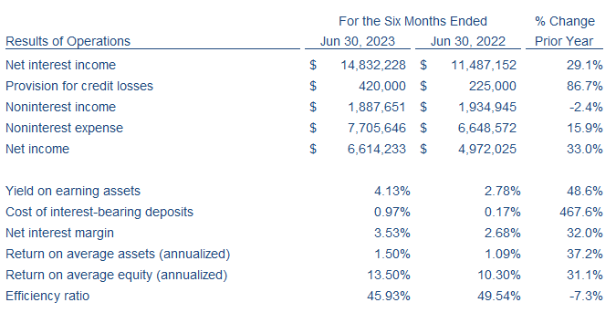
Net interest income increased $3.3 million or 29.1% for the six months ended June 30, 2023, as compared to same period last year, and was attributable to organic loan growth and higher yields on debt securities, fed funds sold and loans. The Federal Reserve Bank has increased fed funds rates 350 bps since June 30, 2022, which has increased yields on debt securities, fed funds sold, and loans. Organic loan growth combined with higher yields increased interest revenue from loans by $2.8 million or 27.8% for the six months ended June 30, 2023, as compared to the same period in the prior year. Interest revenue from debt securities and fed funds sold increased by $2.6 million or 144.9% for the six months ended June 30, 2023, as compared to the same period in 2022. Loan balances increased $70.7 million or 14.4% since June 30, 2022 and the growth was primarily funded by decreases in debt securities and fed funds sold which decreased by $110.6 million or 27.9% in the same period. Costs of interest-bearing deposits increased by 80 bps for the six months ended June 30, 2023 as compared to the six months ended June 30, 2022. Deposit rates have been increased over the last 12 months to remain competitive in local markets and to preserve on-balance sheet liquidity.

On January 1, 2023 the Company adopted the CECL model pursuant to ASU 2016-13. The estimate of expected credit losses considers historical information, current information, and supportable forecasts, including estimates of prepayments. The provision for credit losses of $420 thousand recorded for the six months ended June 30, 2023 was primarily the result of growth in the loan portfolio during the same period. No significant changes in the economic indicators and related forecasts utilized in the CECL model were noted in 2023.

Noninterest income for the six months ended June 30, 2023 decreased by $47 thousand or 2.4%, as compared to the six months ended June 30, 2022, due to a decrease in income from death proceeds of bank owned life insurance policies. Nonrecurring income of $276 thousand was recognized in the 1st quarter of 2022 related to death proceeds of bank owned life insurance policies. Increases in realized losses on disposition of debt securities also reduced noninterest income by $59 thousand when comparing the same periods. Restructuring of the debt securities portfolio in 2023 resulted in the sale of lower-yielding debt securities at a loss so proceeds could be reinvested into new securities or fund loans at substantially higher yields to maximize future interest revenue. Increases in other sources of noninterest income including service charges on deposits, debit card interchange fees, and deposit network placement fees partially offset the aforementioned decreases in noninterest income.

Noninterest expense for the six months ended June 30, 2023 increased by $1.1 million or 15.9%, as compared to the same period in 2022, and is primarily the result of increases in employee salaries, employee benefits expenses, and deposit insurance premiums assessed by the FDIC. Higher salaries expense relates to the fulfillment of open positions and higher salaries paid to remain competitive in the current labor market and resulted in a 6.7% increase in year to date salaries expense compared to the prior year. Employee health insurance is provided through a partially self-funded plan and year to date claims incurred by the plan were higher in 2023, resulting in the increase in year to date employee benefits costs by 73.0% in 2023. Claims incurred by the plan in the six months ended June 30, 2022 were well below average and resulted in low expenses during this period. Deposit insurance premiums increased by $76k or 63.0% for the six months ended June 30, 2023, as compared to the same period last year, and is the result of a change in the FDIC assessment calculation effective January 1, 2023. The bank is subject to the minimum deposit insurance assessment imposed by the FDIC as a result of strong levels of capital and other regulatory measurements. The changes implemented by the FDIC resulted in the increase of the minimum assessment from 3 bps to 5 bps which is a 66.6% increase.

Per share data and repurchases of stock by the Company for each period is included in the following table.
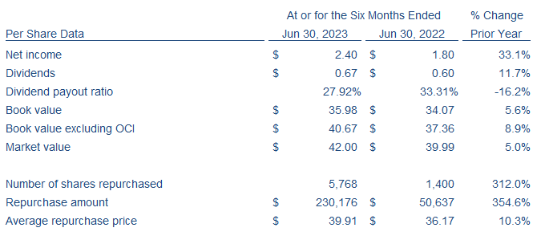

Financial Condition
Recent disruption in the banking industry has highlighted the importance of deposit insurance, core deposits, liquidity and capital. The Company relies mostly on core deposits, as defined by bank regulators, which are gathered from customers in local markets. The Company and the Bank remain well-capitalized according to regulatory capital standards and exceed the threshold to be considered well-capitalized (Community Bank Leverage Ratio) by 40% as of June 30, 2023. The Company’s financial condition at quarter end is summarized in the table and comments that follow.
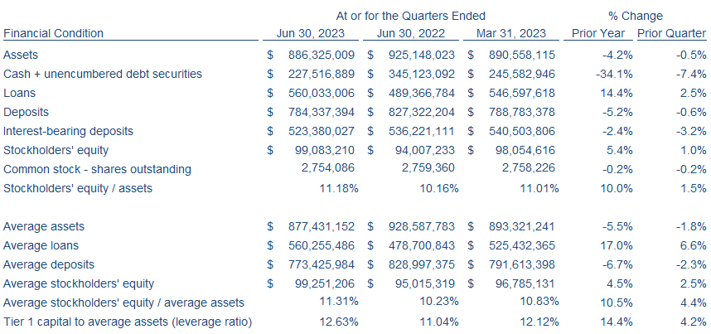
Following several years of significant growth, deposits decreased by $43.0 million or 5.2% in the previous 12 months which resulted in total assets decreasing by $38.8 million, or 4.2% since June 30, 2022. Significant increases in short term interest rates have encourage certain depositors to invest excess cash into short term government bonds resulting in a decrease in deposits. During the six months ended June 30, 2023, deposits decreased by $24.7 million or 3.0% as a result of seasonal deposit decreases and outflows of other deposits seeking higher yields from short term government bonds. The Bank operates with a high level of core deposits. Core deposits are defined by banking regulators as checking, money market, and savings accounts plus any time deposits less than $250,000. Bank failures earlier this year have increased the focus on concentrations of uninsured deposits. All deposit accounts with a balance in excess of the FDIC insurance limit of $250,000 are disclosed on quarterly regulatory reports filed with bank regulators. As of June 30, 2023, the Bank had deposit accounts with balances in excess of $250,000 totaling $222.0 million which represents 28.3% of total deposits, as compared to $229.0 million or 29.0% of total deposits as of March 31, 2023 and $258.9 million or 33.0% as of December 31, 2022. The Company did not experience any significant outflow of uninsured deposits during the six months ended June 30, 2023. The Bank is a member of the IntraFi Network which enables large depositors with access to multi-million dollar FDIC insurance for funds placed into the network and provides an equal amount of reciprocal deposits under FDIC insurance limits to the bank. Recent events in the banking industry led to an increase in usage of the IntraFi Network by existing and new customers. Reciprocal deposits from the IntraFi Network were $93.8 million as of June 30, 2023, as compared to $93.9 million and 82.8 million as of March 31, 2023 and December 31, 2022, respectively.

On-balance sheet liquidity, as measured by cash and unencumbered available for sale debt securities, remains strong as of June 30, 2023 and equaled 29.0% of total deposits. Selected liquidity metrics are summarized in the table below.
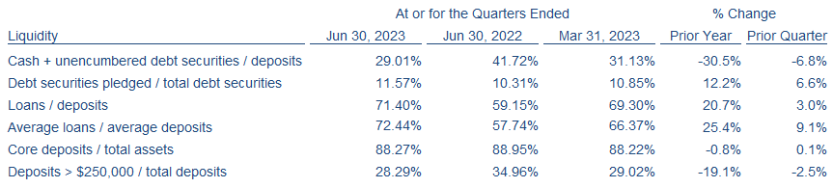

Noncore funding sources are available to the Bank but are intended for contingency funding needs and not to pursue growth. As of June 30, 2023, the Bank has the ability to borrow up to $204.1 million from the Federal Home Loan Bank (“FHLB”) that would require pledging of loans and/or debt securities as collateral. Debt securities currently pledged are collateral for public deposits.

Loans and Asset Quality
Increasing interest rates, economic uncertainty and other factors have impacted current loan demand as compared to demand experienced in the previous 12 months. Conversely, funding of previously committed construction loans, localized demand for commercial and residential real estate loans, and seasonal borrowings during the first six months of 2023 resulted in continued organic loan growth with loans increasing $47.0 million or 9.2% since December 31, 2022. Loan growth of $70.7 million or 14.4% in the previous 12 months was the result of strong demand for local real estate and borrowers seeking to lock in lower interest rates as the Federal Reserve engaged in aggressive interest rate increases during the same period. Growth in the loan portfolio during the rising interest rate environment over the last 12 months along with variable rate loans within the portfolio has expanded the yield on loans from 4.45% in 2Q22 to 4.89% in 2Q23. Loan yields increased 16 bps in 2Q23 as compared to 1Q23.

Loan performance has remained strong over the past 12 months as local economic conditions have remained stable. Inflation and higher interest rates have not resulted in a deterioration of credit quality as of June 30, 2023. The increase in the allowance for credit losses from 0.45% of total loans as of June 30, 2022 to 0.62% of total loans as of June 30, 2023 was primarily related to adoption of the CECL model pursuant to ASU 2016-13 on January 1, 2023. The adoption of the CECL model resulted in an increase in the allowance for credit losses of $826 thousand. Selected asset quality metrics are summarized in the table below.
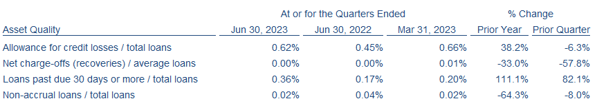
Financial Statements
Consolidated balance sheets at period end and consolidated statements of income for the periods ended are presented below.

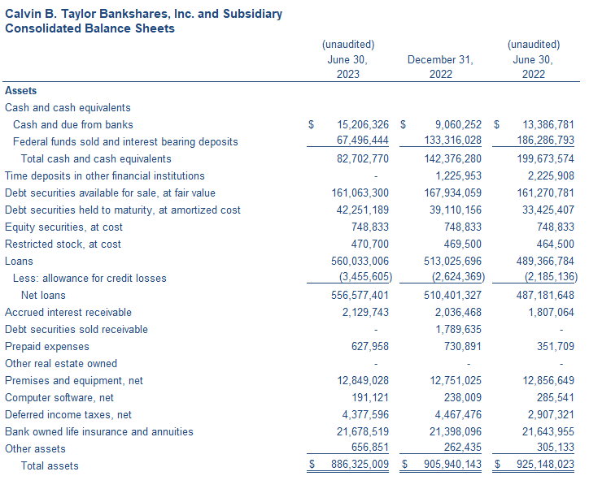
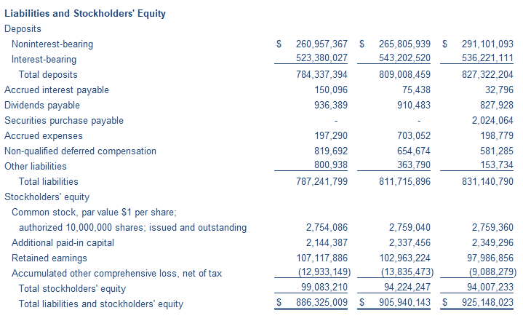
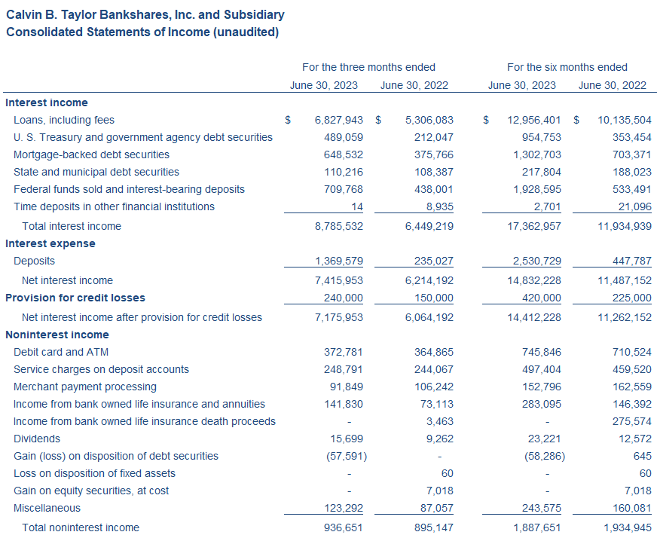
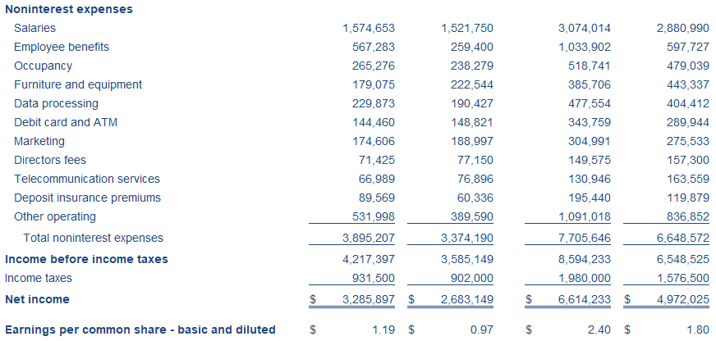

###

About Calvin B. Taylor Banking Company
Calvin B. Taylor Banking Company, the bank subsidiary of Calvin B. Taylor Bankshares, Inc. (OTCQX: TYCB), founded in 1890, offers a wide range of loan, deposit, and ancillary banking services through both physical and digital delivery channels. The Company has 12 banking locations within the eastern coastal area of the Delmarva Peninsula including Worcester County, Maryland, Sussex County, Delaware and Accomack County, Virginia.
Contact
M. Dean Lewis, Senior Vice President and Chief Financial Officer
410-641-1700, taylorbank.com

