GAMELANCER MEDIA LAUNCHES NEW WEBSITE

Toronto, Ontario / Accesswire / September 7, 2023, Gamelancer Media Corp. (TSX: GMNG) (OTCQB: GAMGF) (FRA: P93) (“Gamelancer” or the “Company”) a leading digital media, entertainment, production and distribution company, unveils its latest all-new website, now live at https://gamelancer.com/!
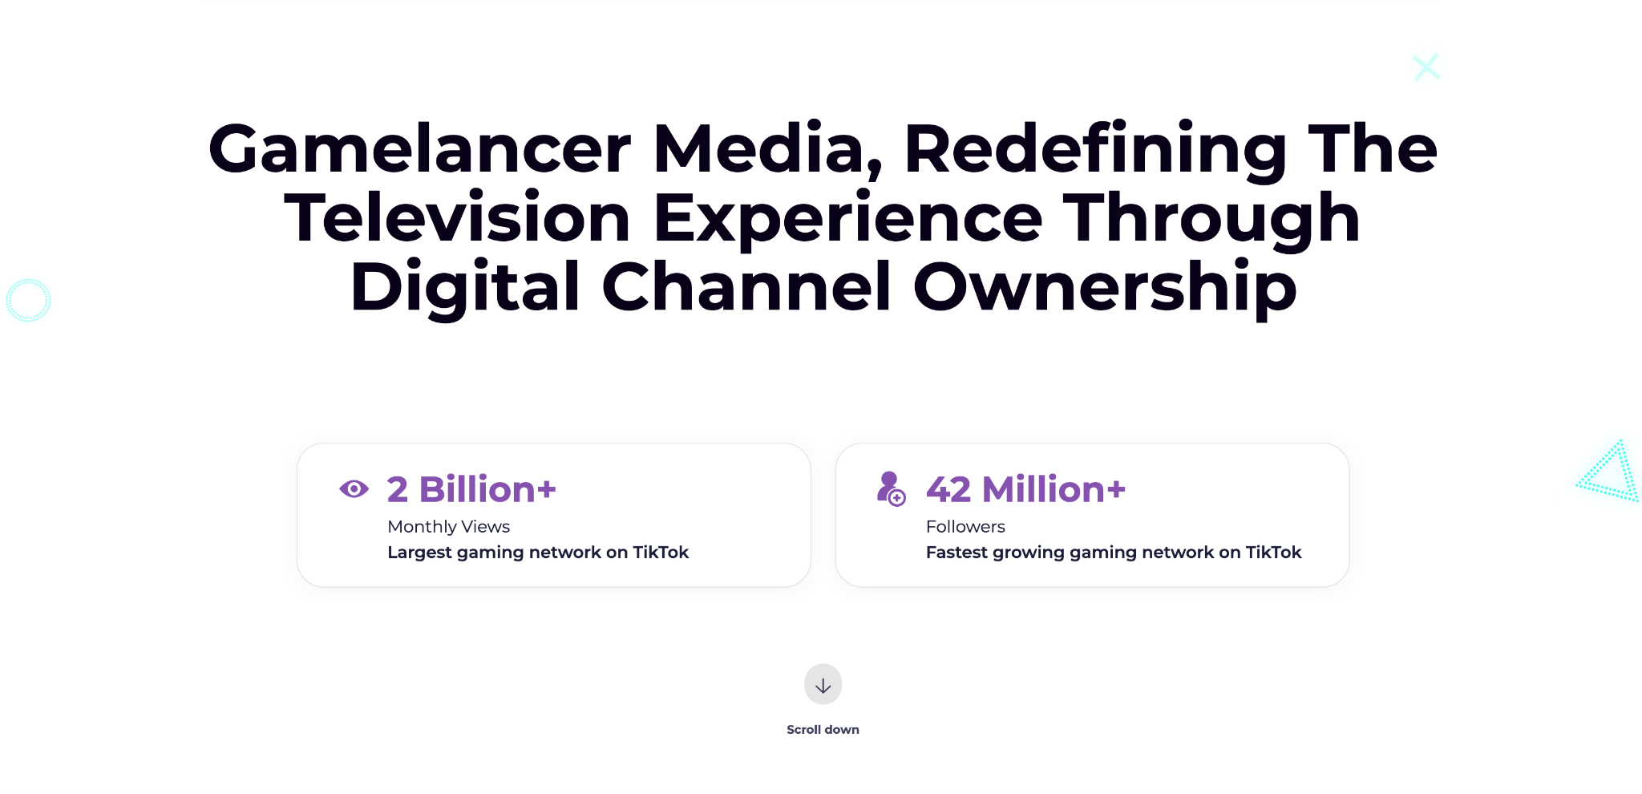
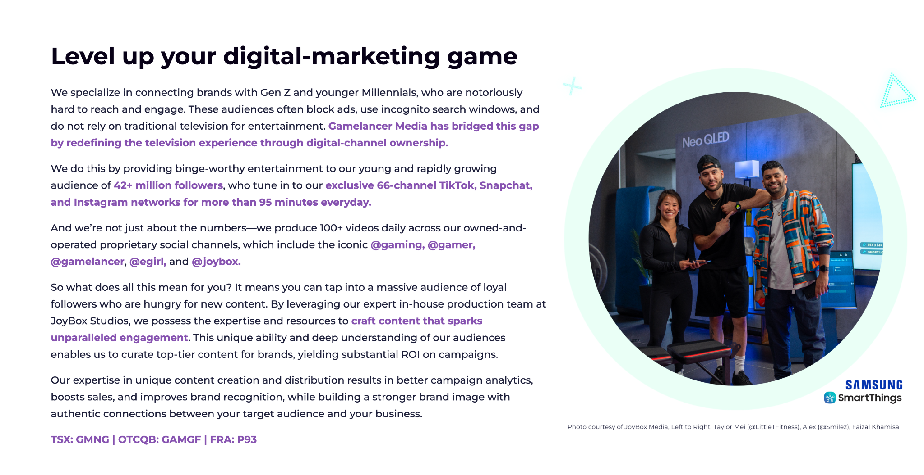

About Gamelancer
Gamelancer Media Corp. is an owned & operated digital-channel network and video-production studio. Specializing in the creation of viral videos, Gamelancer produces & distributes 100+ videos daily across 66 owned-and-operated channels, utilizing TV-economics to monetize TikTok & Instagram, and revenue-share with OTT platforms such as Snapchat. Gamelancer’s strategic focus is producing high-performing organic (not paid) video across our channels in order to continue building our audience of over 42 million followers and subscribers, who generate over 2 billion monthly video views. With a growing owned & operated network, Gamelancer cultivates scalable marketing concepts with brands, agencies, and creators, to build full-production + distribution brand campaigns for the largest brands in North America, the UK, and Australia on TikTok, Snapchat, and Instagram.

With advanced user data analytics, Gamelancer provides its audience with content relevant to the Gen Z & Millennial respective communities. Gamelancer owns the largest gaming media inventory on TikTok and monetizes across its Snapchat Discover channels in partnership with Snapchat.

Visit us at gamelancer.com to join our email subscribers list and receive press releases and newsletters directly to your inbox.

For further information, please contact:
Jon Dwyer, Chairman and Chief Executive Officer
Tel: (416) 627-8868
Email: ir@gamelancer.com
IR Email: info@gamelancer.com
Forward Looking Information
This news release contains forward‐looking statements and forward‐looking information within the meaning of applicable securities laws. These statements relate to future events or future performance. All statements other than statements of historical fact may be forward‐looking statements or information. The forward‐looking statements and information are based on certain key expectations and assumptions made by management of the Company. Although management of the Company believes that the expectations and assumptions on which such forward-looking statements and information are based are reasonable, undue reliance should not be placed on the forward‐looking statements and information since no assurance can be given that they will prove to be correct.
Forward-looking statements and information are provided for the purpose of providing information about the current expectations and plans of management of the Company relating to the future. Readers are cautioned that reliance on such statements and information may not be appropriate for other purposes, such as making investment decisions. Since forward‐looking statements and information address future events and conditions, by their very nature they involve inherent risks and uncertainties. Actual results could differ materially from those currently anticipated due to a number of factors and risks. Accordingly, readers should not place undue reliance on the forward‐looking statements and information contained in this news release. Readers are cautioned that the foregoing list of factors is not exhaustive. The forward‐looking statements and information contained in this news release are made as of the date hereof and no undertaking is given to update publicly or revise any forward‐looking statements or information, whether as a result of new information, future events or otherwise, unless so required by applicable securities laws. The forward-looking statements or information contained in this news release are expressly qualified by this cautionary statement.
Neither the Toronto Stock Exchange nor its Market Regulator (as that term is defined in the policies of the Toronto Stock Exchange) accepts responsibility for the adequacy or accuracy of this release.
SOURCE: Gamelancer Media Corp.

