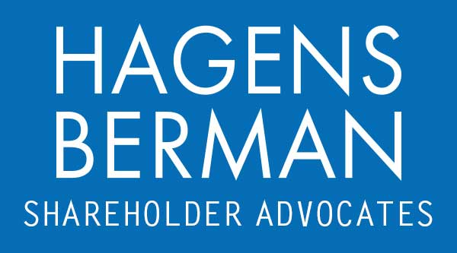

FOR IMMEDIATE RELEASE
Contact:
Reed Kathrein, 844-916-0895

HAGENS BERMAN, NATIONAL TRIAL ATTORNEYS, Encourages Napco Security Technologies (NSSC) Investors with Substantial Losses to Contact Firm’s Attorneys, Securities Fraud Class Action Pending
Sept. 23, 2023

SAN FRANCISCO − Hagens Berman urges Napco Security Technologies, Inc. (NASDAQ: NSSC) investors who suffered substantial losses to submit your losses now.

Class Period: Nov. 7, 2022 – Aug. 18, 2023
Lead Plaintiff Deadline: Oct. 30, 2023
Visit: www.hbsslaw.com/investor-fraud/NSSC
Contact An Attorney Now: NSSC@hbsslaw.com
844-916-0895

Napco Security Technologies, Inc. (NASDAQ: NSSC) Securities Fraud Class Action:
The complaint alleges that Defendants made false and misleading statements and failed to disclose Napco: (1) had not addressed material weaknesses in internal controls over its financial reporting of its cost of goods sold (“COGS”) and inventory; (2) downplayed the severity of material weaknesses regarding its internal controls; (3) overstated inventory and understated COGS from Sept. 30, 2022 to the present; and (4) would need to restate certain of its previously filed unaudited financial statements.
The truth emerged on Aug. 18, 2023, when the company announced that investors should no longer rely on its previously filed financial statements covering the quarters ended Sep. 30 and Dec. 31, 2022 and the quarter ended Mar. 31, 2023. The company also said that it would restate those financial statements, admitting to its improper calculation of cost of goods sold and inventory.
In addition, Napco estimated that: (1) its net income for the quarter ended Sep. 30, 2022 was overstated by 120%; (2) its net income for the quarter ended Dec. 31, 2022 was overstated by 127%; and (3) its net income for the quarter ended Mar. 31, 2023 was overstated by 13%.
This news was followed by a wave of analyst downgrades and drove the price of Napco shares crashing lower.
“We’re focused on investors’ losses and determining whether Napco engaged in an accounting fraud,” said Reed Kathrein, the Hagens Berman partner leading the investigation.
If you invested in Napco Security Technologies and have substantial losses, or have knowledge that may assist the firm’s investigation, submit your losses now »
If you’d like more information and answers to frequently asked questions about Napco Security Technologies’ fraud and our investigation, read more »
Whistleblowers: Persons with non-public information regarding Napco Security Technologies should consider their options to help in the investigation or take advantage of the SEC Whistleblower program. Under the new program, whistleblowers who provide original information may receive rewards totaling up to 30 percent of any successful recovery made by the SEC. For more information, call Reed Kathrein at 844-916-0895 or email NSSC@hbsslaw.com.
# # #
About Hagens Berman
Hagens Berman is a global plaintiffs’ rights complex litigation law firm focusing on corporate accountability through class-action law. The firm is home to a robust securities litigation practice and represents investors as well as whistleblowers, workers, consumers and others in cases achieving real results for those harmed by corporate negligence and fraud. More about the firm and its successes can be found at hbsslaw.com. Follow the firm for updates and news at @ClassActionLaw.
Attorney advertising.
Past results do not guarantee future outcomes.
Services may be performed by attorneys in any of our offices.

