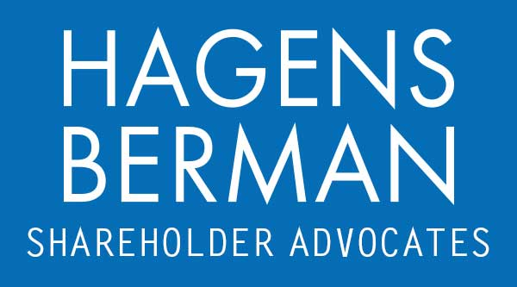

FOR IMMEDIATE RELEASE
Contact:
Reed Kathrein, 844-916-0895

FMC ALERT: Hagens Berman, National Trial Attorneys, Encourages FMC Corporation (FMC) Investors with Substantial Losses to Contact Firm’s Attorneys, Firm Continuing Investigation of Possible Securities Law Violations
Sept. 25, 2023

SAN FRANCISCO − Hagens Berman urges FMC Corporation (NYSE: FMC) investors who suffered substantial losses to submit your losses now.

Visit: www.hbsslaw.com/investor-fraud/FMC
Contact An Attorney Now: FMC@hbsslaw.com
844-916-0895

FMC Corporation (FMC) Investigation:
The investigation focuses on the propriety of FMC’s sales and inventory management practices, and on the sustainability of growth and financial results flowing from its patented diamide insect control products.
On May 1, 2023, FMC announced its Q1 2023 financial results, said Q2 2023 revenue would be flat to the prior year quarter, and maintained FY 2023 revenue outlook of $6.08 to $6.22 billion.
But, on July 10, 2023, FMC announced updated expectations for its Q2 and FY 2023 outlook. In particular, the company slashed its Q2 2023 revenue outlook by about 30%, reduced its FY 2023 revenue outlook by over 14%, and blamed the reduced guidance on reductions in channel inventory that adversely impacted the company’s sales volumes in the quarter.
Then, on Sept. 7, 2023, Blue Orca published a report alleging that “FMC has concealed from investors that it has suffered a recent string of defeats around the globe that have enabled competitors to now launch competing generics at prices up to 80% below the price of FMC’s flagship insecticide product[]” and “[c]ontrary to the Company’s claims, FMC’s process patents do not protect its flagship product from generic competition.”
Blue Orca concluded that “without patent protection for its leading product in its key markets, and battling a flood of capable generics, we believe that FMC’s revenues, margins and cash flows are set to collapse.”
Following these events, the price of FMC shares has sharply declined.
“We’re focused on investors’ losses and are investigating whether FMC may have misrepresented its sales and inventory management practices and the strength of certain patent protections,” said Reed Kathrein, the Hagens Berman partner leading the investigation.
If you invested in FMC and have substantial losses, or have knowledge that may assist the firm’s investigation, click here to discuss your legal rights with Hagens Berman.
Whistleblowers: Persons with non-public information regarding FMC Corporation should consider their options to help in the investigation or take advantage of the SEC Whistleblower program. Under the new program, whistleblowers who provide original information may receive rewards totaling up to 30 percent of any successful recovery made by the SEC. For more information, call Reed Kathrein at 844-916-0895 or email FMC@hbsslaw.com.
# # #
About Hagens Berman
Hagens Berman is a global plaintiffs’ rights complex litigation law firm focusing on corporate accountability through class-action law. The firm is home to a robust securities litigation practice and represents investors as well as whistleblowers, workers, consumers and others in cases achieving real results for those harmed by corporate negligence and fraud. More about the firm and its successes can be found at hbsslaw.com. Follow the firm for updates and news at @ClassActionLaw.
Attorney advertising.
Past results do not guarantee future outcomes.
Services may be performed by attorneys in any of our offices.

