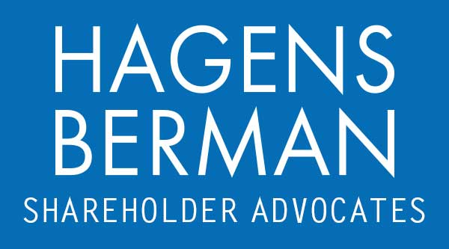

FOR IMMEDIATE RELEASE
Contact:
Reed Kathrein, 844-916-0895

EFXT ALERT: Hagens Berman, National Trial Attorneys, Investigating Enerflex (EFXT) Regarding Circumstances Surrounding Recent Departures of 2 CFOs and Encourages Investors with Substantial Losses to Contact Firm’s Attorneys
Oct. 4, 2023

SAN FRANCISCO − Hagens Berman urges Enerflex Ltd. (NYSE: EFXT) investors who suffered substantial losses to submit your losses now. The firm also encourages persons with knowledge who may be able to assist in the investigation to contact its attorneys.

Email EFXT@hbsslaw.com or call 844-916-0895
Enerflex Ltd. (NYSE: EFXT) investigation:
The investigation focuses on the abrupt departures of two Enerflex CFOs within the last seven months and the propriety of Enerflex’s financial reporting.
On Mar. 19, 2023, Enerflex announced the departure of its CFO (Sanjai Bishnoi) effective Apr. 10, 2023.
On June 28, 2023, Enerflex announced the appointment of Rodney D. Gray as CFO to steward financial strategy and drive long-term shareholder value. The company’s CEO said, “I am confident that Rod will steward Enerflex’s disciplined capital allocation decisions, enhance our financial capabilities, and drive long-term profitable growth, while upholding our strong values-based culture.”
Just 3 months later, on Oct. 1, 2023, Enerflex abruptly announced that Mr. Gray resigned “to pursue other opportunities.” This announcement came one day after the company’s quarter ended Sept. 30, 2023 and shortly before the company was estimated to report its quarterly financial results.
This news sent the price of Enerflex shares down about 27% on Oct. 2, 2023.
If you invested in Enerflex and have substantial losses, or have knowledge that may assist the firm’s investigation, click here to discuss your legal rights with Hagens Berman.
# # #
About Hagens Berman
Hagens Berman is a global plaintiffs’ rights complex litigation law firm focusing on corporate accountability through class-action law. The firm is home to a robust securities litigation practice and represents investors as well as whistleblowers, workers, consumers and others in cases achieving real results for those harmed by corporate negligence and fraud. More about the firm and its successes can be found at hbsslaw.com. Follow the firm for updates and news at @ClassActionLaw.
Attorney advertising.
Past results do not guarantee future outcomes.
Services may be performed by attorneys in any of our offices.

