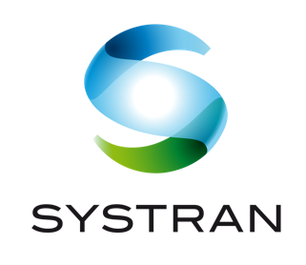

FOR IMMEDIATE RELEASE
Oct. 5, 2023

SYSTRAN translate Server Version 10 Unveiled: a major step toward increasing business performance of organizations operating internationally
Brand new Customer Experience, advanced customization tools for higher translation quality, integrated speech translation module

Paris, San Diego, Seoul, Tokyo, (Oct. 5, 2023) – SYSTRAN, a pioneer and leader in AI language translation technology for over 50 years, with offices in France, USA, South Korea and Japan, today announced a new, innovative and major version of its SYSTRAN translate Server, a comprehensive piece of software for professional Machine Translation.

SYSTRAN translate Server v10 is designed to increase the business performance of organizations operating internationally and serves all professional machine translation needs - from individuals to governments to large corporations. This server solution can be deployed in a Private Cloud (dedicated server operated by SYSTRAN) or within the company's IT (operated by the Customer), in parallel with our Public Cloud offerings: an unprecedented coverage that allows SYSTRAN to address a wide audience of professionals.

To celebrate this launch, SYSTRAN is now bringing together more than 100 of its customers in the “Community Day”, a one-day conference in Paris to share, be inspired and shape the future of machine translation. Industry leaders such as AstraZeneca, Eplan, ING, RATP, Stadler, TCS… will share their experience with machine translation and the concrete benefits they get in their company among various use cases - including localization, multilingual collaboration, customer support, e-commerce and much more.

SYSTRAN translate Server v10 offers an array of enhancements, including an even more user-friendly interface, the highest translation quality to-date, enhanced performance and security, and a groundbreaking new speech-to-text translation module, making it an indispensable tool for organizations doing business globally.

This new version includes:

- An extended translation tool set, including: IDML and .SRT support, three new languages (Armenian, Hausa, Tajik) for a total of 55 languages overall, and new domains (Energy, Finance, Healthcare).
- Dynamic fine-tuning of translations with AI-generated alternative translations displayed interactively inline for easy editing that maintains productivity workflows.
- The ability to easily tailor translation tone, locale and formality to ensure customers’ messages resonate with their target audiences.
- Ability to translate audio from videos and files to enable multi-modal communications across media channels.
- A freshly designed, streamlined user experience, featuring an updated Translate box which ensures a more immersive and user-centric translation journey.
- The state-of-the-art adaptive AI translation technology, Neural Fuzzy Adaptation (NFA), which adapts its output in real-time to match a company's unique translation output.

Customers can also expect to benefit from robustly improved performance and security and from the latest advances on ModelStudio, the self-service tool for training specialized translation models with their company’s own data.

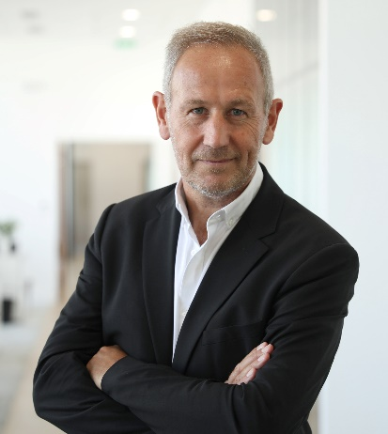
“SYSTRAN Translate Server V10 represents a major milestone in our history of continuous innovation,” said SYSTRAN CEO Vincent Godard. “This new release allows our customers to maximize the value they get from their SYSTRAN translation solution, reducing localization costs while accelerating workflows. It promotes multilingual communication internally and with their business partners, and contributes to the company’s global competitiveness, all while ensuring the security of their data.”

Access the dedicated SYSTRAN translate Server V10 page here.

About SYSTRAN
To help organizations master their multilingual communication and increase their productivity, SYSTRAN offers automated and specialized translation solutions to address growing challenges: global collaboration, content localization, multilingual customer support, global e-commerce platform, and electronic market intelligence and investigation. With the ability to facilitate communication in more than 140 language combinations with highly secure and customized solutions, SYSTRAN is the first choice for businesses, public organizations and language service providers. SYSTRAN is a pioneer at the forefront of innovation and today offers the best neural translation technology supported by a team of researchers, AI engineers, linguists and technical consultants who support clients step-by-step in their transformation projects.

For more information on SYSTRAN, visit www.systransoft.com.

Press Contact:
Gaelle.bou@systrangroup.om

