FOR IMMEDIATE RELEASE  Taranis Resources Inc.  681 Conifer Lane  Estes Park, Colorado  80517  www.taranisresources.com | 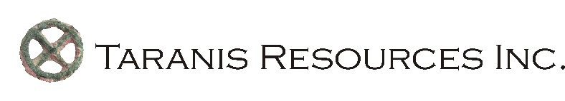

Taranis Resources Inc. Takes BC Government to Court Over Permitting Delays

Estes Park, Colorado, October 16, 2023 – Taranis Resources Inc. (“Taranis” or the “Company”) [TSX.V: TRO, OTCQB: TNREF] has filed a judicial review petition with the British Columbia Supreme Court, due to government’s ongoing (14 month) delay in processing an exploration permit application under the B.C. Mines Act.

“We believe the government is unwilling to do its legal duty here because of First Nation pressure” said President and CEO John Gardiner. “While consideration of Indigenous rights is part of the Crown’s duty to consult, the Supreme Court of Canada has repeatedly said that First Nations do not have veto. So government has to follow the law here”.

The exploration permit application relates to Taranis’s Thor project located south of Revelstoke B.C. The project has been the subject of prior exploration for 16 years, including more than 250 drill holes.

“It is regrettable that we have to apply to Court to have our rights respected” added Gardiner. “We have tried everything else including letters to Minister Josie Osbourne and Premier David Eby and we hope the government is asking itself what message this sends to international investors.”

The full petition can be found on the company’s website, or by clicking on the following link: https://www.jjgmining.com/uploads/2/7/0/2/27029932/2023_10_13_petition__filed__.pdf

It asks the court to:

- Order the Chief Permitting Officer or his delegate to make a decision on the application

- Issue a declaration that Minister Osbourne’s public statement that First Nations are “the rightful owners of the land”, and her written reference to a First Nation imposed “moratorium”, are contrary to law and must not guide the Chief Permitting Officer or his delegate.

A date for the Court hearing has not yet been set.

Qualified Person

Exploration activities at the Thor project are overseen by John Gardiner (P. Geo.), who is a Qualified Person under the meaning of Canadian National Instrument 43-101. Mr. Gardiner is responsible for, and approves of, the content in this News Release. John Gardiner is a principal of John J. Gardiner & Associates, LLC which operates in British Columbia under Firm Permit Number 1002256.

About Taranis Resources Inc.

For additional information on Taranis or its 100%-owned Thor project in British Columbia, visit www.taranisresources.com

Taranis currently has 94,587,027 shares issued and outstanding (109,262,027 shares on a fully diluted basis).

TARANIS RESOURCES INC.
Per: John J. Gardiner (P. Geol.),

President and CEO

For further information contact:

John J. Gardiner
681 Conifer Lane
Estes Park, Colorado
80517
Phone: (303) 716-5922
Cell: (720) 209-3049
johnjgardiner@earthlink.net

NEITHER THE TSX VENTURE EXCHANGE NOR ITS REGULATION SERVICES PROVIDER (AS THAT TERM IS DEFINED IN THE POLICIES OF THE TSX VENTURE EXCHANGE) ACCEPTS RESPONSIBILITY FOR THE ADEQUACY OR ACCURACY OF THIS NEWS RELEASE.

This News Release may contain forward looking statements based on assumptions and judgments of management regarding future events or results that may prove to be inaccurate as a result of factors beyond its control, and actual results may differ materially from expected results.

