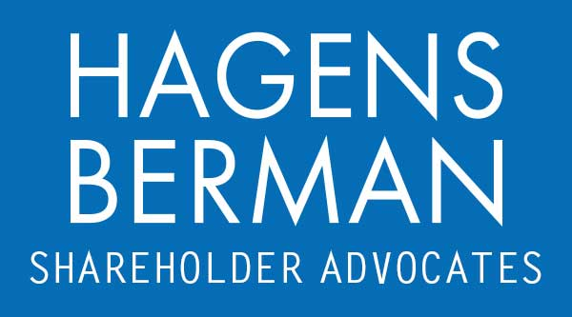

FOR IMMEDIATE RELEASE
Contact:
Reed Kathrein, 844-916-0895

HAGENS BERMAN, NATIONAL TRIAL ATTORNEYS, Encourages R1 RCM (RCM) Investors with Substantial Losses to Contact Firm’s Attorneys, Firm Investigating Possible Securities Law Violations
Oct. 24, 2023

SAN FRANCISCO − Hagens Berman urges R1 RCM Inc. (NASDAQ: RCM) investors who suffered substantial losses to submit your losses now.

Visit: www.hbsslaw.com/investor-fraud/RCM
Contact An Attorney Now: RCM@hbsslaw.com
844-916-0895

R1 RCM Inc. (NASDAQ: RCM) Investigation:
The investigation focuses on the propriety of R1 RCM’s financial disclosures.
On Oct. 16, 2023, financial fraud investigator Jehoshaphat Research published a scathing forensic report accusing R1 RCM of engaging in misrepresentative accounting and calling its stock “practically uninvestible today.”
Among other matters, Jehoshaphat accused R1 RCM of engaging in “aggressive mark-to-model revenue recognition creating most of the revenue growth in the company today, creatively deflat[ing] expenses that inflate Adjusted EBITDA by approximately 55%, potentially systematic under-reserving for customer bad debts” and “increasingly aggressive revenue recognition practices to pull forward revenues[.]”
In response, the price of R1 RCM shares fell about 8% on Oct. 16, 2023.
“We’re focused on investors’ losses and investigating whether R1 RCM may have engaged in improper revenue recognition practices,” said Reed Kathrein, the Hagens Berman partner leading the investigation.
If you invested in R1 RCM and have significant losses, or have knowledge that may assist the firm’s investigation, submit your losses now »
If you’d like more information and answers to frequently asked questions about the R1 RCM investigation, read more »
Whistleblowers: Persons with non-public information regarding R1 RCM should consider their options to help in the investigation or take advantage of the SEC Whistleblower program. Under the new program, whistleblowers who provide original information may receive rewards totaling up to 30 percent of any successful recovery made by the SEC. For more information, call Reed Kathrein at 844-916-0895 or email RCM@hbsslaw.com.
# # #
About Hagens Berman
Hagens Berman is a global plaintiffs’ rights complex litigation law firm focusing on corporate accountability through class-action law. The firm is home to a robust securities litigation practice and represents investors as well as whistleblowers, workers, consumers and others in cases achieving real results for those harmed by corporate negligence and fraud. More about the firm and its successes can be found at hbsslaw.com. Follow the firm for updates and news at @ClassActionLaw.
Attorney advertising.
Past results do not guarantee future outcomes.
Services may be performed by attorneys in any of our offices.

