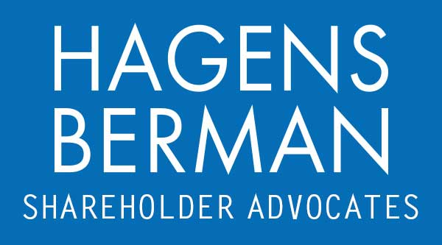

FOR IMMEDIATE RELEASE
Contact:
Reed Kathrein, 844-916-0895

Paycom Software (PAYC) Faces Investor Fraud Lawsuit for Concealing the Adverse Impact its Beti Product Had on Other Offerings – Hagens Berman
HAGENS BERMAN Encourages PAYC Investors with Substantial Losses to Contact Firm’s Attorneys Before Jan. 9th Deadline in Securities Fraud Lawsuit
Jan. 1, 2024

SAN FRANCISCO − Hagens Berman urges Paycom Software, Inc. (NYSE: PAYC) investors who suffered substantial losses to submit your losses now.

Class Period: May 3, 2023 – Nov. 1, 2023
Lead Plaintiff Deadline: Jan. 9, 2024
Visit: www.hbsslaw.com/investor-fraud/PAYC
Contact An Attorney Now: PAYC@hbsslaw.com
844-916-0895
Paycom Software, Inc. (NYSE: PAYC) Securities Fraud Class Action:
“The litigation focuses on whether Paycom knew and should have disclosed challenges associated with the ongoing transition to its new payroll solution, Beti,” said Reed Kathrein, the Hagens Berman partner leading the investigation.
After Paycom delivered its 3Q 2023 results, BMO Capital Markets dropped their price target on PAYC over 40%, from $320.00 to $190.00 in a research note dated Nov. 1. Stifel Nicolaus similarly downgraded PAYC from a "buy" rating to a "hold" rating and dropped their price target from $400.00 to $160.00 on Nov. 1.
Apart from analyst downgrades, Paycom and its executives face a securities class action brought by investors. The complaint there alleges that Paycom misrepresented and concealed that: (1) Paycom’s Beti product led to cannibalization of the company’s other services and revenues; (2) Paycom knew but did not disclose the cannibalization problem and did not warn of cannibalization as a general risk; (3) as a result of cannibalization, Paycom missed its expected 3Q 2023 revenue and would have to revise its expected FY 2023 revenues; and (4) the cannibalization issue resulted in 2024 year-over-year revenue growth sharply lower.
Investors learned the truth on Oct. 31, 2023, when Paycom reported its Q3 2023 financial results, including disappointing Q3 revenues, and guided for Q4 2023 and 2024 revenues that were significantly below consensus estimates. At the earnings call, Paycom CFO Craig Boelte explained that Paycom’s growth is being curbed by cannibalization, noting that clients have been cutting down spending on some services and other purchases because Beti has made them nonessential.
In response, the price of Paycom shares crashed $94.28 lower (or 38%) on Nov. 1, 2023.
If you invested in Paycom and have significant losses, or have knowledge that may assist the firm’s investigation, submit your losses now »
If you’d like more information and answers to frequently asked questions about the Paycom case and our investigation, read more »
Whistleblowers: Persons with non-public information regarding Paycom should consider their options to help in the investigation or take advantage of the SEC Whistleblower program. Under the new program, whistleblowers who provide original information may receive rewards totaling up to 30 percent of any successful recovery made by the SEC. For more information, call Reed Kathrein at 844-916-0895 or email PAYC@hbsslaw.com.
# # #
About Hagens Berman
Hagens Berman is a global plaintiffs’ rights complex litigation law firm focusing on corporate accountability through class-action law. The firm is home to a robust securities litigation practice and represents investors as well as whistleblowers, workers, consumers and others in cases achieving real results for those harmed by corporate negligence and fraud. More about the firm and its successes can be found at hbsslaw.com. Follow the firm for updates and news at @ClassActionLaw.
Attorney advertising.
Past results do not guarantee future outcomes.
Services may be performed by attorneys in any of our offices.

