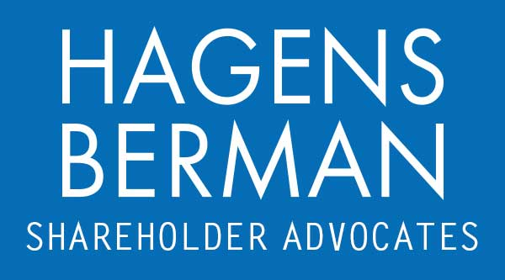

FOR IMMEDIATE RELEASE
Contact:
Reed Kathrein, 844-916-0895

Nuclear Expert Blasts NuScale (SMR) Amid Investor Suit Arising From Cancelled Idaho Project – Hagens Berman
HAGENS BERMAN, NATIONAL TRIAL ATTORNEYS, Encourages NuScale (SMR) Investors with Substantial Losses to Contact Firm’s Attorneys
Jan. 5, 2024

SAN FRANCISCO − Hagens Berman urges NuScale Power Corporation (NYSE: SMR) investors who suffered substantial losses to submit your losses now.

Class Period: Mar. 15, 2023 – Nov. 8, 2023
Lead Plaintiff Deadline: Jan. 16, 2024
Visit: www.hbsslaw.com/investor-fraud/SMR
Contact An Attorney Now: SMR@hbsslaw.com
844-916-0895
NuScale Power Corporation (NYSE: SMR) Securities Fraud Class Action:
Nuclear expert Mycle Schneider recently weighed in on NuScale’s stunning Nov. 8, 2023 announcement that it was cancelling its partnership with Utah power systems on a project that called for the development of six NuScale reactors at the U.S. Department of Energy’s Idaho National Laboratory.
In a recent interview with the Bulletin of the Atomic Scientists published on Dec. 18, 2023, Schneider, the lead author of the “World Nuclear Industry Status Report,” was asked to explain the demise of the Idaho project. Schneider reportedly responded, “What happened there is that NuScale had promised in 2008 that it would start generating power by 2015. We are now in 2023 and they haven’t started construction of a single reactor. They have not even actually a certification license for the model that they’ve been promoting in the Utah municipal conglomerate.” (Emphasis added.)
Schneider’s comments come after the filing of a securities class action suit against NuScale and its executives stemming from the cancelled Idaho project. The complaint there alleges that Defendants failed to disclose that: (1) due to the inflationary impact on cost of construction and power, NuScale and UAMPS would be unable to sign up enough subscribers to fulfill the CFPP; and (2) Standard Power did not have the financial ability to support its agreement with NuScale.
The complaint alleges that the fraud began to unravel on Oct. 19, 2023, when activist short seller Iceberg Research published a scathing report about the company. As to NuScale’s deal with the Utah Power systems, Iceberg expressed concerns about constant cost overruns and questioned NuScale’s ability to commercialize the deal due to the company’s apparent undisclosed failure to meet contractual subscription rates. Iceberg presciently concluded that “[t]his contract has zero chance of being executed as Standard Power clearly does not have the means to support contracts of this size[]” and opined about concerns relative to NuScale management integrity.
NuScale’s shares have lost nearly 70% of their value since going public at $10 per share in June 2022.
If you invested in NuScale and have substantial losses, or have knowledge that may assist the firm’s investigation, submit your losses now »
If you’d like more information and answers to frequently asked questions about the NuScale case and our investigation, read more »
Whistleblowers: Persons with non-public information regarding NuScale should consider their options to help in the investigation or take advantage of the SEC Whistleblower program. Under the new program, whistleblowers who provide original information may receive rewards totaling up to 30 percent of any successful recovery made by the SEC. For more information, call Reed Kathrein at 844-916-0895 or email SMR@hbsslaw.com.

# # #
About Hagens Berman
Hagens Berman is a global plaintiffs’ rights complex litigation law firm focusing on corporate accountability through class-action law. The firm is home to a robust securities litigation practice and represents investors as well as whistleblowers, workers, consumers and others in cases achieving real results for those harmed by corporate negligence and fraud. More about the firm and its successes can be found at hbsslaw.com. Follow the firm for updates and news at @ClassActionLaw.
Attorney advertising.
Past results do not guarantee future outcomes.
Services may be performed by attorneys in any of our offices.

