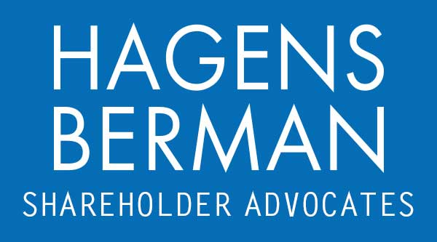

FOR IMMEDIATE RELEASE
Contact:
Reed Kathrein, 844-916-0895

Investors Sue Fisker (FSR) for Allegedly Obscuring Costs and Concealing Material Weaknesses in Financial Reporting – Hagens Berman
Hagens Berman, National Trial Attorneys, Encourages FSR Investors with Substantial Losses to Contact Firm’s Attorneys
Jan. 10, 2024

SAN FRANCISCO − Hagens Berman urges Fisker Inc. (NYSE: FSR) investors who suffered substantial losses to submit your losses now.

Class Period: Aug. 4, 2023 – Nov. 20, 2023
Lead Plaintiff Deadline: Jan. 26, 2024
Visit: www.hbsslaw.com/investor-fraud/FSR
Contact An Attorney Now: FSR@hbsslaw.com
844-916-0895
Fisker Inc. (NYSE: FSR) Securities Fraud Class Action:
Fisker’s recent decision to dial back its full-year production target has caused news outlets to question whether the company will survive the next year.
On Dec. 7, 2023, MotleyFool observed, in response to the production cut, that the company “prioritized liquidity[,]” “[p]ut another way, Fisker requires cash for working capital needs and is therefore scaling back production[,]” and “[t]hat’s a pretty dire situation to be in for any company.”
Then, on Dec. 19, The Wall Street Journal noted the “cash crunch” several EV makers are facing, including Fisker. According to WSJ, Fisker recently reported as having only 187 days of cash on hand, meaning it could run out of cash before the middle of next year.
The recent reports questioning Fisker’s solvency come in the wake of the filing of a securities class action suit, alleging that earlier this year Fisker tried to obscure its costs to make it appear more viable.
“The litigation challenges Fisker’s cost accounting and internal controls over financial reporting,” said Reed Kathrein, the Hagens Berman partner leading the investigation.
Specifically, the complaint alleges that Defendants misrepresented and concealed: (1) that Fisker had a material weakness in its internal control over financial reporting; (2) that Fisker had incorrectly accounted for certain costs; (3) that as a result the Company was likely to delay filing its quarterly report; and (4) that Fisker’s infrastructure was limiting its ability to deliver its production.
Investors began to learn the truth on Nov. 8, 2023, when Fisker announced that it was delaying its Q3 2023 earnings release until after markets close on Nov. 13, 2023. Fisker blamed the delay on the unexplained departure of its, now former, Chief Accounting Officer John Finnucan on Oct. 27, 2023 and the appointment of a replacement effective Nov. 6, 2023.
Then, on Nov. 13, 2023, Fisker released dismal Q3 2023 results. It further revealed that material weaknesses in its internal control over financial reporting prevented it from timely filing its quarterly report with the SEC.
On Nov. 20, 2023, WSJ reported that Fisker has lost another Chief Accounting Officer. According to the WSJ, Florus Belting, who was named to the post in early Nov., resigned from the company the day after Fisker reported Q3 results.
Finally, on Nov. 22, 2023, the Company filed its Q3 2023 quarterly report on Form 10-Q, which disclosed that the Company had “identified approximately $20 million of expenses” which were “incorrectly recorded primarily as selling, general and administrative expenses in our preliminary earnings results, but were later determined to be associated with production set-up activities” and that “other inventory adjustments were recorded resulting in a $4.0 million increase in net loss subsequent to the preliminary earnings results.”
If you invested in Fisker and have substantial losses, or have knowledge that may assist the firm’s investigation, submit your losses now »
If you’d like more information and answers to frequently asked questions about the Fisker case and our investigation, read more »
Whistleblowers: Persons with non-public information regarding Fisker should consider their options to help in the investigation or take advantage of the SEC Whistleblower program. Under the new program, whistleblowers who provide original information may receive rewards totaling up to 30 percent of any successful recovery made by the SEC. For more information, call Reed Kathrein at 844-916-0895 or email FSR@hbsslaw.com.

# # #
About Hagens Berman
Hagens Berman is a global plaintiffs’ rights complex litigation law firm focusing on corporate accountability through class-action law. The firm is home to a robust securities litigation practice and represents investors as well as whistleblowers, workers, consumers and others in cases achieving real results for those harmed by corporate negligence and fraud. More about the firm and its successes can be found at hbsslaw.com. Follow the firm for updates and news at @ClassActionLaw.
Attorney advertising.
Past results do not guarantee future outcomes.
Services may be performed by attorneys in any of our offices.

