FOR IMMEDIATE RELEASE


Boxwood Partners Teams up with PGA Tour Veteran & Entrepreneur Zac Blair
Leading M&A Advisory Firm Sponsors Pro for the 2024 PGA Tour Season
JUPITER, FL – Boxwood Partners – a leading boutique middle-market M&A advisory firm – is pleased to announce the signing of a PGA Tour sponsorship agreement with professional golfer, Zac Blair for the 2024 PGA Tour season. The partnership marks a significant milestone for both Boxwood and Blair as they embark on a shared journey supporting entrepreneurship, excellence and success.
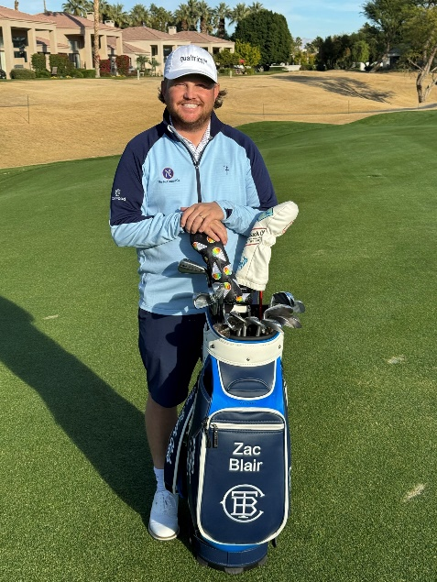
Throughout the PGA Tour season, Boxwood’s name will be featured on Blair's golf apparel and mentioned in social media posts through the 2024 season, reaching a global audience of golf enthusiasts and business professionals alike.
“We are excited to join forces with Zac Blair as he competes on the PGA Tour in 2024," said J. Patrick Galleher, Managing Partner at Boxwood. “He is not only a skilled athlete, but a likeminded entrepreneur who understands what we do and why we are so passionate about it. The partnership exemplifies the importance of process, taking a data driven approach, hard work and entrepreneurial spirit – the same core values we strive to emulate every day at Boxwood.”
While playing on many golf courses throughout his career, Blair had always dreamed of having one of his own. After discovering a 500-acre pine nursery property near Aiken, SC, Blair acquired the land in early 2020 and worked with well-known architects to transform it into a world class golf course, The Tree Farm. The golf course, which has attracted a national, young-in-age membership, reflects Blair’s passion for walking, fast play, head-to-head matches and creative architecture.
“Zac’s ability to play golf at the highest level and realizing his vision of developing a unique world class golf course with a fun, relaxed atmosphere demonstrates his core values and ability to overcome adversity,” Galleher added.
Expressing his own enthusiasm for the partnership, Blair noted, "A spirited entrepreneur myself, I’m honored to be associated with Boxwood, one of the leading boutique investment banks that shares my drive for success. As the premier advisor for middle market clients across multiple sectors within franchising, consumer, business services and industrial services, , my goal is to partner with them to elevate their brand both on and off the golf course.”

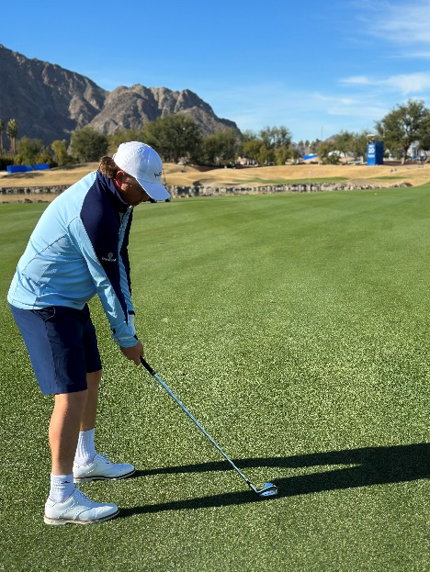
A Salt Lake City native, Blair played college golf at Brigham Young University (BYU) before turning professional. He made his PGA Tour debut in 2014 and has competed in various tournaments since then. He won the Ellie Mae Classic on the Korn Ferry Tour on August 4, 2019 at TPC Stonebrae; after this victory, his PGA Tour card was reinstated for the 2019-2020 season. Facing physical challenges, he was unable to play for nearly two years due to a surgery in 2020. After healing and finding his motivation again, he earned two top-10 finishes during 2023, including the Travelers Championship (T2) and the Valspar Championship (T10).
About Boxwood Partners
Boxwood Partners, LLC is a boutique investment bank based in Jupiter, Florida with offices in Richmond, Virginia. Boxwood Partners combines a unique blend of senior-level transaction advisory, business operating experience, and proven process execution skills to give its clients a distinct advantage in the market. The firm’s extensive relationships within the global capital and buyer communities (including U.S. and international private equity groups, corporations, and lenders) and other important transaction-related service providers such as consultants, attorneys, and accountants, ensure that the firm’s clients receive the attention, service, and results they deserve. Boxwood Partners was recently included in The Axial Advisor 100 List, which identifies, verifies and acknowledges the most highly regarded lower middle market sell-side M&A advisors. For more information about Boxwood Partners, please visit www.boxwoodpartners.com.
###

