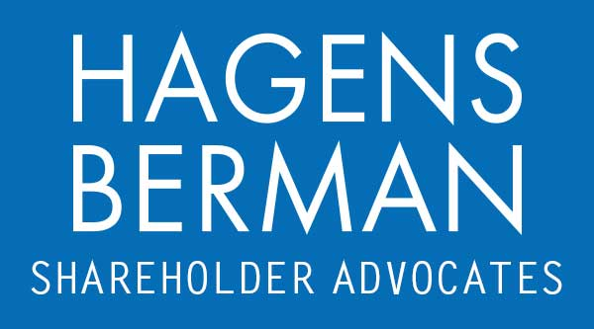

FOR IMMEDIATE RELEASE
Contact:
Reed Kathrein, 844-916-0895

Investors Sue Amylyx Pharmaceuticals (AMLX) After Analyst Questions RELYVRIO® Data – Hagens Berman
AMLX Investors with Substantial Losses Encouraged to Contact Hagens Berman, National Trial Attorneys
Feb. 16, 2024

SAN FRANCISCO − Hagens Berman urges Amylyx Pharmaceuticals, Inc. (NASDAQ: AMLX) investors who suffered substantial losses to submit your losses now.

Class Period: Nov. 11, 2022 – Nov. 8, 2023
Lead Plaintiff Deadline: Apr. 9, 2024
Visit: www.hbsslaw.com/investor-fraud/amlx
Contact An Attorney Now: AMLX@hbsslaw.com
844-916-0895

Amylyx Pharmaceuticals, Inc. (AMLX) Securities Fraud Class Action:
The litigation focuses on Amylyx’s repeated emphasis on commercial prospects and prescription rates for its product intended to treat patients with Lou Gehrig’s disease -- RELYVRIO®.
The complaint alleges that Amylyx made false and misleading statements and failed to disclose that: (1) it overstated RELYVRIO®’s commercial prospects; (2) patients were discontinuing treatment with RELYVRIO® after 6 months; (3) the rate at which new patients were beginning treatment with RELYVRIO® was declining; (4) accordingly, Amylyx overstated RELYVRIO®’s prescription rate; and (5) the company attempted to hide the foregoing negative trends by blocking analysts from viewing RELYVRIO® prescription data.
Investors learned the truth on Nov. 9, 2023, when Amylyx announced disappointing Q3 2023 financial results and blamed the slowdown in its business on increased discontinuations.
The same day, Investor’s Business Daily published an article citing an Evercore ISI analyst, who reportedly questioned the company’s assertion that new patients starting treatment with RELYVRIO® was “steady,” noted that his math suggested otherwise, and said that Amylyx blocked analysts from viewing RELYVRIO® prescription data in the summer of 2023.
These events sent the price of Amylyx shares crashing $5.74, or about 31% lower, on Nov. 9, 2023.
"We’re focused on investors’ losses and whether Amylyx intentionally misrepresented RELYVRIO®’s commercial prospects, “steady” prescription rates, and discontinuations,” said Reed Kathrein, the Hagens Berman partner leading the firm’s investigation.
If you invested in Amylyx Pharmaceuticals and have substantial losses, or have knowledge that may assist the firm’s investigation, submit your losses now »
If you’d like more information and answers to frequently asked questions about the Amylyx case and our investigation, read more »
Whistleblowers: Persons with non-public information regarding Amylyx Pharmaceuticals should consider their options to help in the investigation or take advantage of the SEC Whistleblower program. Under the new program, whistleblowers who provide original information may receive rewards totaling up to 30 percent of any successful recovery made by the SEC. For more information, call Reed Kathrein at 844-916-0895 or email AMLX@hbsslaw.com.
# # #
About Hagens Berman
Hagens Berman is a global plaintiffs’ rights complex litigation law firm focusing on corporate accountability through class-action law. The firm is home to a robust securities litigation practice and represents investors as well as whistleblowers, workers, consumers and others in cases achieving real results for those harmed by corporate negligence and fraud. More about the firm and its successes can be found at hbsslaw.com. Follow the firm for updates and news at @ClassActionLaw.
Attorney advertising.
Past results do not guarantee future outcomes.
Services may be performed by attorneys in any of our offices.

