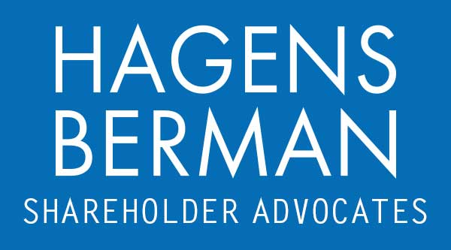

FOR IMMEDIATE RELEASE
Contact:
Reed Kathrein, 844-916-0895

Evolv Technologies (EVLV) Crashes After Disclosing SEC Investigation - Hagens Berman
HAGENS BERMAN, NATIONAL TRIAL ATTORNEYS, Encourages EVLV Investors Who Suffered Substantial Losses and Persons with Knowledge Who May Assist Investigation to Contact Firm’s Attorneys
Feb. 22, 2024

SAN FRANCISCO − Hagens Berman urges Evolv Technologies Holdings, Inc. (NASDAQ: EVLV) investors who suffered substantial losses to submit your losses now. The firm also encourages persons with knowledge who may be able to assist in the investigation to contact the firm’s attorneys.

Visit: www.hbsslaw.com/investor-fraud/EVLV
Contact An Attorney Now: EVLV@hbsslaw.com
844-916-0895

Evolv Technologies Holdings, Inc. (NASDAQ: EVLV) Investigation:
Evolv touts its multimillion-dollar weapons detectors as using artificial intelligence to recognize concealed weapons and distinguish them from harmless metal objects like phones and keys.
But the propriety of Evolv’s statements concerning its products’ technical capabilities have recently come into question.
Specifically, on Feb. 19, 2024, Evolv disclosed that the SEC has opened a “non-public, fact-finding inquiry” into the company. News of the SEC investigation caused Evolv shares to drop 19% in one trading day.
The SEC investigation comes on the heels of a separate probe initiated by the U.S. Federal Trade Commission over allegations Evolv uses deceptive marketing practices.
The company has also been recently sued by a highschooler in Upstate New York, alleging Evolv misrepresented its technology and is responsible for his stabbing. The lawsuit contends that an Evolv weapons detector failed to spot the large knife that the victim’s assailant used.
“We are investigating whether Evolv may have deceived investors about the capabilities and effectiveness of Evolv’s technology,” said Reed Kathrein, the Hagens Berman partner leading the firm’s investigation.
If you invested in Evolv Technologies and have substantial losses, or have knowledge that may assist the firm’s investigation, contact Hagens Berman now »
If you’d like more information and answers to frequently asked questions about the Evolv Technologies investigation, read more »
Whistleblowers: Persons with non-public information regarding Evolv Technologies should consider their options to help in the investigation or take advantage of the SEC Whistleblower program. Under the new program, whistleblowers who provide original information may receive rewards totaling up to 30 percent of any successful recovery made by the SEC. For more information, call Reed Kathrein at 844-916-0895 or email EVLV@hbsslaw.com.
# # #
About Hagens Berman
Hagens Berman is a global plaintiffs’ rights complex litigation law firm focusing on corporate accountability through class-action law. The firm is home to a robust securities litigation practice and represents investors as well as whistleblowers, workers, consumers and others in cases achieving real results for those harmed by corporate negligence and fraud. More about the firm and its successes can be found at hbsslaw.com. Follow the firm for updates and news at @ClassActionLaw.
Attorney advertising.
Past results do not guarantee future outcomes.
Services may be performed by attorneys in any of our offices.

