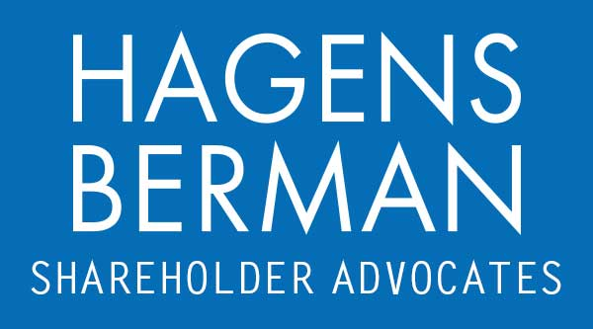

FOR IMMEDIATE RELEASE
Contact:
Reed Kathrein, 844-916-0895

Hagens Berman, National Trial Attorneys, Encourages Inari Medical, Inc. (NARI) Investors with Substantial Losses to Contact Firm’s Attorneys, Stock Plummets on News of DOJ Investigation
Mar. 8, 2024

SAN FRANCISCO − Hagens Berman urges Inari Medical, Inc. (NASDAQ: NARI) investors who suffered substantial losses to submit your losses now.

Visit: www.hbsslaw.com/investor-fraud/nari
Contact An Attorney Now: NARI@hbsslaw.com
844-916-0895

Inari Medical, Inc. (NARI) Investigation:
Inari Medical shares recently tumbled after the commercial-stage medical device company disclosed it was being investigated by the DOJ over certain payments to healthcare professionals.
The disclosure of the federal probe stands in contrast to the positive statements the company made in previous quarters concerning the company’s “record revenue” purportedly driven by “the strength in our core [venous thromboembolism] VTE business.”
But on Feb. 29, 2024, the true drivers of Inari’s revenue growth came into question, when Inari revealed that federal regulators had initiated an investigation into its payments to Health Care Professionals (“HCPs”) sometime during Dec. 2023. Specifically, Inari disclosed that the Department of Justice had served it with a civil investigative demand (“CID”) under the federal Anti-Kickback Statute and Civil False Claims Act, demanding information and documents primarily relating to the company’s payments to HCPs.
The disclosure prompted analysts at Piper Sandler to downgrade NARI to neutral and lower its price target for the stock to $55 from $85, adding that the DOJ investigation may present an overhang on the shares.
This news sent the price of Inari shares crashing $12.14, or down about 21%, on Feb. 29, 2024.
“We are investigating the propriety of Inari’s touted revenue growth and repeated claims that its strategy had positioned it for sustained operating profitability by the first half of 2025,” said Reed Kathrein, the Hagens Berman partner leading the investigation.
If you invested in Inari and have substantial losses, or have knowledge that may assist the firm’s investigation, submit your losses now »
If you’d like more information and answers to frequently asked questions about the Inari investigation, read more »
Whistleblowers: Persons with non-public information regarding Inari should consider their options to help in the investigation or take advantage of the SEC Whistleblower program. Under the new program, whistleblowers who provide original information may receive rewards totaling up to 30 percent of any successful recovery made by the SEC. For more information, call Reed Kathrein at 844-916-0895 or email NARI@hbsslaw.com.
# # #
About Hagens Berman
Hagens Berman is a global plaintiffs’ rights complex litigation law firm focusing on corporate accountability through class-action law. The firm is home to a robust securities litigation practice and represents investors as well as whistleblowers, workers, consumers and others in cases achieving real results for those harmed by corporate negligence and fraud. More about the firm and its successes can be found at hbsslaw.com. Follow the firm for updates and news at @ClassActionLaw.
Attorney advertising.
Past results do not guarantee future outcomes.
Services may be performed by attorneys in any of our offices.

