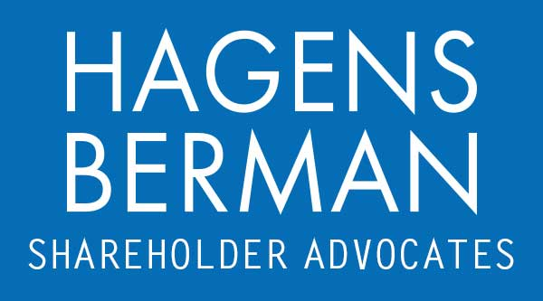

FOR IMMEDIATE RELEASE
Contact:
Reed Kathrein, 844-916-0895

Mobileye Global (MBLY) Hit With Securities Class Action After Revealing Customers’ Excess Inventories – Hagens Berman
Hagens Berman, National Trial Attorneys, Encourage MBLY Investors with Substantial Losses to Contact Firm Before Mar. 18th Deadline
Mar. 9, 2024

SAN FRANCISCO − Hagens Berman urges Mobileye Global Inc. (NASDAQ: MBLY) investors who suffered substantial losses to submit your losses now.

Class Period: Jan. 26, 2023 – Jan. 3, 2024
Lead Plaintiff Deadline: Mar. 18, 2024
Visit: www.hbsslaw.com/investor-fraud/mbly
Contact An Attorney Now: MBLY@hbsslaw.com
844-916-0895

Mobileye Global Inc. (MBLY) Securities Fraud Class Action:
The complaint alleges that Mobileye misrepresented and concealed that: (1) to avoid the shortages experienced amid supply chain constraints in 2021 and 2022, its Tier 1 customers purchased inventory in excess of fiscal 2023 demand; (2) as a result, its customers had excess inventory, including approximately 6-7 million units of EyeQ® System-on-Chips systems (“EyeQ® SoCs”); and (3) due to the customers’ inventory build-up, there was a significant risk that they would buy less product during the company’s fiscal 2024, which would negatively impact its 2024 financial results.
The truth emerged on Jan. 4, 2024, when Mobileye revealed that its OEM customers have excess inventories totaling 6-7 million units of EyeQ® SoCs. The company also slashed 2024 expected EyeQ® shipments to 31-33 million units compared to 37 million units shipped in 2023 (representing a 10%-16% year-over-year reduction) and said it expects Q1 2024 revenue to be down 50% compared to the prior year quarter.
This news sent the price of Mobileye shares crashing $9.75 (or nearly 25%) lower on Jan. 4, 2024.
"We are investigating whether Mobileye may have misled investors about the true driver for its 2021-22 sales growth,” said Reed Kathrein, the Hagens Berman partner leading the firm’s investigation.
If you invested in Mobileye and have substantial losses, or have knowledge that may assist the firm’s investigation, click here to discuss your legal rights with Hagens Berman »
If you’d like more information and answers to frequently asked questions about the Mobileye case and our investigation, read more »
Whistleblowers: Persons with non-public information regarding Mobileye should consider their options to help in the investigation or take advantage of the SEC Whistleblower program. Under the new program, whistleblowers who provide original information may receive rewards totaling up to 30 percent of any successful recovery made by the SEC. For more information, call Reed Kathrein at 844-916-0895 or email MBLY@hbsslaw.com.
# # #
About Hagens Berman
Hagens Berman is a global plaintiffs’ rights complex litigation law firm focusing on corporate accountability through class-action law. The firm is home to a robust securities litigation practice and represents investors as well as whistleblowers, workers, consumers and others in cases achieving real results for those harmed by corporate negligence and fraud. More about the firm and its successes can be found at hbsslaw.com. Follow the firm for updates and news at @ClassActionLaw.
Attorney advertising.
Past results do not guarantee future outcomes.
Services may be performed by attorneys in any of our offices.

