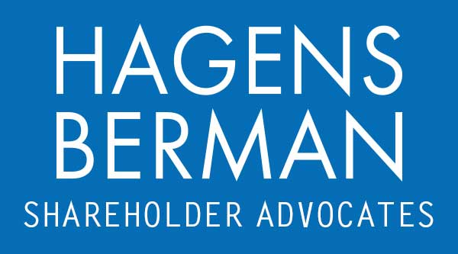

FOR IMMEDIATE RELEASE
Contact:
Reed Kathrein, 844-916-0895

Luna Innovations (LUNA) Hit with Securities Class Action After Admitting to Improper Accounting – Hagens Berman
LUNA Investors with Substantial Losses Encouraged to Contact Hagens Berman, National Trial Attorneys
Apr. 2, 2024

SAN FRANCISCO − Hagens Berman urges Luna Innovations Incorporated (NASDAQ: LUNA) investors who suffered substantial losses to submit your losses now.

Class Period: Aug. 11, 2023 – Mar. 25, 2024
Lead Plaintiff Deadline: May 31, 2024
Visit: www.hbsslaw.com/investor-fraud/LUNA
Contact An Attorney Now: LUNA@hbsslaw.com
844-916-0895

Luna Innovations Incorporated (LUNA) Securities Fraud Class Action:
The litigation focuses on the propriety of Luna’s past financial statements and adherence to U.S. generally accepted accounting principles (“GAAP”).
More specifically, the complaint alleges that Luna made misleading statements and failed to disclose that: (1) its financial statements from Aug. 10, 2023 to the present included false figures as a result of improper revenue recognition; (2) as a result, Luna would be required to restate financial statements filed during Aug. 10, 2023 through Nov. 14, 2023; and (3) it lacked adequate internal controls.
Investors began to learn the truth on Mar. 12, 2024, when Luna revealed that it would not timely file its annual financial statements for the year ended Dec. 31, 2023 as a result of having reported revenues during Q2 and Q3 2023 “that did not qualify for revenue recognition under [GAAP].” The company also warned that investors should no longer rely on its financial statements for the quarters ended June 30 and September 30, 2023 and that its internal controls over financial reporting was not sufficient. This news drove the price of Luna shares crashing over 35% lower on Mar. 13, 2024.
Then, on Mar. 25, 2024, Luna announced that its CEO Scott Graeff has retired from his role as President and Chief Executive Officer of the Company and has stepped down from the Board of Directors, sending the price of Luna shares sharply lower on Mar. 26, 2024.
“We’re investigating whether Luna management may have intentionally violated GAAP and its stated revenue recognition policies to appear more profitable,” said Reed Kathrein, the Hagens Berman partner leading the investigation.
If you invested in Luna Innovations and have substantial losses, or have knowledge that may assist the firm’s investigation, click here to discuss your legal rights with Hagens Berman »
If you’d like more information and answers to frequently asked questions about the Luna Innovations case and our investigation, read more »
Whistleblowers: Persons with non-public information regarding Luna Innovations should consider their options to help in the investigation or take advantage of the SEC Whistleblower program. Under the new program, whistleblowers who provide original information may receive rewards totaling up to 30 percent of any successful recovery made by the SEC. For more information, call Reed Kathrein at 844-916-0895 or email LUNA@hbsslaw.com.
# # #
About Hagens Berman
Hagens Berman is a global plaintiffs’ rights complex litigation law firm focusing on corporate accountability through class-action law. The firm is home to a robust securities litigation practice and represents investors as well as whistleblowers, workers, consumers and others in cases achieving real results for those harmed by corporate negligence and fraud. More about the firm and its successes can be found at hbsslaw.com. Follow the firm for updates and news at @ClassActionLaw.
Attorney advertising.
Past results do not guarantee future outcomes.
Services may be performed by attorneys in any of our offices.

