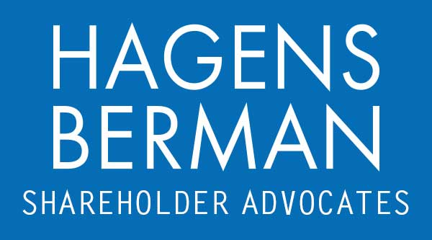

FOR IMMEDIATE RELEASE
Contact:
Reed Kathrein, 844-916-0895

INMD 10-DAY DEADLINE ALERT: Hagens Berman, National Trial Attorneys, Encourages InMode Ltd. (INMD) Investors with $100K+ Losses to Contact Firm’s Attorneys Before Apr. 15th Deadline in Securities Class Action
Apr. 5, 2024

SAN FRANCISCO − Hagens Berman urges InMode Ltd. (NASDAQ: INMD) investors who purchased during the class period and suffered at least $100,000 in losses to submit your losses now.

Class Period: June 4, 2021 – Oct. 12, 2023
Lead Plaintiff Deadline: Apr. 15, 2024
Visit: www.hbsslaw.com/investor-fraud/INMD
Contact An Attorney Now: INMD@hbsslaw.com
844-916-0895
InMode Ltd. (NASDAQ: INMD) Securities Fraud Class Action:
The complaint alleges that InMode repeatedly touted the demand for its devices and told investors that the devices were never sold at a discount. InMode also assured investors that it had FDA clearance for the current treatments for which it offered its products and that no third-party claims had been brought against it.
The truth began to emerge on Feb. 17, 2023, after an investigative publication revealed that InMode customers were threatened with legal action after filing complaints about InMode’s devices and sales tactics.
Then, on Mar. 10, 2023, The Capitol Forum reported that prior to Feb. 2023 InMode had not been submitting mandatory reports to the FDA regarding injuries and malfunctions stemming from the use of its devices. The report also observed “a search of personal injury lawsuits filed against InMode over the last several years indicates the company has been aware of dozens more alleged serious injuries that it never reported to the FDA.”
Then, on Oct. 12, 2024 The Capitol Forum published another investigative report finding that “far from charging full price for its products, InMode heavily discounts almost every device it sells and expects sales representatives to discount devices anywhere from 16% and 40% off the ‘list price[]’” and “[a]ccording to one former salesperson at InMode ‘the price is basically whatever the customer can get financing for.’”
These events sent the price of InMode shares sharply lower.
“We’re investigating whether InMode made adequate disclosures concerning its pricing, margins and inventory, and about any off-label marketing the company may have engaged in,” said Reed Kathrein, the Hagens Berman partner leading the InMode investigation.
If you invested in InMode during the class period and have suffered losses of at least $100,000, or have knowledge that may assist the firm’s investigation, contact Hagens Berman now »
If you’d like more information and answers to frequently asked questions about the InMode case and our investigation, read more »
Whistleblowers: Persons with non-public information regarding InMode should consider their options to help in the investigation or take advantage of the SEC Whistleblower program. Under the new program, whistleblowers who provide original information may receive rewards totaling up to 30 percent of any successful recovery made by the SEC. For more information, call Reed Kathrein at 844-916-0895 or email INMD@hbsslaw.com.

# # #
About Hagens Berman
Hagens Berman is a global plaintiffs’ rights complex litigation law firm focusing on corporate accountability through class-action law. The firm is home to a robust securities litigation practice and represents investors as well as whistleblowers, workers, consumers and others in cases achieving real results for those harmed by corporate negligence and fraud. More about the firm and its successes can be found at hbsslaw.com. Follow the firm for updates and news at @ClassActionLaw.
Attorney advertising.
Past results do not guarantee future outcomes.
Services may be performed by attorneys in any of our offices.

