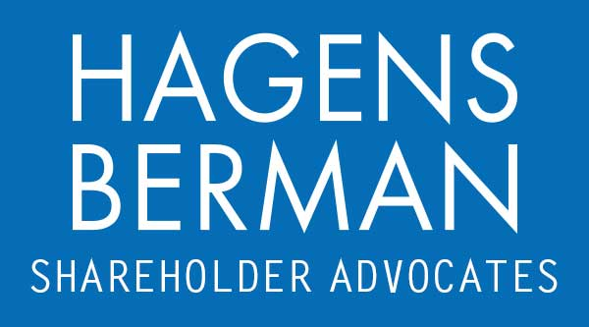

FOR IMMEDIATE RELEASE
Contact:
Reed Kathrein, 844-916-0895

AMPL FINAL DEADLINE ALERT: Hagens Berman, National Trial Attorneys, Encourages Amplitude (AMPL) Investors with Substantial Losses to Contact Firm’s Attorneys Before Apr. 15th Deadline in Securities Fraud Class Action
Apr. 14, 2024

SAN FRANCISCO − Hagens Berman urges Amplitude, Inc. (NASDAQ: AMPL) investors who suffered substantial losses during the Class Period to submit your losses now.

Class Period: Sept. 21, 2021 – Feb. 16, 2022
Lead Plaintiff Deadline: Apr. 15, 2024
Visit: www.hbsslaw.com/investor-fraud/AMPL
Contact An Attorney Now: AMPL@hbsslaw.com
844-916-0895
Amplitude, Inc. (NASDAQ: AMPL) Securities Fraud Class Action:
The litigation focuses on Amplitude’s assurances that its “land-and-expand” business model (whereby it grew revenue by upselling existing clients on increased usage and new products) would continue to support revenue growth acceleration.
The complaint alleges that Amplitude made misleading statements and failed to disclose that: (1) Amplitude’s land-and-expand strategy was years away from significantly accelerating revenues among its newer client cohorts; and (2) the rapid acceleration in Amplitude’s Q2 2021 results was due to the short-lived effects of the COVID-19 pandemic which had not continued by the start of the Class Period, as Amplitude’s clients were expanding at a slower pace.
Investors learned the truth on Feb. 16, 2022, when Amplitude announced financial results for Q4 2021 and revised downward its fiscal 2022 guidance. The company revealed that its land-and-expand strategy was in fact poised to “take a few years” before it was expected to accelerate results and that (despite prior assurances of sustainable growth) Amplitude management “really [did not] know” when this impact would occur.
This news drove the price of Amplitude shares crashing $24.51, or over 58%, lower on Feb. 17, 2022.
“We’re investigating whether Amplitude may have misled investors about the sustainability of its plan for accelerating growth,” said Reed Kathrein, the Hagens Berman partner leading the Amplitude investigation.
If you invested in Amplitude during the Class Period and have substantial losses, or have knowledge that may assist the firm’s investigation, contact Hagens Berman now »
If you’d like more information and answers to frequently asked questions about the Amplitude case and our investigation, read more »
Whistleblowers: Persons with non-public information regarding Amplitude should consider their options to help in the investigation or take advantage of the SEC Whistleblower program. Under the new program, whistleblowers who provide original information may receive rewards totaling up to 30 percent of any successful recovery made by the SEC. For more information, call Reed Kathrein at 844-916-0895 or email AMPL@hbsslaw.com.
# # #
About Hagens Berman
Hagens Berman is a global plaintiffs’ rights complex litigation law firm focusing on corporate accountability through class-action law. The firm is home to a robust securities litigation practice and represents investors as well as whistleblowers, workers, consumers and others in cases achieving real results for those harmed by corporate negligence and fraud. More about the firm and its successes can be found at hbsslaw.com. Follow the firm for updates and news at @ClassActionLaw.
Attorney advertising.
Past results do not guarantee future outcomes.
Services may be performed by attorneys in any of our offices.

