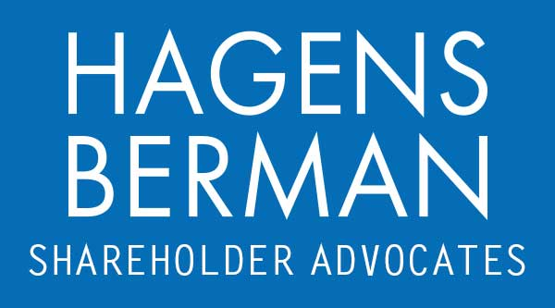

FOR IMMEDIATE RELEASE
Contact:
Reed Kathrein, 844-916-0895

NOVA FINAL DEADLINE ALERT: Hagens Berman, National Trial Attorneys, Encourages Sunnova (NOVA) Investors with Substantial Losses to Contact its Attorneys Before Apr. 16th Deadline in Securities Fraud Class Action
Apr. 15, 2024

SAN FRANCISCO − Hagens Berman urges Sunnova Energy International Inc. (NYSE: NOVA) investors who suffered substantial losses to submit your losses now.

Class Period: Feb. 25, 2020 – Dec. 7, 2023
Lead Plaintiff Deadline: Apr. 16, 2024
Visit: www.hbsslaw.com/investor-fraud/NOVA
Contact An Attorney Now: NOVA@hbsslaw.com
844-916-0895
Sunnova Energy International Inc. (NOVA) Securities Fraud Class Action:
The litigation focuses on Sunnova’s disclosures about its business practices and the recent award by the Department of Energy (DOE) Loan Programs Office (LPO) of a $3 billion partial loan guarantee pursuant to a new solar loan channel named Project Hestia.
The complaint alleges that Sunnova made misleading statements and failed to disclose that: (1) it routinely engaged in predatory business practices against disadvantaged homeowners and communities, the same groups that Project Hestia was purportedly intended to benefit; and (2) the foregoing conduct subjected it to a heightened risk of regulatory and government scrutiny, as well as significant reputational and/or financial harm.
That loan guarantee and associated benefits to Sunnova were all placed at risk of not coming to fruition on Dec. 7, 2023, after the Chair of the US House Energy and Commerce Committee and the Ranking Member of the US Senate Energy and Resources Committee sent a letter to the LPO Director (Jigar Shah) regarding “disturbing reports” about Sunnova and demanding additional information and documents by no later than Dec. 21, 2023.
The Chair and Ranking Member wrote that they were alarmed about: (1) “recent, credible reports that Sunnova has racked up numerous consumer complaints, including those alleging troubling sales practices, such as Sunnova pressing elderly homeowners in poor health to sign long-term contracts costing tens of thousands of dollars[;]” (2) “predatory sales strategies[;]” and (3) “[a]dditional reports suggest these troubling reports are not isolated incidents”.
This news sent the price of Sunnova shares down $2, or about 16%, on Dec. 8, 2023.
If you invested in Sunnova and have substantial losses, or have knowledge that may assist the firm’s investigation, submit your losses now »
If you’d like more information and answers to frequently asked questions about the Sunnova case and our investigation, read more »
Whistleblowers: Persons with non-public information regarding Sunnova should consider their options to help in the investigation or take advantage of the SEC Whistleblower program. Under the new program, whistleblowers who provide original information may receive rewards totaling up to 30 percent of any successful recovery made by the SEC. For more information, call Reed Kathrein at 844-916-0895 or email NOVA@hbsslaw.com.

# # #
About Hagens Berman
Hagens Berman is a global plaintiffs’ rights complex litigation law firm focusing on corporate accountability through class-action law. The firm is home to a robust securities litigation practice and represents investors as well as whistleblowers, workers, consumers and others in cases achieving real results for those harmed by corporate negligence and fraud. More about the firm and its successes can be found at hbsslaw.com. Follow the firm for updates and news at @ClassActionLaw.
Attorney advertising.
Past results do not guarantee future outcomes.
Services may be performed by attorneys in any of our offices.

