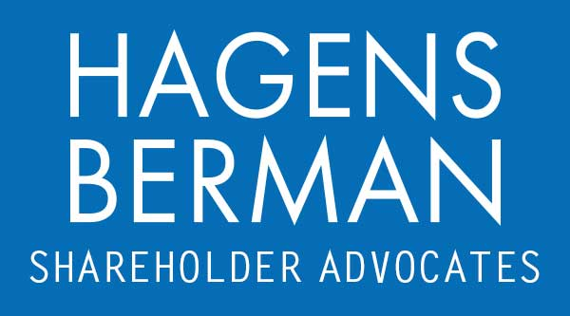

FOR IMMEDIATE RELEASE
Contact:
Reed Kathrein, 844-916-0895

SSRM INVESTOR ALERT: Hagens Berman, National Trial Attorneys, Encourages SSR Mining (SSRM) Investors with Substantial Losses to Contact its Attorneys, Landslide at Turkish Mine Prompts Securities Fraud Class Action
Apr. 19, 2024

SAN FRANCISCO − Hagens Berman urges SSR Mining Inc. (NASDAQ: SSRM) investors who suffered substantial losses to submit your losses now.

Class Period: Feb. 23, 2022 – Feb. 27, 2024
Lead Plaintiff Deadline: May 17, 2024
Visit: www.hbsslaw.com/investor-fraud/ssrm
Contact An Attorney Now: SSRM@hbsslaw.com
844-916-0895

SSR Mining Inc. (SSRM) Securities Fraud Class Action:
Over the past month, it has been one negative news story after another for SSR Mining. Most recently, on Mar. 8, 2024, the Denver, Colorado-based precious metal producer, SSR announced that its Chief Financial Offer Alison White left the company effective Mar. 7, 2024, sending the price of SSR shares significantly lower.
By the date of CFO White’s abrupt departure, SSR shares were down nearly 55% since Feb. 12, 2024 on reports of a catastrophic event at the Company’s gold mine in Eastern Turkey.
Apart from suspending operations and provoking the ire of Turkish regulators, the devasting landslide triggered a securities class action against SSR and its senior management. The complaint, brought on behalf of investors who purchased SSR securities between Feb. 23, 2022 and Feb. 27, 2024, inclusive, alleges Defendants made misleading statements and failed to disclose that (1) SSR overstated its commitment to safety and the efficacy of its safety measures, and (2) the company engaged in unsafe mining practices that were reasonably likely to result in a mining disaster.
Investors began to learn the truth on Feb. 13, 2024, when SSR suffered a devastating landslide at its Çöpler mine, leading to the tragic disappearance of nine workers and concerns of contamination of a nearby river due to the cyanide and other chemicals stored in the mine. The landslide has led to a broad investigation into the mine’s safety practices, including the detention and arrest of SSR employees, the company’s suspension of Çöpler mine operations, and management’s withdrawal of guidance.
These events have caused the price of SSR securities to plummet, injuring SSR investors.
“We’re investigating circumstances surrounding White’s departure and whether SSR may have intentionally misled investors about its commitment to safety in its core mining operation,” said Reed Kathrein, the Hagens Berman partner leading the investigation.
If you invested in SSR Mining and have substantial losses, or have knowledge that may assist the firm’s investigation, submit your losses now »
If you’d like more information and answers to frequently asked questions about the SSR Mining case and our investigation, read more »
Whistleblowers: Persons with non-public information regarding SSR Mining should consider their options to help in the investigation or take advantage of the SEC Whistleblower program. Under the new program, whistleblowers who provide original information may receive rewards totaling up to 30 percent of any successful recovery made by the SEC. For more information, call Reed Kathrein at 844-916-0895 or email SSRM@hbsslaw.com.
# # #
About Hagens Berman
Hagens Berman is a global plaintiffs’ rights complex litigation law firm focusing on corporate accountability through class-action law. The firm is home to a robust securities litigation practice and represents investors as well as whistleblowers, workers, consumers and others in cases achieving real results for those harmed by corporate negligence and fraud. More about the firm and its successes can be found at hbsslaw.com. Follow the firm for updates and news at @ClassActionLaw.
Attorney advertising.
Past results do not guarantee future outcomes.
Services may be performed by attorneys in any of our offices.

