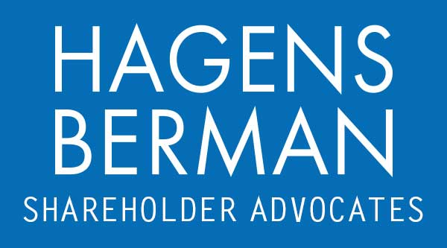

FOR IMMEDIATE RELEASE
Contact:
Reed Kathrein, 844-916-0895

Akero Therapeutics (AKRO) Slides After Failed Trial, Hit With Class Action Lawsuit – Hagens Berman
May 3, 2024

SAN FRANCISCO − Hagens Berman urges Akero Therapeutics, Inc. (NASDAQ: AKRO) investors who suffered substantial losses to take action by submitting your losses now.

Class Period: Sep. 13, 2022 – Oct. 9, 2023
Lead Plaintiff Deadline: June 25, 2024
Visit: www.hbsslaw.com/investor-fraud/AKRO
Contact An Attorney Now: AKRO@hbsslaw.com
844-916-0895

Akero Therapeutics, Inc. (AKRO) Securities Fraud Class Action:
Akero Therapeutics, a biopharmaceutical company developing treatments for liver disease, is facing a securities class action lawsuit over allegations it misled investors about a key clinical trial. The lawsuit centers on the SYMMETRY study, designed to evaluate efruxifermin ("EFX"), Akero's lead drug candidate, for treating nonalcoholic steatohepatitis (NASH), a serious liver condition.
The crux of the complaint lies in Akero's portrayal of the SYMMETRY study's patient population. In June 2019, the FDA issued guidance discouraging the inclusion of patients with cryptogenic cirrhosis, a condition with an unclear cause, in NASH treatment trials. The lawsuit alleges Akero:
- Enrolled ~20% of SYMMETRY study participants with cryptogenic cirrhosis, who lacked definitive NASH diagnoses.
- Failed to ensure these patients had biopsy-confirmed compensated cirrhosis due to NASH.
- Excluded the cryptogenic cirrhosis patients' data from a crucial secondary endpoint measuring NASH resolution.
- Introduced a potential confounding factor by including these patients, jeopardizing the study's integrity, and increasing the risk of failure.
- Misrepresented the trial's design and its ability to support future drug applications.
The lawsuit further claims Akero misled investors regarding the likelihood of the study's success and EFX's potential as a commercial NASH treatment.
The truth reportedly came to light on October 10, 2023, when Akero announced the SYMMETRY study missed its primary endpoint and disclosed the exclusion of 11 cryptogenic patients from the placebo arm's secondary endpoint data.
The news triggered a dramatic plunge in Akero's stock price, dropping $30.39 (down 62%) on October 10, followed by analyst downgrades.
"We are investigating whether Akero intentionally misrepresented its SYMMETRY patient population," stated Reed Kathrein, the Hagens Berman partner leading the investigation.
If you invested in Akero Therapeutics and have substantial losses, or have knowledge that may assist the firm’s investigation, submit your losses now »
If you’d like more information and answers to frequently asked questions about the Akero case and our investigation, read more »
Whistleblowers: Persons with non-public information regarding Akero Therapeutics should consider their options to help in the investigation or take advantage of the SEC Whistleblower program. Under the new program, whistleblowers who provide original information may receive rewards totaling up to 30 percent of any successful recovery made by the SEC. For more information, call Reed Kathrein at 844-916-0895 or email AKRO@hbsslaw.com.
# # #
About Hagens Berman
Hagens Berman is a global plaintiffs’ rights complex litigation law firm focusing on corporate accountability through class-action law. The firm is home to a robust securities litigation practice and represents investors as well as whistleblowers, workers, consumers and others in cases achieving real results for those harmed by corporate negligence and fraud. More about the firm and its successes can be found at hbsslaw.com. Follow the firm for updates and news at @ClassActionLaw.
Attorney advertising.
Past results do not guarantee future outcomes.
Services may be performed by attorneys in any of our offices.

