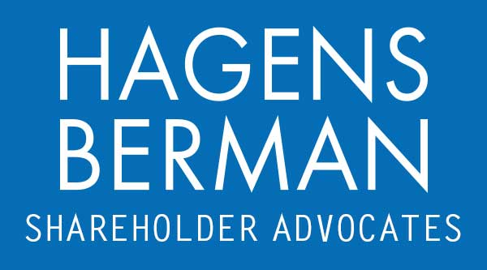

FOR IMMEDIATE RELEASE
Contact:
Reed Kathrein, 844-916-0895

Contact Hagens Berman by June 28, 2024 Deadline to Join Class Action Against SSR Mining (SSRM)
May 10, 2024

SAN FRANCISCO − Hagens Berman alerts investors in SSR Mining Inc. (NASDAQ: SSRM) of a class-action securities lawsuit.
Am I Included? The lawsuit seeks to recover losses on behalf of investors who purchased SSR Mining securities between Feb. 23 2022 and Feb. 27, 2024 and were adversely affected by the alleged fraud. If you suffered a loss in SSR Mining between these dates, you have until May 17, 2024 to request that the Court appoint you as lead plaintiff. Your ability to share in any recovery doesn’t require that you serve as a lead plaintiff. Follow the link below to get more information and be contacted by a member of our team:
www.hbsslaw.com/investor-fraud/SSRM
What Happened? The lawsuit alleges that the company made misleading statements and failed to disclose that (1) SSR overstated its commitment to safety and the efficacy of its safety measures, and (2) the company engaged in unsafe mining practices that were reasonably likely to result in a mining disaster.
More About the SSR Mining Inc. (SSRM) Class Action:
The Denver-based precious metals producer's stock price has plummeted nearly 55% since mid-February following a devastating landslide at its gold mine in eastern Turkey. On Feb. 13, 2024, a significant slip occurred from the heap leach pad with an estimated 18-20 million tonnes sliding into Sabirli Valley and the Manganese Pit. The landslide resulted in the disappearance of nine miners and raised concerns about environmental contamination from the mine's storage of cyanide and other chemicals.
In the aftermath, SSR has suspended operations at the Çöpler mine and is facing investigations by Turkish regulators. The Turkish government also insists that SSR Mining will pay for the clean-up costs of the accident. Additionally, the company's Chief Financial Officer, Alison White, abruptly departed on Mar. 8, 2024, further unsettling investors.
What are Hagens Berman’s Next Steps? “We are investigating whether the devasting landslide at the Çöpler Mine may have been a materialization of the risk presented by potentially unsafe core mining operations,” said Reed Kathrein, the Hagens Berman partner leading the investigation.
How much does it cost? There is no cost or obligation to participate. If you have been affected and qualify as a class member, you may be entitled to compensation. In no case will any class member ever be asked to pay any out-of-pocket sum.
What should I do? If you invested in SSR Mining and have substantial losses, submit your losses now »
If you’d like more information about the SSR Mining case and our investigation, read more »
# # #
About Hagens Berman
Hagens Berman is a global plaintiffs’ rights complex litigation law firm focusing on corporate accountability through class-action law. The firm is home to a robust securities litigation practice and represents investors as well as whistleblowers, workers, consumers and others in cases achieving real results for those harmed by corporate negligence and fraud. More about the firm and its successes can be found at hbsslaw.com. Follow the firm for updates and news at @ClassActionLaw.

