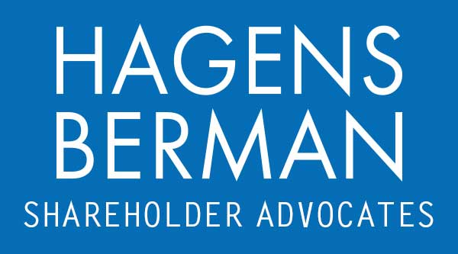

FOR IMMEDIATE RELEASE
Contact:
Reed Kathrein, 844-916-0895

Contact Hagens Berman by May 21, 2024 Deadline to Join Class Action Against Shoals Technologies Group (SHLS)
May 12, 2024

SAN FRANCISCO − Hagens Berman urges Shoals Technologies Group, Inc. (NASDAQ: SHLS) investors who suffered substantial losses to submit your losses now.

Class Period: May 17, 2022 – Nov. 7, 2023
Lead Plaintiff Deadline: May 21, 2024
Visit: www.hbsslaw.com/investor-fraud/shls
Contact the Firm Now: SHLS@hbsslaw.com
844-916-0895

Shoals Technologies Group, Inc. (SHLS) Class Action:
The litigation focuses on the propriety of Shoals’ statements about the quality and reliability of wire harnesses used in its electrical balance of systems (“EBOS”) solutions that presented excessive pullback of wire insulation at connection points (“wire shrinkback”), and on the company’s related accounting.
The complaint alleges that Shoals made misleading statements and failed to disclose that: (1) it did not deliver EBOS (which utilize a custom wire harness for aggregating electricity from multiple solar panels to deliver that electricity to inverters) products that met the highest levels of quality and reliability; (2) it received reports of exposed copper conduit in EBOS wire harnesses in a large number of solar fields and was aware that a significant portion of its wire harnesses had defects; (3) it would have to incur between $60 million and $185 million in costs to remediate the wire shrinkback issue; and (4) it understated its cost of revenue by millions of dollars.
Investors learned the truth on Nov. 7, 2023, when Shoals filed its Q3 2023 financial results and held its earnings call, revealing that wire shrinkback was far more severe than previously disclosed. In particular, Shoals said wire shrinkback affected 30% of harnesses the company installed during 2020 – 2022 and booked a $50.2 million warranty expense related to the shrinkback issue. The company also estimated a range of potential losses related to the shrinkback issue of $59.7 million to $184.9 million.
In response to this news, the price of Shoals shares fell $3.28 (over 20%) over the next two trading days.
“We’re investigating whether Shoals intentionally understated its cost of revenues while concealing the extent of its wire shrinkback problems,” said Reed Kathrein, the Hagens Berman partner leading the investigation.
If you invested in Shoals Technologies and have substantial losses, or have knowledge that may assist the firm’s investigation, submit your losses now »
If you’d like more information and answers to frequently asked questions about the Shoals Technologies case and our investigation, read more »
# # #
About Hagens Berman
Hagens Berman is a global plaintiffs’ rights complex litigation firm focusing on corporate accountability. The firm is home to a robust practice and represents investors as well as whistleblowers, workers, consumers and others in cases achieving real results for those harmed by corporate negligence and other wrongdoings. Hagens Berman’s team has secured more than $2.9 billion in this area of law. More about the firm and its successes can be found at hbsslaw.com. Follow the firm for updates and news at @ClassActionLaw.

