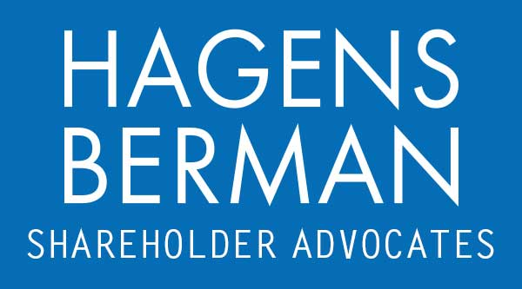

FOR IMMEDIATE RELEASE
Contact:
Reed Kathrein, 844-916-0895

Contact Hagens Berman by May 20, 2024 Deadline to Join Class Action Against The Chemours Company (CC)
May 12, 2024

SAN FRANCISCO − Hagens Berman urges The Chemours Company (NYSE: CC) investors who suffered substantial losses to submit your losses now.

Class Period: Feb. 10, 2023 – Feb. 28, 2024
Lead Plaintiff Deadline: May 20, 2024
Visit: www.hbsslaw.com/investor-fraud/CC
Contact the Firm Now: CC@hbsslaw.com
844-916-0895
The Chemours Company (NYSE: CC) Class Action:
"We’re investigating the propriety of Chemours’ financial statements, including its internal controls, and the company’s tone at the top,” said Reed Kathrein, the Hagens Berman partner leading the investigation.
On Mar. 27, 2024, Chemours announced that “payments of up to approximately $100 million were delayed until the first quarter of 2024, primarily to certain vendors that were originally due to be paid in the fourth quarter of 2023; and collection of up to approximately $260 million of receivables that were originally not due to be received until the first quarter of 2024 were accelerated into the fourth quarter of 2023.”
Chemours also revealed this was not the first time such accounting manipulation occurred. Similar actions “were taken in the fourth quarter of 2022, resulting in a delay of up to $40 million of payments to vendors that were originally due to be paid in the fourth quarter of 2022 until the first quarter of 2023; and the acceleration of the collection of up to approximately $175 million of receivables into the fourth quarter of 2022 that were originally not due to be received until the first quarter of 2023.”
Chemours’ bombshell announcement follows the filing of a securities class action complaint, which alleges that Chemours misrepresented and failed to disclose that (1) certain of its executive officers manipulated Free Cash Flow targets as a means to maximize additional cash and stock incentive compensation applicable to executive officers pursuant to its Annual Incentive Plans (“AIPs”) and Long-Term Incentive Plans (“LTIPs”), and (2) its accounting practices and procedures, including its internal control over financial reporting, were deficient.
The Chemours saga began on Feb. 13, 2024, when the company announced that it postponed the release of its financial results and conference call related to its Q4 and FYE Dec. 31, 2023.
Shortly afterward, on Feb. 28, 2024, Chemours announced its Board suspended CEO Mark Newman, CFO Jonathan Lock and Controller and Principal Accounting Officer Camela Wisel pending completion of the company’s internal accounting probe and the effectiveness of “tone at the top” set by senior management.
Then, on Mar. 7, 2024, Chemours revealed that Newman, Lock and Wisel: (1) “engaged in efforts in the fourth quarter of 2023 to delay payments to certain vendors that were originally due to be paid in the fourth quarter of 2023 until the first quarter of 2024[;]” (2) “to accelerate the collection of receivables into the fourth quarter of 2023 that were not originally due to be received until the first quarter of 2024[;]” and (3) “these individuals engaged in these efforts in part to meet free cash flow targets that the Company had communicated publicly, and which also would be part of a key metric for determining incentive compensation applicable to executive officers[]” under the AIPs and LTIPs.
These events drove the price of Chemours shares sharply lower.
If you invested in The Chemours Company and have substantial losses, or have knowledge that may assist the firm’s investigation, submit your losses now »
If you’d like more information and answers to frequently asked questions about the Chemours case and our investigation, read more »
# # #
About Hagens Berman
Hagens Berman is a global plaintiffs’ rights complex litigation firm focusing on corporate accountability. The firm is home to a robust practice and represents investors as well as whistleblowers, workers, consumers and others in cases achieving real results for those harmed by corporate negligence and other wrongdoings. Hagens Berman’s team has secured more than $2.9 billion in this area of law. More about the firm and its successes can be found at hbsslaw.com. Follow the firm for updates and news at @ClassActionLaw.

