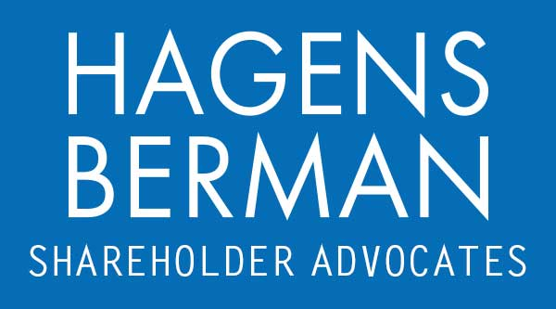

FOR IMMEDIATE RELEASE
Contact:
Reed Kathrein, 844-916-0895

Contact Hagens Berman by May 24, 2024 Deadline to Join Class Action Against Evolv Technologies (EVLV)
May 12, 2024

SAN FRANCISCO − Hagens Berman urges Evolv Technologies Holdings, Inc. (NASDAQ: EVLV) investors who suffered substantial losses to submit your losses now.

Class Period: June 28, 2021 – Mar. 13, 2024
Lead Plaintiff Deadline: May 24, 2024
Visit: www.hbsslaw.com/investor-fraud/EVLV
Contact the Firm Now: EVLV@hbsslaw.com
844-916-0895

Evolv Technologies Holdings, Inc. (NASDAQ: EVLV) Class Action:
Evolv Technologies, Inc., the company known for its artificial intelligence-powered weapons scanners, saw its stock price plummet by over 47% in intraday trading on May 10, 2024. This dramatic drop follows a series of setbacks for the company, including a lowered revenue forecast, an investor class action and ongoing investigations by the Securities and Exchange Commission (SEC) and the Federal Trade Commission (FTC).
On May 9th, Evolv released its first-quarter 2024 financial results. While the report did not offer any updates on the SEC or FTC investigations, it slashed the company’s previously issued 2024 revenue outlook. This revision reflected a projected 13% decrease in revenue compared to Evolv’s February 29th, 2024 forecast.
This news comes amidst a period of heightened scrutiny for Evolv. In February, investors brought a class-action lawsuit against the company and its executives alleging that they had misled shareholders about the effectiveness of their weapons detection technology. The lawsuit claims that Evolv misrepresented the scanners’ ability to detect guns and knives.
Adding to Evolv’s woes, both the SEC and FTC launched investigations into the company’s marketing practices in early 2024. These investigations center on allegations of potentially deceptive claims surrounding the capabilities of Evolv’s technology.
In an attempt to bolster investor confidence, Evolv previously announced that their scanners had undergone testing and validation by Metix NDT Ltd., a U.K. firm, against the National Protective Security Authority’s (NPSA) standards. However, a BBC report published in March cast doubt on these claims. The BBC found that the NPSA does not perform the type of testing Evolv had described, and Metix reportedly clarified that they did not “validate” the Evolv Express system.
The combined weight of the lowered revenue forecast, ongoing regulatory investigations, and challenged claims about their technology appears to have shaken investor confidence in Evolv. The company's stock price has experienced significant volatility throughout 2024, and the May 10th drop reflects a new low point.
“We’re investigating whether Evolv falsely marketed the capabilities of its weapon scanners,” said Reed Kathrein, the Hagens Berman partner leading the firm’s investigation.
If you invested in Evolv Technologies and have substantial losses, or have knowledge that may assist the firm’s investigation, contact Hagens Berman now »
If you’d like more information and answers to frequently asked questions about the Evolv Technologies case and our investigation, read more »
# # #
About Hagens Berman
Hagens Berman is a global plaintiffs’ rights complex litigation firm focusing on corporate accountability. The firm is home to a robust practice and represents investors as well as whistleblowers, workers, consumers and others in cases achieving real results for those harmed by corporate negligence and other wrongdoings. Hagens Berman’s team has secured more than $2.9 billion in this area of law. More about the firm and its successes can be found at hbsslaw.com. Follow the firm for updates and news at @ClassActionLaw.

