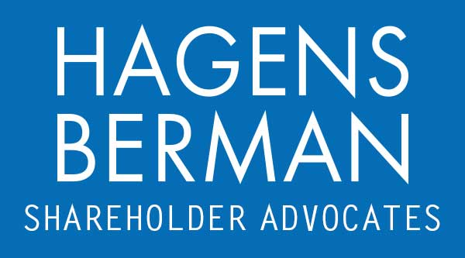

FOR IMMEDIATE RELEASE
Contact:
Reed Kathrein, 844-916-0895

Hagens Berman Expands Class Period in Class Action Against Plug Power (PLUG) – PLUG Investors with Substantial Losses Encouraged to Contact Firm by May 21, 2024 Deadline
May 19, 2024

SAN FRANCISCO − Hagens Berman urges investors who suffered substantial losses in Plug Power Inc. (NASDAQ: PLUG) to submit their losses now.

Expanded Class Period: Mar. 1, 2023 – Jan. 16, 2024
Lead Plaintiff Deadline: May 21, 2024
Website: www.hbsslaw.com/investor-fraud/PLUG
Contact Email: PLUG@hbsslaw.com Phone: 844-916-0895
Class Action Against Plug Power Inc. (NASDAQ: PLUG): The lawsuit challenges Plug Power’s claims that its green hydrogen production plant construction was “on track” and that it had identified non-dilutive funding opportunities. The complaint alleges that Plug Power misled investors by omitting to disclose:
- Supply Chain Challenges: Plug overstated its ability to mitigate the negative impacts of supply chain constraints and material shortages on its hydrogen business. It also exaggerated the sufficiency of its cash and capital to fund operations.
- Delays and Funding Issues: The company continued to experience delays in its green hydrogen production facility build-out plans and faced challenges securing external funding sources for growth.
Investors learned the truth on Nov. 9, 2023, when Plug announced dismal Q3 2023 results. The company blamed supply challenges in the North American hydrogen network and revealed liquidity problems that raised doubts about its ability to continue as a going concern. This news caused Plug shares to plummet by over 40% on Nov. 10, 2023. Subsequently, analyst downgrades followed. On Jan. 17, 2024, Plug’s shares dropped again after Seeking Alpha reported that Morgan Stanley analyst Andrew Percoco maintained an underweight rating and a $3 price target. The analyst also reportedly warned of the increasing likelihood that Plug would need to raise $1 billion to $1.5 billion in equity capital to support its capital-intensive business.

After the Class Period, on May 9, 2024, Plug reported its Q1 2024 financial results, including a sharp increase in net loss and a whopping 43% drop in revenues from the year earlier period. Plug also informed investors that “we’ve implemented a series of restructuring measures aimed at reducing costs and improving efficiencies[]” and “[t]his includes headcount reductions and operational considerations[.]”
“We are investigating whether Plug may have downplayed supply chain and funding hurdles,” said Reed Kathrein, the Hagens Berman partner leading the firm’s investigation.
If you invested in Plug Power and have substantial losses, or have knowledge that may assist the firm’s investigation, contact Hagens Berman now »
If you’d like more information and answers to frequently asked questions about the Plug Power case and our investigation, read more »
# # #
About Hagens Berman
Hagens Berman is a global plaintiffs’ rights complex litigation firm focusing on corporate accountability. The firm is home to a robust practice and represents investors as well as whistleblowers, workers, consumers and others in cases achieving real results for those harmed by corporate negligence and other wrongdoings. Hagens Berman’s team has secured more than $2.9 billion in this area of law. More about the firm and its successes can be found at hbsslaw.com. Follow the firm for updates and news at @ClassActionLaw.

