Demether Completes Successful Angel Investment Round to Solve Capital Fragmentation Among Blockchains

Panama City, Panama – 8 July 2024 – Demether, an upcoming DeFi project working to enable zero-cost access to TVL for blockchains, announced today that it has successfully completed an initial angel investment round. Led by marquee Web3 names, such as SkyVision Capital, Formless Capital, Gandel Invest and M Capital, the oversubscribed round saw participation from a total of 17 family offices and angel investors.

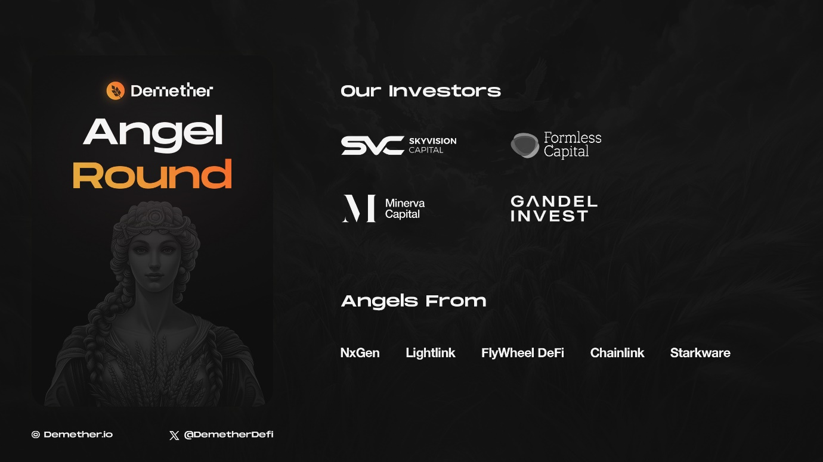

Blockchain ecosystems strive to cultivate healthy and sustainable ecosystems by onboarding users, capital and applications. Traditional models help with onboarding capital at a high associated cost and are often unsustainable. Demether intends to solve capital fragmentation and retention through an innovative business model that leverages compelling incentives and by aligning interests across the ecosystem.

"We are thrilled to have such prominent investors backing our collective vision for Demether," said Kartik Swaminathan, Founder and CEO of Rolling Thunder Labs, a core contributor to the Demether protocol. "Blockchain foundations face ever-increasing competition for users' attention and capital from new entrants; a problem which has only compounded through every cycle. That is why Demether has adopted capital retention as its north star. We are focused on crafting unique incentive mechanisms that ensure that blockchains can secure low-cost capital while providing users access to sufficient incentives to retain their capital within an ecosystem. This investment round is a testament to the value-creation potential of Demether’s model and the investors’ support of Demether’s mission to seed sustainable ecosystems."

"We are proud to support the development of Demether’s funding round as the team aims to enable the launch of an innovative and compelling solution to persistent challenges faced by nascent blockchain ecosystems", commented the Managing Partner of SkyVision Capital, Sandra Wu. Renowned for backing disruptive crypto and blockchain startups, SkyVision Capital's involvement will bring invaluable industry expertise and networking opportunities.

The secured funding will be utilised to accelerate product development, attract talent and build a strong market presence underpinned by a vibrant community. The project aims to launch during Q4 2024 and already has a shortlist of chains looking to deploy the protocol with initial deployment occurring on the Ethereum and Arbitrum networks.

About Rolling Thunder Labs Limited:
Rolling Thunder Labs Limited is a Web3 R&D company headquartered in London, United Kingdom, specialising in developing innovative solutions for the DeFi space. Founded in 2024, the firm aims to combine cutting edge technologies with a seamless user experience to onboard the next generation of internet users as true Web3 natives.
Find out more at Rolling Thunder Labs’ website.

About Demether Protocol:
Demether is a DeFi protocol which aggregates, mobilises and allocates capital to blockchain ecosystems while preserving trustlessness, decentralisation and composability. The goal of the protocol is to attract and retain value within Web3 ecosystems.
Find out more on Demether’s website. Follow Demether on X @demetherdefi.

Contact Information:
info@rtlabs.xyz

SOURCE Demether International Foundation

