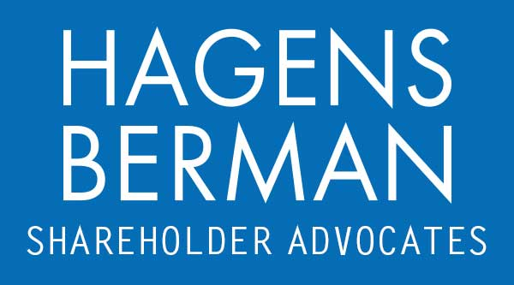

FOR IMMEDIATE RELEASE
Contact:
Reed Kathrein, 844-916-0895

FAT Brands (FAT, FATBB, FATBP, FATBW) Indicted in Connection With $47 Million in Alleged Sham Loans to Former CEO, Faces Securities Class Action – Hagens Berman
Contact Hagens Berman by August 6, 2024 Deadline to Join Class Action Against FAT
July 25, 2024

SAN FRANCISCO − Hagens Berman urges FAT Brands Inc. (NASDAQ: FAT, FATBB, FATBP, FATBW) investors who suffered substantial losses to take action now by submitting your losses here.

Class Period: Mar. 24, 2022 – May 10, 2024
Lead Plaintiff Deadline: Aug. 6, 2024
Visit: www.hbsslaw.com/investor-fraud/fat
Contact the Firm Now: FAT@hbsslaw.com
844-916-0895

Class Action Lawsuit Against FAT Brands Inc.:
An investor class action lawsuit has been filed against FAT Brands Inc. (FAT, FATBB, FATBP, FATBW), alleging that the company made misleading statements and failed to disclose crucial information. The lawsuit centers around the actions of Andrew A. Wiederhorn, the current Chairman and former CEO of FAT Brands.
Background:
Historically, FAT Brands has assured investors of its cooperation with the U.S. Department of Justice (DOJ) and the Securities and Exchange Commission (SEC) in their investigations into the company’s transactions with Wiederhorn, including matters related to compensation, credit extensions, and other benefits received by Wiederhorn and his family from the company. FAT Brands maintained that its financial statements were accurate and that its internal controls over financial reporting were adequate.
The Indictment Allegations:
However, on May 9, 2024, the DOJ escalated the situation by filing a grand jury criminal indictment against several key figures. The indictment specifically targets FAT Brands, Wiederhorn, tax advisor William J. Amon, and FAT CFO Rebecca D. Hershinger. According to the allegations, Wiederhorn orchestrated the extension, maintenance, and forgiveness of approximately $47 million in compensation to himself through what authorities describe as sham shareholder loans. Both Wiederhorn and Amon were allegedly aware that these transactions were, in fact, disguised compensation.
Board Dynamics:
In addition, the criminal indictment sheds light on the actions taken by FAT Brands’ board members. After learning of the federal criminal investigation on December 1, 2021, some board members reportedly communicated with the government. Subsequently, on March 28, 2023, Wiederhorn made significant changes to the board composition. He removed all directors except himself and filled the board with mostly non-independent directors under his control.

Following this news, the prices of FAT Brands’ Class A and B shares, Series B Preferred shares, and Warrants plummeted on May 10, 2024.
“Our investigation centers on the extent to which FAT understated its compensation expenses and overstated earnings metrics,” said Reed Kathrein, the Hagens Berman partner leading the investigation.
If you invested in FAT and have substantial losses, or have knowledge that may assist the firm’s investigation, submit your losses now »
If you’d like more information and answers to frequently asked questions about the FAT case and our investigation, read more »
# # #
About Hagens Berman
Hagens Berman is a global plaintiffs’ rights complex litigation firm focusing on corporate accountability. The firm is home to a robust practice and represents investors as well as whistleblowers, workers, consumers and others in cases achieving real results for those harmed by corporate negligence and other wrongdoings. Hagens Berman’s team has secured more than $2.9 billion in this area of law. More about the firm and its successes can be found at hbsslaw.com. Follow the firm for updates and news at @ClassActionLaw.

