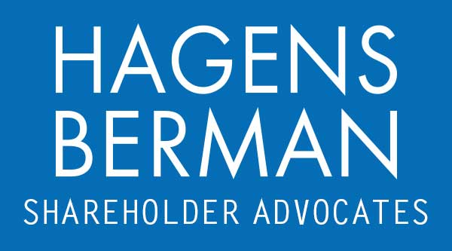

FOR IMMEDIATE RELEASE
Contact:
Reed Kathrein, 844-916-0895

Acadia Healthcare (ACHC) Stock Plummets Again on Reported Veterans Affairs Department Investigation - Hagens Berman
Oct. 24, 2024

SAN FRANCISCO − On October 18, 2024, The New York Times reported that the Veterans Affairs Department is investigating whether Acadia Healthcare, a leading provider of behavioral health services, is defrauding government health insurance programs by holding patients longer than is medically necessary. This latest development comes on top of a reported DOJ investigation and a private federal securities class-action lawsuit against the company and certain of its key executives alleging defendants violated federal securities laws by misleading investors about its patient detention practices and business operations.

Hagens Berman urges Acadia Healthcare investors who suffered substantial losses to submit your losses now.

Class Period: Feb. 28, 2020 – Sept. 26, 2024
Lead Plaintiff Deadline: Dec. 16, 2024
Visit: www.hbsslaw.com/investor-fraud/ACHC
Contact the Firm Now: ACHC@hbsslaw.com
844-916-0895

Acadia Healthcare Company, Inc. (ACHC) Securities Class Action:
The suit, filed in the Middle District of Tennessee, seeks to recover damages for investors who purchased Acadia Healthcare securities between February 28, 2020, and September 26, 2024.
According to the complaint, Acadia Healthcare has engaged in a pattern of detaining patients against their will, even when such detention was not medically necessary. The company is accused of using deceptive tactics to lure patients into its facilities and then holding them captive for financial gain, rather than for their medical treatment.
The lawsuit alleges that Acadia Healthcare's executives were aware of these practices and intentionally misled investors about the company's business model and financial prospects.
The complaint cites a recent investigation by The New York Times that revealed widespread allegations of patient abuse and illegal detention at Acadia Healthcare facilities across the country.
Following the publication of The New York Times investigation on September 1, 2024, the company's stock price plummeted by 4.5%. The decline accelerated on September 27, 2024, when Acadia Healthcare disclosed that it was under investigation by federal authorities. The stock price dropped by a further 16.36% on that day, reflecting investor concerns about the potential legal and financial consequences of the company's misconduct.
Most recently, on October 18, 2024, The New York Times reported on a fresh round of investigations into Acadia Healthcare. According to the reporting, the Veterans Affairs Department is looking into whether the company “billed insurance programs for patients who were stable enough to be released and did not need intensive inpatient care[.]” This news drove the price of Acadia Healthcare shares down over 12%.
Shareholder rights firm Hagens Berman is investigating the alleged claims. “Acadia Healthcare’s alleged conduct, if proven, represents a significant breach of patient rights and a betrayal of investor trust,” said Reed Kathrein, the Hagens Berman partner leading the firm’s investigation.
If you invested in Acadia Healthcare and have substantial losses, or have knowledge that may assist the firm’s investigation, submit your losses now »
If you’d like more information and answers to frequently asked questions about the Acadia Healthcare case and our investigation, read more »
Whistleblowers: Persons with non-public information regarding Acadia Healthcare should consider their options to help in the investigation or take advantage of the SEC Whistleblower program. Under the new program, whistleblowers who provide original information may receive rewards totaling up to 30 percent of any successful recovery made by the SEC. For more information, call Reed Kathrein at 844-916-0895 or email ACHC@hbsslaw.com.
# # #
About Hagens Berman
Hagens Berman is a global plaintiffs’ rights complex litigation firm focusing on corporate accountability. The firm is home to a robust practice and represents investors as well as whistleblowers, workers, consumers and others in cases achieving real results for those harmed by corporate negligence and other wrongdoings. Hagens Berman’s team has secured more than $2.9 billion in this area of law. More about the firm and its successes can be found at hbsslaw.com. Follow the firm for updates and news at @ClassActionLaw.

