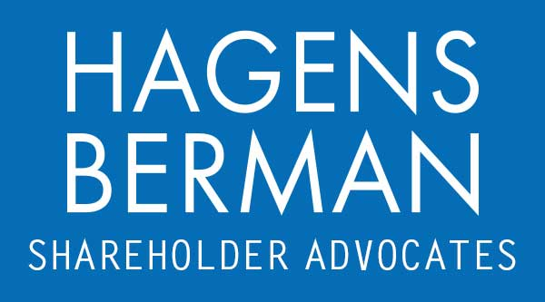

FOR IMMEDIATE RELEASE
Contact:
Reed Kathrein, 844-916-0895

Super Micro Computer (SMCI) Faces Multiple Legal Fronts Amid Financial Allegations - Hagens Berman
SMCI Investors with Losses Encouraged to Contact the Firm Before Oct. 29, 2024 Deadline
Oct. 28, 2024

SAN FRANCISCO − Technology hardware manufacturer Super Micro (SCMI) continues to face legal challenges amid allegations of financial impropriety. In addition to the ongoing federal investigation, the company is now the subject of another class-action lawsuit filed on behalf of investors alleging an expansive class period.

Hagens Berman urges Super Micro Computer, Inc. (NASDAQ: SMCI) investors who suffered substantial losses to submit your losses now.

Expanded Class Period: Feb. 2, 2021 – Sept. 25, 2024
Lead Plaintiff Deadline for All Class Actions: Oct. 29, 2024
Visit: www.hbsslaw.com/investor-fraud/smci
Contact the Firm Now: SMCI@hbsslaw.com
844-916-0895

The New Super Micro Computer, Inc. (SMCI) Securities Class Action:

The new complaint alleges that the company and certain of its officers misled investors during a period spanning from February 2, 2021, to September 25, 2024. The suit, filed in the Northern District of California, seeks to represent all individuals or entities who purchased or acquired Super Micro securities during this time.

The lawsuit is related to several other similar actions previously filed against Super Micro, expanding upon the allegations and extending the class period. The complaint alleges that Super Micro made materially false and misleading statements regarding its financial performance, internal controls, and related party transactions.
Defendants’ façade began to crack on August 27, 2024, when investment firm Hindenburg Research published a report that provided credible evidence of “glaring accounting red flags, evidence of undisclosed related party transactions, sanctions and export control failures, and customer issues” at Super Micro.
The next day, on August 28, 2024, Super Micro announced that it would delay the filing of its annual report on Form 10-K to assess the “design and operating effectiveness of its internal controls over financial reporting.”
Finally, on September 26, 2024, The Wall Street Journal reported that the U.S. Department of Justice (DOJ) had initiated an investigation into Super Micro. The investigation reportedly focused on allegations made by a whistleblower and former employee, who accused the company of accounting violations.
Law firm Hagens Berman has announced it is investigating Super Micro Computer, Inc. following allegations of financial misconduct. The firm's partner leading the probe, Reed Kathrein, stated that the claims raised in the litigation "raise significant concerns about Super Micro’s financial reporting and internal controls."
If you invested in Super Micro Computer and have substantial losses, or have knowledge that may assist the firm’s investigation, submit your losses now »
If you’d like more information and answers to frequently asked questions about the Super Micro Computer case and our investigation, read more »
Whistleblowers: Persons with non-public information regarding Super Micro Computer should consider their options to help in the investigation or take advantage of the SEC Whistleblower program. Under the new program, whistleblowers who provide original information may receive rewards totaling up to 30 percent of any successful recovery made by the SEC. For more information, call Reed Kathrein at 844-916-0895 or email SMCI@hbsslaw.com.
# # #
About Hagens Berman
Hagens Berman is a global plaintiffs’ rights complex litigation firm focusing on corporate accountability. The firm is home to a robust practice and represents investors as well as whistleblowers, workers, consumers and others in cases achieving real results for those harmed by corporate negligence and other wrongdoings. Hagens Berman’s team has secured more than $2.9 billion in this area of law. More about the firm and its successes can be found at hbsslaw.com. Follow the firm for updates and news at @ClassActionLaw.

